**PUPQC Scheduler System**

# Title page

A Capstone Project

Presented to the Faculty of the

Polytechnic University of the Philippines

Quezon City Campus

By

**Bacani, Alexa Leinor Rose J.**

**Camania, John Kyle Bryan A.**

**Pajela, Jane Samer B.**

BSIT 4 – 2

JANUARY 2024

# ABSTRACT

In response to the escalating complexities of academic scheduling at the Polytechnic University of the Philippines, Quezon City (PUPQC), the PUPQC Scheduler System emerged as a comprehensive solution aimed at streamlining and automating the class assignment processes. Addressing challenges inherent in manual scheduling, the system integrates cutting-edge technologies, such as Django and FastAPI, to ensure optimal performance and a user-friendly interface. The iterative development approach guided by the Agile Scrum methodology facilitated adaptability to evolving requirements and effective communication within a remote work environment. Stakeholder engagement, particularly with the Academic Head Administrator played a crucial role in identifying and refining system requirements.

The system's architecture, meticulously designed with components such as the Manage Schedule Module, User Interface, Database Management, and Integration Module, ensures a seamless scheduling experience. The business processes within the system, illustrated through diagrams, demonstrate the efficiency of class assignment and room allocation, providing stakeholders with valuable insights into academic scheduling. The robust data architecture, anchored in PostgreSQL, integrates diverse data sources, such as academic records, faculty details, room allocations, and curriculum specifics. Synchronization mechanisms especially with external systems like the Faculty Information System underscore the commitment to real-time and accurate data exchange.

Project outcomes highlight the achievements of the PUPQC Scheduler System, including streamlined scheduling processes, enhanced collaboration, and real-time data exchange. The future work and enhancements section envisions expanding features, considering scalability, and integrating continuous feedback mechanisms. The valuable lessons learned throughout the development process serve as a foundation for ongoing improvement and future innovations in academic scheduling systems.

# ACKNOWLEDGEMENT

The researchers extend heartfelt gratitude to the invaluable individuals who played fundamental roles in the successful realization of this capstone project.

First and foremost, immense appreciation is owed to **Prof. Rosicar E. Escober, Ph.D,** our esteemed project adviser. Her wealth of knowledge, insightful remarks, and constructive suggestions have been instrumental in refining and enhancing the overall quality of our project.

Special thanks are also extended to **Prof. Demelyn E. Monzon, Ph.D**, who served not only as our primary stakeholder but also as the Academic Head Administrator of the University of the Philippines, Quezon City Branch. Her invaluable inputs served as a guiding light throughout the development of the scheduling system, shaping its direction and ensuring its relevance.

Recognition is due to **Inst. Leandro B. Avena IV MIT**, our former research adviser, whose unwavering dedication and guidance significantly contributed to the successful completion of our capstone project.

In the actual execution of this endeavor, our deepest appreciation goes to our **PARENTS**. Their unwavering moral and financial support, coupled with boundless love, has been our anchor and driving force.

Above all, we express our profound gratitude to **JESUS CHRIST**, the ultimate source of courage and strength, empowering us to overcome challenges and see this thesis through to completion.

The Researchers

Table of Contents

Title page i

ABSTRACT i

ACKNOWLEDGEMENT ii

List of Tables vii

List of Figures ix

1. Introduction 1

1.1 Objectives and Goals 1

1.2 Significance and Relevance 2

1.3 Structure of the Document 2

2. Literature Review 1

2.1 Agile Methodology in Software Development 1

2.2 Agile Scrum Methodology 1

2.3 Enterprise Architecture Concepts. 2

2.4 Relevant Studies and Research 4

2.4.1 Scheduling Systems 4

2.4.2 Rule-Based Algorithm 5

2.4.2.1 Rule-based Algorithm in System Development 5

2.4.2.2 Personalization and Tailored Rulings for Rule-Based Algorithm 6

2.4.2.3 Advantages and Disadvantages of Rule-Based Algorithm 6

2.5 Integration of Information Systems in Enterprise Environments. 7

3. Methodology 2

3.1 Agile Scrum Methodology in the Project. 2

3.2 Roles 3

3.3 Sprint Events 4

3.4 Scrum Artifacts 5

4.0.1 System Requirements Specifications 6

4.0.2 System Design Specifications. 7

4.1 Stakeholder Identification. 8

4.2 Requirements Gathering Techniques 12

4.3 User Stories and Use Cases 13

4.3.1 User Stories 13

4.3.2 Use Cases 14

4.4 Functional Requirements for Integration 14

5. Business Process Architecture 16

5.1 Identification of Business Processes 16

5.1.1 System Business Requirements 16

5.2 Business Process Diagrams 18

5.2.1 Log-in Process 18

5.2.2 Admin Workbench 19

5.3 Alignment of Integrated System with Business Processes 24

6. Application Architecture 25

6.1 Components of Application Architecture 25

6.1.1 Manage Schedule Module 25

6.1.2 User Interface 25

6.1.3 Database Management 25

6.1.4 Integration Module 26

6.2 System Architecture Diagram 26

6.3 Faculty Information System (FIS) Integration 27

6.3.1 Local Network Deployment 28

6.4 Communication and Interaction Patterns 28

6.4.1 Iterative Communication (Agile Scrum) 28

6.4.2 API-Based Communication 28

7. Data Architecture 29

7.1 Data Sources and Types 29

7.1 Data Sources and Types 30

7.2 Data Flow and Diagrams 31

7.3 Data Storage and Management 40

7.4 Data Synchronization Across Systems 40

7.5 Alignment of Integrated System with Business Processes 40

8. Technology Architecture 42

8.1 Technology Stack and Infrastructure. 42

8.2 Network Topology and Configuration 42

8.4 Scalability and Performance Considerations. 44

9. Development Process 46

9.1 Agile Scrum Roles and Responsibilities 46

9.2 Sprint Planning and Backlog Management 46

9.2.1 Sprint Planning 47

9.2.2 Backlog Management 47

9.3 Sprint Execution and Deliverables 48

9.4 Challenges Faced in the Development Process 49

10. Implementation 50

10.1 Technical Implementation Details 50

10.2 Tools and Technologies Used 50

10.3 Code Integration and Interoperability 50

10.4 Integration Testing and Debugging 50

11. Testing and Quality Assurance 52

11.1 Testing Strategies and Methodologies 52

11.2 Test Cases, Test Data, And Test Results 53

11.2.1 Test Cases, Test Data, And Test Results Tables 54

11.3 Quality Assurance Measures 59

12. Results and Evaluation 60

12.1 Project Outcomes and Deliverables 60

12.1.1 Key deliverables 60

12.2 Alignment with Project Objectives 61

12.2.1 Key Objectives Achieved 61

12.3 Stakeholder and User Feedback 62

12.4 Lessons Learned 62

13. Conclusion 63

13.1 Key Takeaways and Summary 63

13.2 Project Achievements and Contributions 63

13.3 Future Work and Enhancements 64

13.4 Closing Remarks 64

14. References 65

15. Appendices – Technical Documentation 68

15.1 System Architecture 68

15.2 Information Systems Integration 69

15.3 Application Design and Development 70

15.3.1 Software Modules 70

15.3.2 System Code Snippets 72

15.3.3 Algorithms and Data Structures 88

15.3.4 Algorithms and Data Structures 88

15.4 Database Schema and Data Management 89

15.4.1 Schema Design 89

15.4.2 Entity-Relationship Diagram 90

15.4.3 CRUD Operations 91

15.5 Database Schema and Data Management 92

15.5.1 Topology 92

15.5.2 Security Measures 92

15.5.3 Protocols 93

15.5.4 Loading Balance 93

15.6 Database Schema and Data Management 94

15.6.1 Deployment Strategies 94

15.6.2 Hardware Specifications 94

15.6.3 Configuration Management 95

15.6.4 Scalability 95

15.7 Database Schema and Data Management 96

15.7.1 Protocols 96

15.7.2 Authentication and Authorization 96

15.7.3 Encryption 97

15.7.4 Incident Response 97

15.8 User Documentation 98

15.8.1 User Manual 98

15.9 Version Control and Source Code Repository 114

15.9.1 Version Control System 114

15.9.2 Repository Details 114

15.9.4 Branching 114

15.10 DevOps and CI/CD 115

15.10.1 Pipeline Setup 115

15.11.2 Deployment Strategies 115

15.12 Licensing and Open-source Libraries 116

15.12.1 Licenses 116

15.12.2 Credits 116

15.13 Product Backlogs 117

# List of Tables

| **#** | **NAME** | **PAGE** |
| --- | --- | --- |
|  | System Functional and Non-Functional Requirements. | 7 |
|  | System Design Specifications | 8 |
|  | Stakeholder Engagement Assessment Matrix | 9 |
|  | Stakeholder Register | 11 |
|  | Functional Requirements for Integration | 14 |
|  | System Business Requirements | 15 |
|  | Data Sources and Types | 20 |
|  | Technology Stack and Infrastructure | 41 |
|  | Network Topology and Configuration | 42 |
|  | Scalability and Performance Considerations | 43 |
|  | Agile Scrum Roles and Responsibilities | 45 |
|  | Sprint Planning | 46 |
|  | Backlog Management | 46 |
|  | Sprint Execution and Deliverables | 47 |
|  | Challenges Faced in the Development Process | 48 |
|  | Test Case for Add Curriculum Module | 53 |
|  | Test Case for View Curriculum Module | 54 |
|  | Test Case for Creation of Class Schedule Module | 55 |
|  | Test Case for Faculty Loading Module | 56 |
|  | Test Case for View Class Schedule Module | 57 |
|  | Test Case for View Faculty Schedule Module | 58 |
| **22.** | Software Modules | 71 |
|  |  |  |

# List of Figures

| **#** | **NAME** | **PAGE** |
| --- | --- | --- |
|  | Agile Model | 11 |
|  | The basic elements of the Scrum framework | 12 |
|  | Business Process: Log-In | 27 |
|  | Business Process: System Configuration | 28 |
|  | Business Process: Adding Curriculum | 29 |
|  | Business Process: Scheduling Classes with Courses | 30 |
|  | Business Process: Faculty Loading for Courses | 31 |
|  | Business Process: View Class & Faculty Schedule | 32 |
|  | Integration Business Process: Faculty Information System & Scheduler | 33 |
|  | Top-level System Architecture | 35 |
|  | System Software Architecture | 36 |
|  | Add User Type Data Flow | 42 |
|  | Faculty Information Data Flow Diagram | 43 |
|  | Add Curriculum Data Flow | 44 |
|  | .View Curriculum Data Flow | 45 |
|  | Manage Schedule Data Flow Diagram | 46 |
|  | Faculty Loading Data Flow Diagram | 47 |
|  | Faculty Schedule Data Flow Diagram. | 48 |
|  | Class Schedule Data Flow Diagram | 49 |
|  | System Software Architecture | 68 |
|  | Data flow Integration with the Faculty Information System | 70 |
|  | Login Page Server’s end | 72 |
|  | Login Page Client’s end | 73 |
|  | Home Page Client’s end | 74 |
|  | View Schedule Page Client’s end | 75 |
|  | View Class Schedule Page Client’s end | 76 |
|  | View Faculty Schedule Page Client’s end | 77 |
|  | View Faculty Schedule Page Server’s end | 78 |
|  | Faculty Loading Page Client’s end | 79 |
|  | Manage Schedule Server’s end | 80 |
|  | System Configuration Client’s end | 81 |
|  | Manage Room Server’s end | 82 |
|  | Manage Section Server’s end | 83 |
|  | Manage Semester Server’s end | 84 |
|  | Manage Subject Server’s end | 85 |
|  | Manage User Server’s end | 86 |
|  | Manage Year Level Server’s end | 87 |
|  | Entity-relationship Diagram for Faculty & Class Scheduler System | 90 |
|  | User Manual – Cover Page | 98 |
|  | User Manual – Table Contents | 99 |
|  | User Manual – Overview | 100 |
|  | User Manual – Objectives, System Requirements | 101 |
|  | User Manual – Navigation to access the System | 102 |
|  | User Manual – Login Page | 103 |
|  | User Manual – Home Page | 104 |
|  | User Manual – View Schedule Page | 105 |
|  | User Manual – View Class Schedule Page | 106 |
|  | User Manual – View Faculty Schedule Page | 107 |
|  | User Manual – View Room Schedule Page | 108 |
|  | User Manual – Manage Schedule Page | 109 |
|  | User Manual – Curriculum Page | 110 |
|  | User Manual – Faculty Loading Page | 111 |
|  | User Manual – Faculty Information Page | 112 |
|  | User Manual – System Configurator Page | 113 |
|  | Product Backlogs – Part 1 | 117 |
|  | Product Backlogs – Part 1 | 118 |

# Introduction

In response to the evolving landscape of academic scheduling demands, the PUPQC Scheduler System stands as an innovative solution designed to address the challenges associated with classroom assignments within the Polytechnic University of the Philippines, Quezon City (PUPQC). The current manual scheduling processes, characterized by inefficiencies, conflicts, and suboptimal resource utilization, necessitate a paradigm shift toward automation and streamlining. The complexities of scheduling, including limited resources and diverse subject requirements, prompted the need for a sophisticated tool to enhance the academic experience for both students and faculty (Chen et al., 2021; Wang et al., 2015; Al-Negheimish et al., 2018). The existing manual practices have not only resulted in operational inefficiencies but also impacted the overall satisfaction of the stakeholders involved. The PUPQC Scheduler System, through its user-centric design and automation capabilities, strives to eradicate these issues, ushering in an era of efficiency, conflict resolution, and positive user experience.

## 1.1 Objectives and Goals

The primary objectives of the PUPQC Scheduler System revolve around the automation of scheduling processes and the implementation of efficient procedures for classroom allocation. By providing flexibility for stakeholders to adjust class schedules, the system aims to accommodate the dynamic nature of academic requirements. Seamless integration with the synchronization of class schedules per semester further enhances coordination, addressing the diverse needs of students and faculty. The overarching goal is to create a scheduling environment that is not only efficient but also adaptable to the evolving demands of academic institutions.

## 1.2 Significance and Relevance

The importance of the PUPQC Scheduler System lies in its potential to revolutionize academic scheduling, offering a streamlined and conflict-free process. By addressing the challenges posed by manual methods, the system aims to improve the overall academic experience for students and faculty at PUPQC. Its relevance extends beyond immediate operational improvements, influencing various academic programs and accommodating the diverse needs of stakeholders. The scope of the system encompasses the entire university campus, intending to avoid inconsistencies, scheduling conflicts, and underutilization of available spaces.

## 1.3 Structure of the Document

This document is structured to provide a comprehensive overview of the PUPQC Scheduler System, detailing its development, architecture, and integration. Following this introduction, the Requirements Analysis section delves into the crucial phase of defining system requirements, including stakeholder identification, engagement plans, and gathering techniques. The Business Process Architecture section explores the intricacies of the scheduling system's internal processes, illustrated through diagrams. The subsequent sections detail the Application Architecture, Data Architecture, Technology Stack, and Infrastructure, offering insights into the components and technologies employed in the system's development. Challenges faced during the development process and the measures taken to ensure quality assurance are discussed, concluding with the system's potential impact on academic operations at PUPQC. Through this structured presentation, this document aims to provide a thorough understanding of the PUPQC Scheduler System and its significance in optimizing academic scheduling processes.

# Literature Review

## 2.1 Agile Methodology in Software Development

Software engineering is a field that has continually evolved to align with the latest technological advancements and contemporary business demands (Al-Saqqa et al., 2020). This evolution involves the development of effective approaches to successfully deliver the final software product. Agile software development stands out as one of these successful approaches (Al-Saqqa et al., 2020). According to the same study, agile is known as a lightweight methodology designed to address the limitations of more complex development methods, aiming to reduce overhead and costs while offering flexibility to accommodate changes in requirements at any stage. This is achieved through the management of tasks and their coordination based on a specific set of values and principles. As stated in the study that was conducted by Edison et al. (2022), the use of Agile methodology has gained tremendous popularity in terms of high-rate effectivity on project management for software development teams. It’s been the curriculum for software engineers to adopt the agile methodology in project management for software development as it follows the current trend in the industry (Al-Saqqa et al., 2020). The Agile methodology provides an iterative approach to software project development, catering to frequent changes, rapid delivery, and risk reduction (Hayat et al. 2019). Agile methodologies, particularly Scrum, emphasize flexibility, adaptability, and user collaboration.

## 2.2 Agile Scrum Methodology

The application of Agile Scrum methodology in software development has gained prominence in recent years due to its iterative and collaborative approach with the software development team. The fundamental role of administering a framework for software project management is to follow practices in the development process and approach to the completion of the system. Scrum, an interactive agile development framework, outlines a collection of meetings, a set of tools, and defined roles that facilitate collaborative teamwork for effective product development. It emphasizes a structured approach to managing the development process, encouraging communication and adaptability within the team (Hema et al., 2020). The Scrum agile method is particularly notable for its emphasis on iterative cycles, known as sprints, where work is organized into short, focused bursts, fostering flexibility and responsiveness to evolving project requirements. This methodology is recognized for its ability to enhance collaboration, improve communication, and streamline the product development life cycle. Scrum stands out as a widely embraced agile methodology, distinguished as a project management process model. Its uniqueness lies in its iterative nature, where the process is systematically executed until a business owner deems the output as complete. This iterative approach enables continuous refinement and adaptation, aligning with the dynamic nature of contemporary project requirements. The Scrum agile method places a strong emphasis on collaboration, fostering a team-oriented environment that enhances project efficiency and adaptability. Additionally, its iterative cycles, commonly referred to as sprints, contribute to the method's effectiveness in delivering valuable and well-aligned project outcomes. (Chovanova et al., 2020). In the context of developing the PUPQC Scheduler System, understanding, and implementing Agile Scrum principles can facilitate continuous improvement, quick response to changing requirements, and efficient teamwork among developers. This methodology ensures that the development process remains responsive to evolving needs, contributing to the successful and timely delivery of a robust scheduler system.

## 2.3 Enterprise Architecture Concepts.

The development of the PUPQC Scheduler System incorporates essential enterprise architecture concepts to ensure a strategic alignment between technology solutions and the broader goals of the university. These concepts provide a holistic framework that guides the system design, development, and implementation of the system within the existing academic infrastructure.

1. Holistic Alignment

The PUPQC Scheduler System aligns with enterprise architecture principles, considering the entire university ecosystem. The understanding of various components, such as academic processes, data curriculum flows, and schedule management incorporating technological infrastructure, the system ensures a seamless integration within the database that complements the requirements in the system's local website.

1. Scalability and Adaptability

Enterprise architecture emphasizes scalability and adaptability, allowing systems to configure with constantly changing requirements from the stakeholders. The PUPQC Scheduler System is designed to scale effortlessly as the university expands or as scheduling demands evolve. This adaptability ensures the system's long-term relevance and effectiveness.

1. Interoperability

Interoperability is a basic enterprise architectural concept that encourages seamless communication and data sharing among various systems. Upon the long-term maintenance of the PUPQC Scheduler System, it is ready for integration with existing university databases and information systems, such as the faculty information system, ensuring consistent and real-time data synchronization. This interoperability enhances the efficiency of information exchange across various university departments.

1. Business Process Alignment

Enterprise architecture focuses on aligning technology solutions with business processes. This primarily discusses the assurance that the system scheduling processes align with the university's academic goals. The software optimizes classroom assignments while considering factors such as teacher availability, current academic year and semester, and overall classroom allocation, employing the efficiency of academic operations.

1. Technology Alignment

Enterprise architecture also involves aligning technological components with the university's overarching technological strategy. The PUPQC Scheduler System utilizes up-to-date modern technologies, intelligent scheduling logical processes, and user-friendly interfaces, ensuring that the technological aspects align with the university's commitment to innovation and excellence in education especially in the IT Department.

## 2.4 Relevant Studies and Research

## 2.4.1 Scheduling Systems

With a functioning scheduling system, arranging class schedules, managing instructors' workload, and optimizing room utilization for both students and faculty in each institutional department makes it easier for all assignments involved plotted in one overview. The study of Guirre and Alba (n.d.) created an automated system for scheduling faculty, rooms, subjects, and students to enhance the efficiency of school services. The study employed experimental methodology to validate and demonstrate the accuracy and effectiveness of the system. The validation process involved a panel of computer programming experts, consisting of professors and instructors from Bulacan Polytechnic College. By examining this particularly similar system and academic scheduling challenges, the project team gained insights into best practices and potential pitfalls. For example, adopting the approach of efficient scheduling with the conflicting factors of faculty loading, room utilization, courses, and student schedules. Similarly, they used the agile methodology in the software development process as their theoretical framework such as the coding, unit testing, and periodic testing of the system throughout the SDLC (software development life-cycle).

Another course scheduling system conducted and developed by Miranda (2010) wherein the Executive Education Unit at Universidad de Chile formulates course schedules for the upcoming year. Miranda developed the eClasSkeduler with modules such as the input information module, user interface module, optimization module, and report generation module. This specific study will mirror the modules that will be used on the PUPQC Scheduler as the developers aim to produce the necessary configurators to execute the scheduling process. This decision-making throughout the development process ensures that the scheduler system addresses not only current requirements but also anticipates future needs of the university. The references for relevant studies and research serve as a valuable knowledge base, guiding the project team toward innovative and effective solutions for the logical approach of the system.

## 2.4.2 Rule-Based Algorithm

The following related literature and studies will discuss the rule-based algorithm surrounding its topics on system development, personalization and tailored rulings, and its advantages and disadvantages to understand its use, advantages, limitations, and functionalities for its implementation.

## 2.4.2.1 Rule-based Algorithm in System Development

Algorithms play a critical role in delivering specific functionality and guaranteeing user satisfaction while building any software program. Algorithms are a set of rules and instructions that lead a computer through a given task, such as receiving user inputs, conducting calculations, and creating outputs (Upadhyay, 2023). According to Qualitas Technologies, (2020), The rule-based algorithm in systems is based on predetermined rules from if-then conditions that guide the software for providing results from sets of input rules to generate specific outputs.

The rules used in the rule-based algorithm are typically derived from expert knowledge which can be applied as conditions on a system or the IF-ELSE condition in programming and known as the IF-THEN when applied on a rule-based approach. According to Wilkins (2021), the conditional statements in programming called if else are applied into a set or blocks of codes that will be executed when a condition is either true or false. If the condition results to false, the else statement will then be executed. True and false are the values equal to the if else conditions.

## 2.4.2.2 Personalization and Tailored Rulings for Rule-Based Algorithm

Rule-based algorithms are often associated with the use of defined sets of rules that will be implemented in the developmental stage of a system for it to process the necessary logic scenarios in, one strategy performed in implementing rule-based algorithms is the personalization and tailoring the set of rules designed for the system’s overall process. According to Nicastro (2021), personalization of rules for rule-based systems is one of the strategies being implemented in a system, the author also added that when personalizing and tailoring rules for the Rule-Based Systems it is crucial to identify who will be responsible for the process of configuring rules to know what types of personalization rules will be implemented and to control the rules if changes are needed. Similarly, according to Wlosik (2020), rule-based personalization provides results that are generated through manual numbers of predefined rules, this type of personalization can also change from time to time as data changes and if newer rules are to be implemented for the system to be updated.

## 2.4.2.3 Advantages and Disadvantages of Rule-Based Algorithm

According to an article about advantages and disadvantages of rule-based algorithm in a system by Olivia (2022), a rule-based system is employed by human- defined rules, it is a set of rules created only for the system to follow and set as the main baseline for the system to function and identify its purpose for processing data, several advantages are mentioned from using rule-based algorithm and the system mentioned in the article focuses on processing data for corporate governance, the mentioned advantages are the (1) availability of the system to use, Olivia emphasize that the availability of such system using rule-based algorithm is much more efficient in terms of ease of use, (2) cost effective and accurate, given that the rule-based algorithm is grounded and employed by a human, its set of rules are much more focused only on the accuracy its trying to achieve, however according to a blog post by Shikhadeep (2021), disadvantages is also present at applying rule-based algorithms, the blog post mentioned that rule-based algorithms are more likely to (1) have a hard time handling missing values during its first test run, (2) if the data from the system is too large, the algorithm will have a hard time processing all rules since it will be more complexed, (3) for an algorithm to generate a huge number of datasets, it may require a large amount of memory for its development, and lastly, the programmer of such a system must define each set of rules and computations to simplify and satisfy the rules being implemented. According to Caiado et al. (2021), their study found that although uncertain data may lead to disadvantages, a type of rule-based algorithm which is the fuzzy rule-based algorithm has been found to be useful for such problems in handling complex processes.

A similar study by Susan & Vashishtha (2019), found that using a rule-based algorithm in their research in determining analysis techniques for social media posts has shown advantages of using the said algorithm in their system, the advantages include the ability of the system to uncertain and imprecision data and its transparency, and that the system can be easily modified and adapted to different values of rules based from domains and its targeted languages.

## 2.5 Integration of Information Systems in Enterprise Environments.

Understanding the nuances of integrating information systems in enterprise environments is pivotal for the success of the PUPQC Scheduler System. As the development process advances, the Scheduler system is assumed to be ready for integration with the Faculty Information System, which supports the faculty loading availability of the instructors together with the subjects handled. However, with the existing traditional scheduling method, the system is expected to be installed as a local host in a server network machine to aid the haste of utilizing the scheduling process before the second semester of S.Y 2023-2024 starts. The developers open the opportunity to establish methodologies, case studies, and frameworks for seamless information system integration in the future. It also informs the current and future development team about potential challenges, solutions, and best practices, ensuring that the scheduler system aligns seamlessly with existing university systems, thereby enhancing overall operational efficiency as the university chooses to utilize the system for its purpose.

# Methodology

## 3.1 Agile Scrum Methodology in the Project.

The Agile Scrum methodology serves as the project's guiding framework, promoting adaptability, collaboration, and transparency. By adhering to these principles, the PUPQC Scheduler System development team aims to deliver a robust and responsive scheduling solution that effectively addresses the dynamic needs of the academic institution.Top of Form

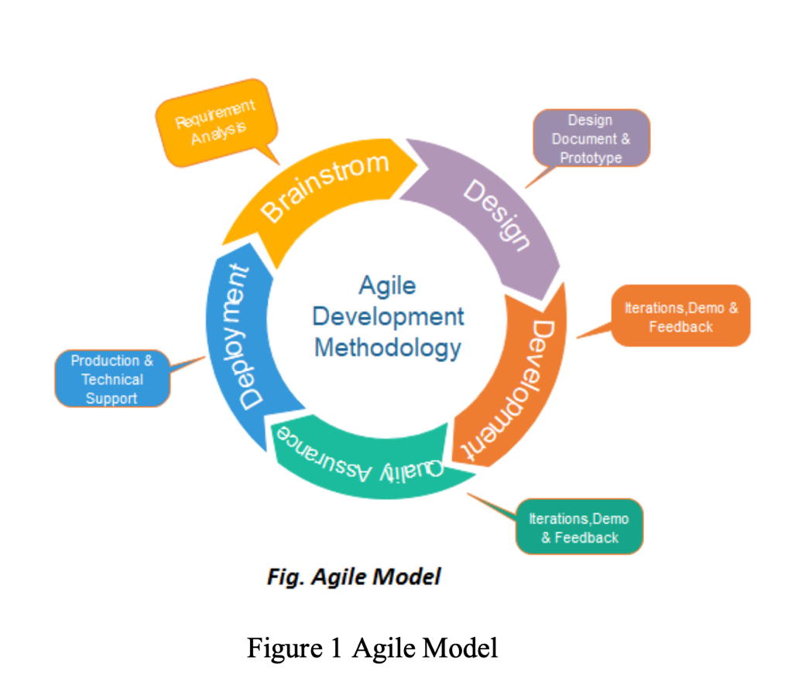Bottom of Form

Figure 1. Agile Model

In the development of the PUPQC Scheduler System, the software development team embraces the Agile Scrum methodology, fostering a responsive and collaborative approach to software development. The adoption of Agile Scrum principles ensures that the project remains adaptive, allowing for quick responses to changing requirements and efficient teamwork among developers.

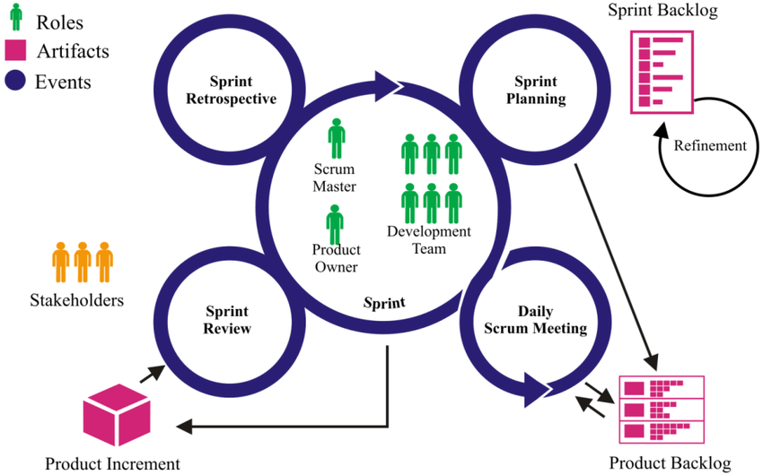

Figure 2. The basic elements of the Scrum framework.

The key components of Agile Scrum according to Obergfell (2019) implemented in the project include:

## 3.2 Roles

1. Scrum Master

The Scrum Master is critical in making it possible the Scrum methodology and ensuring that Agile principles are strictly followed. The scrum master is in charge of removing constraints to team growth and building an inclusive and productive atmosphere in which software development team can thrive.

1. Product Owner

The Product Owner acts as the project's representation to stakeholders. One of their main duties is to prioritize the product backlog based on its business importance. On top of that, the Product Owner establishes acceptance criteria for each user story, giving the development team with a clear and comprehensive vision.

1. Development Team

The Development Team is composed of cross-functional members who share the responsibility of implementing features within the project. This team collaborates closely, working together to deliver potentially shippable increments during each sprint. This collaborative approach promotes a collective ownership mindset, where the success of the project is a shared responsibility among team members.

## 3.3 Sprint Events

1. Sprint Planning

Sprint Planning is an essential procedure that occurs at the beginning of each sprint to define the scope of work for the subsequent phase. The Product Owner, Scrum Master, and Development Team participate in this collaborative session to determine priorities and create sprint objectives.

1. Daily Scrum Meeting

Daily Scrum Meetings are short, daily meetings in which the team shares progress, discusses limitations, and plans for the day ahead. These sessions encourage open communication, early identification and resolution of drawbacks, and the development of a consistent and unified collaborative environment.

1. Sprint Review

The Sprint review occurs at the end of each sprint and provides an opportunity for stakeholders to examine and demonstrate completed work. This session provides an opportunity for stakeholders to provide valuable input, ensuring alignment with changing demands and driving ongoing improvement.

1. Sprint Retrospective

The Sprint Retrospective is a post-sprint reflection session that focuses on the team's processes and identifies areas for development. It serves as a venue for team members to discuss what went well, what may be improved, and how to put those improvements into action in the next sprint.

## 3.4 Scrum Artifacts

1. Product Backlog

The Product Backlog is a prioritized list of features and user requirements which is essentially managed by the Product Owner. In the process of this capstone project, the Project Manager is assigned to prioritize the improvement of the product backlog. This essential output for the allocation of the sprint process is continuously refined and updated based on feedback, change of requirements, and project priorities, ensuring alignment with project goals alongside the SDLC.

1. Sprint Backlog

The Sprint Backlog represents a focused subset of the product backlog, outlining tasks to be completed in the current sprint timeline. This is conceptualized collaboratively by the Software Development Team during sprint planning, and ensures a shared understanding of objectives throughout the project duration and facilitates effective sprint execution. The sprint backlog is a tool used to ensure that every module of the system is divided appropriate to the target deadline.Top of Form

Bottom of Form

1. **Requirements Analysis**

Requirements analysis is a crucial phase in the development of the PUPQC Scheduler System, ensuring that the software meets the needs and expectations of its users. This section outlines the key aspects of the requirements analysis phase, including stakeholder identification, requirements gathering techniques, user stories, and use cases, as well as functional requirements for implementation and use of the Scheduling System. The requirement analysis includes fetching the necessary entities and requirements for the data input for the system. The entire project team must take all considerations that were given by the stakeholders as a premise for the assumed output for the capstone project. The team is expected to follow the requirements and conditions for rulings used in the system, such as assignments of rooms, curriculum configuration, access to view the schedule, etcetera.

## 4.0.1 System Requirements Specifications

The system requirements of the PUPQC Scheduler System include functional and non-functional requirements such as user expectations, system capabilities, and conditional limitations and constraints. The Requirements Specification serves as the primary foundation for the development team to understand what features and functionalities the scheduling system should incorporate.

|  |  |  |
| --- | --- | --- |
| System Modules | Functional Requirements | Non-functional Requirements |
| Log in | Allows the authentication of users to access the scheduler system. | Upon log-in, the user will be directed to the home page and will gain access according to user types. |
| Home page | The landing page must have an overview of all system capabilities and scheduling process data input pages linked for easier comprehension as to how the scheduling system works. | There is an available directory link to the system configuration. |
| View Schedule | Provides an overview of the schedule made on the manage schedule page. | The authorized user will be able to print the schedule based on three segments: faculty, class, and room assignments. |
| Manage Schedule | Allows the assignment of class per program to a day, time, and room for the entire semester. | The administrator is authorized to assign the programs per academic year and semester to a day, time, and room available in the university. |
| Curriculum Configurator | Adding of curriculum year that will be utilized to create the academic year. | This allows the users to add all curriculums with programs available per year directly referenced to all modules in the system in assigning the schedule per class. |
| Faculty Loading | Assignment of faculty members to classes and courses per semester. | It allows the instructors to be assigned to specific courses and classes created in the manage schedule. |
| Faculty Information | Allocation of faculty information such as name, units allowed, and their current faculty status in the university. | Filling out the faculty information inside the system that is used as references on the faculty loading process. |
| System Configurator | Access all system configurations for all modules such as the academic year, semesters, courses, year levels, sections, class, curriculum year, and room allocation. | System Configurator will be used to assign a column in the data table which should be used in adding data inputs in the scheduling process such as academic year, semesters, manage courses, year levels, sections available in the university and so on and so forth. |

Table 1. System Functional and Non-Functional Requirements.

## 4.0.2 System Design Specifications.

In developing the PUPQC Scheduler System, the capstone project utilizes a blend of development tools and standards to ensure a robust and user-friendly scheduling system. The backbone of the project is shaped by the following elements:

|  |  |
| --- | --- |
| Software Design | Description/Compliance |
| Development Tools/Standards | 1. Python 2. JavaScript [Ajax JQuery] 3. CSS 4. HTML 5. Laragon, PostgreSQL [Database Management] 6. Pycharm [Backend] 7. Visual Studio Code [Frontend] |
| System Process | The system will focus on scheduling the entire academic year per semester and will generate Class, Faculty, and Room Schedules with day, time, and room assignments. The schedules can be viewed based on room assignments, with the schedule, class schedules, and faculty schedules all containing the essential information to understand each referencing the established schedule. This benefits the university, particularly its stakeholders, because it enables for a competent scheduling procedure using software at the start of each semester. |
| System Security | 1. Authentication – The scheduler system implements differentiated user access, tailoring permissions based on user types to enhance security. 2. Authorization – Leveraging JSON Web Tokens (JWT), our system employs a secure authorization mechanism, ensuring data integrity and access control. |
| Database Design | The database design in the Scheduler System relies on PostgreSQL, which is a free, open-source relational database management system that prioritizes extensibility and SQL compliance. And Laragon or the SwaggerUI are instrumental in accessing and testing database functions on the server side, ensuring a seamless and efficient database design. |

Table 2. System Design Specifications.

## 4.1 Stakeholder Identification.

Identifying and understanding stakeholders is fundamental to defining the system requirements accurately. PUPQC Scheduler System’s primary stakeholders include the Academic Head Administrator & the university’s Branch Director. The diverse needs and perspectives of these stakeholders influence the functionality and usability of the system. It is crucial to recognize the major stakeholders of the system in preparation for the system requirements needed for the capstone project to begin the creation of the product backlogs and user stories.

|  |  |
| --- | --- |
| Project Name: | Scheduling System |
| Project Manager: | Jane Samer Pajela |

1. Stakeholder Engagement Assessment Matrix:

|  |  |  |  |  |  |
| --- | --- | --- | --- | --- | --- |
| Stakeholder | Unaware | Resistant | Neutral | Supportive | Leading |
| Monzon, Demelyn |  |  |  | **C** | **D** |
| Gutierrez, Jaime | **C** |  |  | **D** |  |
| Bataller, Ednalyn |  |  | **C** |  | **D** |
| Camania, John Kyle Bryan |  |  |  |  | **C, D** |
| Bacani, Alexa Leinor Rose |  |  |  |  | **C, D** |
| Pajela, Jane Samer |  |  |  |  | **C, D** |

|  |  |
| --- | --- |
| LEGEND | |
| C | CURRENT |
| D | DESIRED |
| C, D | CURRENT, DESIRED |

Table 3. Stakeholder Engagement Assessment Matrix

1. Stakeholder Register:

|  |  |  |  |  |  |  |  |
| --- | --- | --- | --- | --- | --- | --- | --- |
| **Name** | **Position/Title** | **Contact Information** | **Expectations** | **Influence** | **Interest** | **Communication Preferences** | **Engagement Strategy** |
| Monzon, Demelyn | Head, Office of Academic Programs  Internal | demonzon@pup.edu.ph | Easy to use system with fast scheduling management functionalities | **H** | **H** | Meetings/  Weekly, Monthly | Actively participate in requirements gathering, providing insights into the academic program needs for the scheduling system. |
| Gutierrez, Jaime | PUPQC Branch Director  Internal | **-** | **-** | **H** | **L** | **-** | **-** |
| Bataller, Ednalyn | Administrative Aide IV  Internal | **-** | Easy to use, comprehensive UI, must be a useful system than scheduling programs manually | **H** | **M** | Meetings/  Weekly/Montly | Participate in usability testing and provide insights into the user interface from an administrative perspective. |
| Bacani, Alexa Leinor Rose | Quality Assurance/ Tester/ Business Analyst  Internal | alexaleinorrosejbacani@ iskolarngbayan.pup.edu.ph | All UI elements must be working as intended, no bugs, no crash and no unresponsive UI | **L** | **H** | Email, Online meeting/ Regularly | Engage in testing phases, including functionality testing, bug identification, and ensuring UI elements work as intended. |
| Camania, John Kyle Bryan | Developer  Internal | Johnkylebryanacamania@ iskolarngbayan.pup.edu.ph | Can successfully schedule, all functions working as intended | **L** | **H** | Meetings/ Regularly | Active participation in the development and coding phases to ensure all scheduling functions work as intended. |
| Pajela, Jane Samer | Project Manager  Internal | jsbpajela@iskolarngbayan .pup.edu.ph | Success for the project’s overall functionalities, documentation, and reliability. And for an error-free deployment | **L** | **H** | Meetings/ Regularly | Actively participate in all project phases, overseeing the overall development, documentation, and reliability of the scheduling system. |

|  |  |
| --- | --- |
| LEGEND | |
| H | HIGH |
| M | MEDIUM |
| L | LOWs |

Table 4. Stakeholder Register

1. Stakeholder Engagement Plan.
2. Communication Plan:
   * Weekly/Monthly meetings with the Academic Head to provide updates on project progress.
   * Weekly/Monthly progress reports for Administrative Aide.
   * Collaboration meetings with the IT Development Team (QA & Developer)
3. Engagement Activities:
   * Involvement of Academic Head in system testing and feedback sessions.
   * Collaborative design sessions with the IT Development Team.
   * Feedback sessions during user testing with System Users.
4. Feedback Mechanisms:
   * Surveys and feedback forms for System Users during and after pilot testing.
   * Regular feedback sessions with the Academic Head during the testing phase.
   * Open channels for communication with all stakeholders for continuous feedback.
5. Training and Support:
   * Comprehensive user training sessions for System Users (Academic Head).
   * On-call support during the initial implementation phase.
   * Collaboration with the IT Support Team for ongoing technical support.
6. Risk Mitigation:
   * Identify potential risks through regular risk assessments.
   * Establish contingency plans for critical stakeholders.
   * Periodic reviews of the project timeline and adjustments as needed.

## 4.2 Requirements Gathering Techniques

The initial technique included during the requirements gathering was through conducting interviews with the primary stakeholder to gather the requirements and structure of the logical flow of the system. The team was tasked to document the meeting, noting every system requirement from the stakeholders, such as requests for the specific layout of the system, the functionalities that are expected to be visible in the system, and the logical programming of the scheduling process utilizing the software as the main programming tool to assign classes to the respective rooms for located in the campus. The main challenges fall within the development team as to how these requirements will be met according to the realistic data which is still inherited from the given curriculums provided to follow the structure in generating new academic year allocation and schedule. They are additionally, reviewing existing scheduling processes and systems, as well as analyzing relevant documents similar to the functionalities that will be used in the development process of the system. will greatly contribute to a thorough requirements-gathering process.

## 4.3 User Stories and Use Cases

User stories and use cases are powerful techniques for gathering and providing user requirements in a manner that both developers and stakeholders are able to understand. The main purpose of using user stories and use cases is to manage the depth and understanding of the system function and mechanism of the entire software according to the needs and the fulfilment of the user’s experience and expectations. The conceptualization of the user stories makes it easier to navigate through the acceptance criteria wherein the concepts of creating a module happen.

## 4.3.1 User Stories

User stories are simple narratives that outline an aspect or functionality present in the system from the perspective of the end user. User stories created from the PUPQC Scheduler System may include situations such as the academic head administrator is preparing a class schedule, monitoring resource allocations, updating the current academic year using different curriculum year, or viewing the schedules for the current semester. Throughout the development process, these user stories are improved according to the feedback that will be gathered upon presentation of the system which serves as the checkpoint for every sprint log as early as the initiation phase.

## 4.3.2 Use Cases

Use cases offer a detailed and systematic perspective of how users can interact with the system to accomplish certain goals. They describe the user-system interactions step by step, and at the same time assist in the identification of diverse circumstances and probable exceptions and conditional restrictions. The PUPQC Scheduler System's use cases may include tasks like scheduling a class, assigning an instructor to a specific course, and providing overview reports for academic administrators.

## 4.4 Functional Requirements for Integration

The outline of the functional requirements related to the integration of the PUPQC Scheduler System provides an extensive logic conceptualization to determine the applied functionalities available in the system and details how the system will be hosted, accessed, and integrated with other university databases or information systems. It includes specifics about data retrieval, access permissions, and limitations on modifying information. This document ensures a clear understanding of integration aspects during the development and implementation phases.

|  |  |
| --- | --- |
| Functional Requirements for Integration | Scheduler System Compliance |
| The system must be able to reference the outputs of schedules created to other related systems that will need it. | The system allows the integration in the backend process of fetching the schedules with the use of Ajax JQuery callback function. |
| The software system must be open for integration to collect data from the Faculty Information and use the reference Faculty Information in the System Scheduler System to use in faculty loading module. | The system will provide routes for APIs to allow the integration inside and outside the system. |
| The scheduler system must link open integration for Student Academic Support System (SASS) & Student Help Desk to provide class & faculty schedules to use in their system for student’s convenience. | The system generated schedules will be allowed to be fetched from the scheduling system’s server in other system’s client side to view schedules of both class and faculty schedules. |
| The integration during the ongoing production of the Scheduling System with Hybrid Faculty Attendance Monitoring System & Faculty Performance System will also provide link of integration to view all faculty loaded outputs with courses. | The system must have successful output during the faculty loading process which will later on be used in other systems to provide Faculty Information & schedules. |

Table 5. Functional Requirements for Integration

# Business Process Architecture

This section of the capstone documentation discusses the business process inside the scheduling system, together with the diagrams and architectures regarding the business analysis.

## 5.1 Identification of Business Processes

With the current system being developed, scheduling of class assignments and room allocation will be efficient for the academic department of the university as it allows system-generated schedule outputs available in a specific academic year per semester. The schedules can be view according to room assignments with the schedule, class schedules, and faculty schedule all consisting of the necessary information that is needed to know the schedules of each referencing from the created schedules. This benefits the university especially the stakeholders since this allows a competent scheduling process with the use of software at the beginning of every semester.

## 5.1.1 System Business Requirements

With the current system being developed, scheduling of class assignments and room allocation will be efficient for the academic department of the university as it allows system-generated schedule outputs available in a specific academic year per semester.

|  |  |
| --- | --- |
| Business Requirements | System Capabilities |
| As an administrator, I should be able to add accounts that can access the system according to user roles. | As a stand-alone system, the scheduler system provides the Superadmin to add accounts that is limited to the user roles that the administrator authorizes access to a specific account. |
| As an administrator, I should be able to add curriculum year and assign subjects for every program, semester, year level, and all courses offered. | The scheduler system allows the user to input adding a curriculum year with all the necessary fields such as program, year level, semester, etc. |
| As a an admin, I want to filter available subjects based on academic parameters to create a schedule. | All subjects/courses are available to be referenced in the manage schedule page from the curriculum page. |
| As the administrator, I want to have an output of all schedules made according to different viewing tables such as: classes, rooms, and faculty schedules. | The system should generate a table-like structure of schedules varying to the options from the administrator and must be easy to comprehend in PDF file. |
| I should be allowed to view faculty information such as faculty status, allowed units, faculty assignment subject, and class assigned and assign instructors to courses. | Faculty loading should be useful in terms of retrieving the appropriate instructors assigned to certain courses. |
| I should be able to create a schedule for the academic year and semester with courses, faculty instructor, day, time, and room available at my disposal. | Managing the schedule must be referenced from all tables such as faculty assignments, and curriculum used, together with all the entities that need to be considered in the scheduling process. |

Table 6. System Business Requirements.

The schedules can be view according to room assignments with the schedule, class schedules, and faculty schedule all consisting of the necessary information that is needed to know the schedules of each referencing from the created schedules. This benefits the university especially the stakeholders since this allows a competent scheduling process with the use of software at the beginning of every semester.

## 5.2 Business Process Diagrams

## 5.2.1 Log-in Process

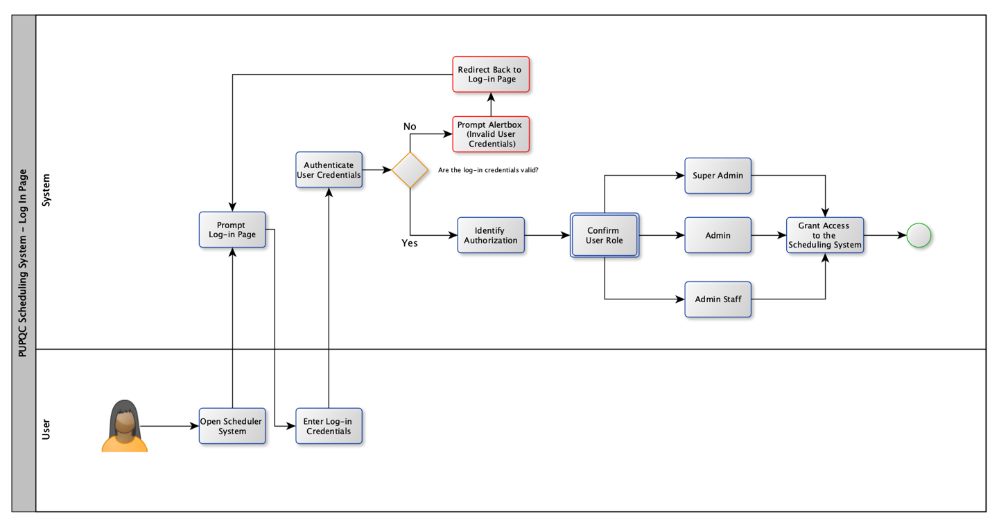

Figure 3. Business Process: Log-In

The figure above shows the log-in process implemented by the PUPQC Scheduler System wherein the user is prompted to log in using their respective credentials and is validated by the system according to their user roles.

## 5.2.2 Admin Workbench

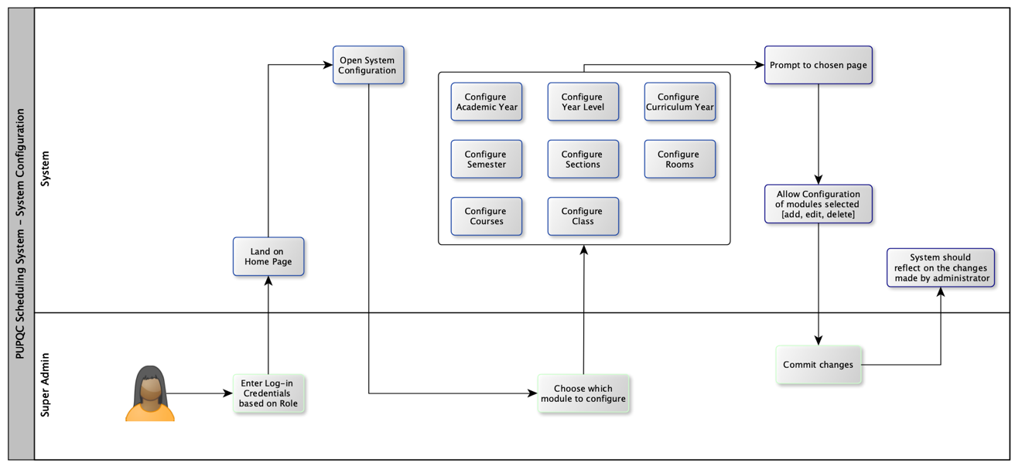

Figure 4. Business Process: System Configuration

The figure above discusses the ability of the system to configure the columns displayed as dropdowns in the system. This allows the administrator to add, edit, and delete the academic & curriculum year, semesters, courses, classes, year levels, sections in the university, and room allocations that are all used in adding curriculum and managing the schedule.

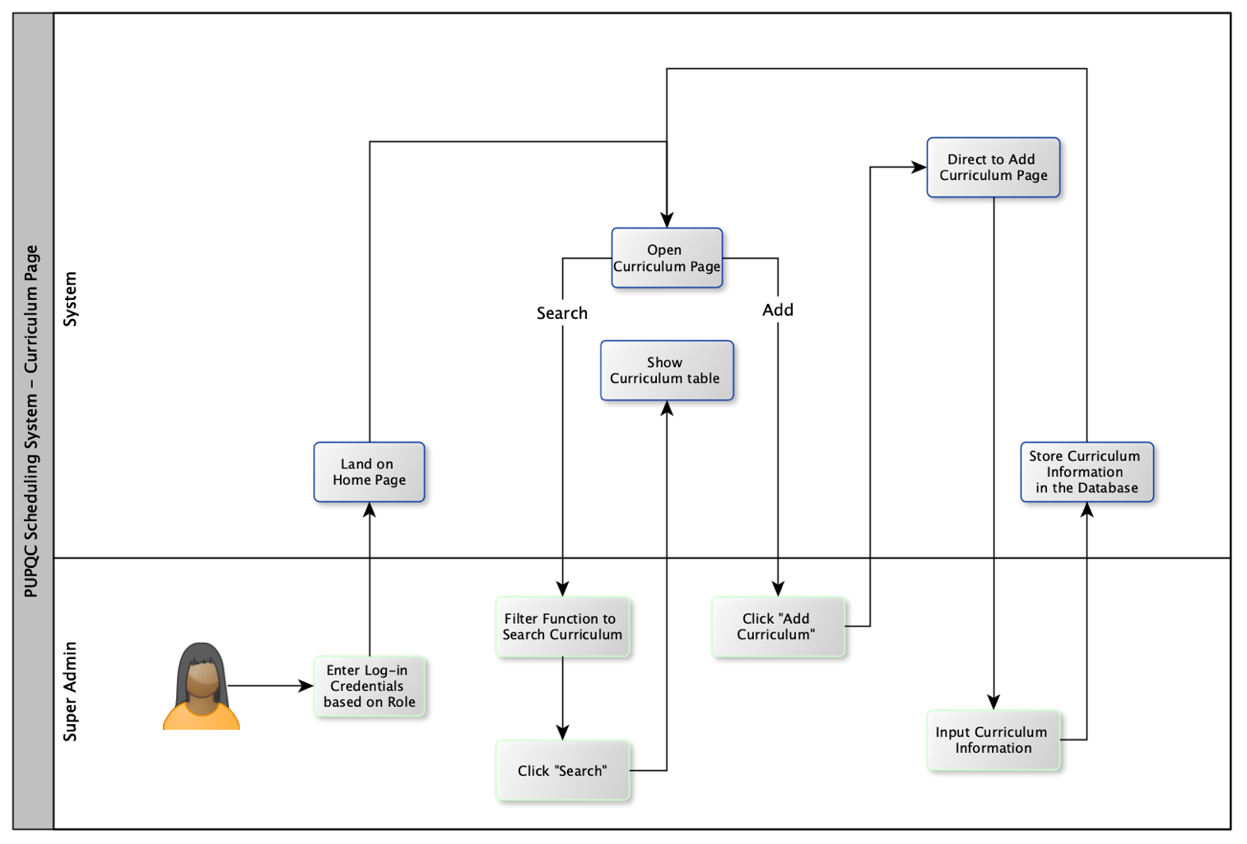

Figure 5. Business Process: Adding Curriculum

The figure provides illustration of the business process done in adding the existing/new curriculum which will then be used in the scheduling process. The process includes the input of courses with all relevant data such as course codes and their pre & co-requisites and assigning them to the existing configurated panel to assign them to specific year levels according to the respective programs.

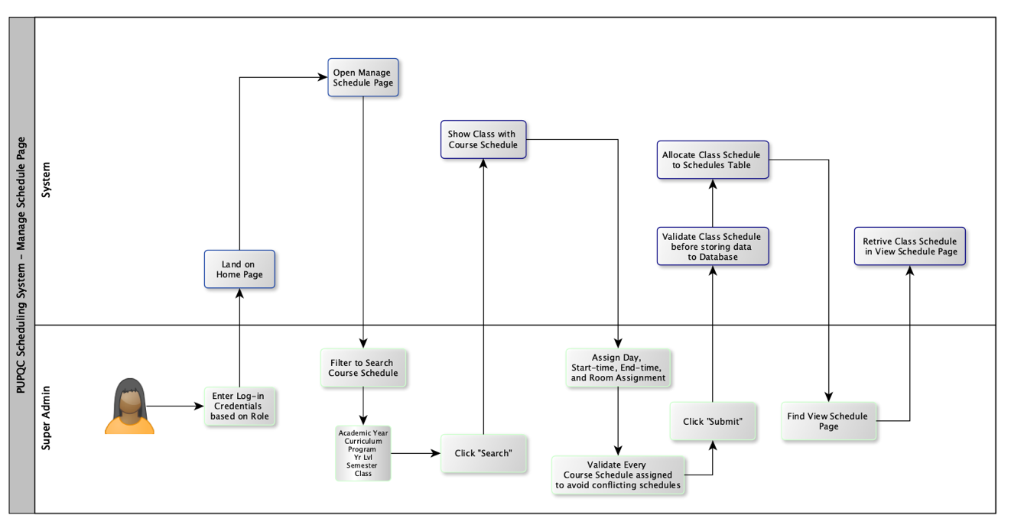

Figure 6. Business Process: Scheduling Classes with Courses

Figure 6 illustrates the process of class scheduling in the Scheduler System. It involves the retrieval of referenced curriculum to use in assigning the academic year and loading of courses including the semester, year level & class. Once the table is retrieved, the ability to validate the day of the week, start and end time of the schedule, and allocate which room or facility per course occurs. Once they are all validated without conflicting with previous schedules, the administrator can then submit the schedule for viewing on the View Schedule Page.

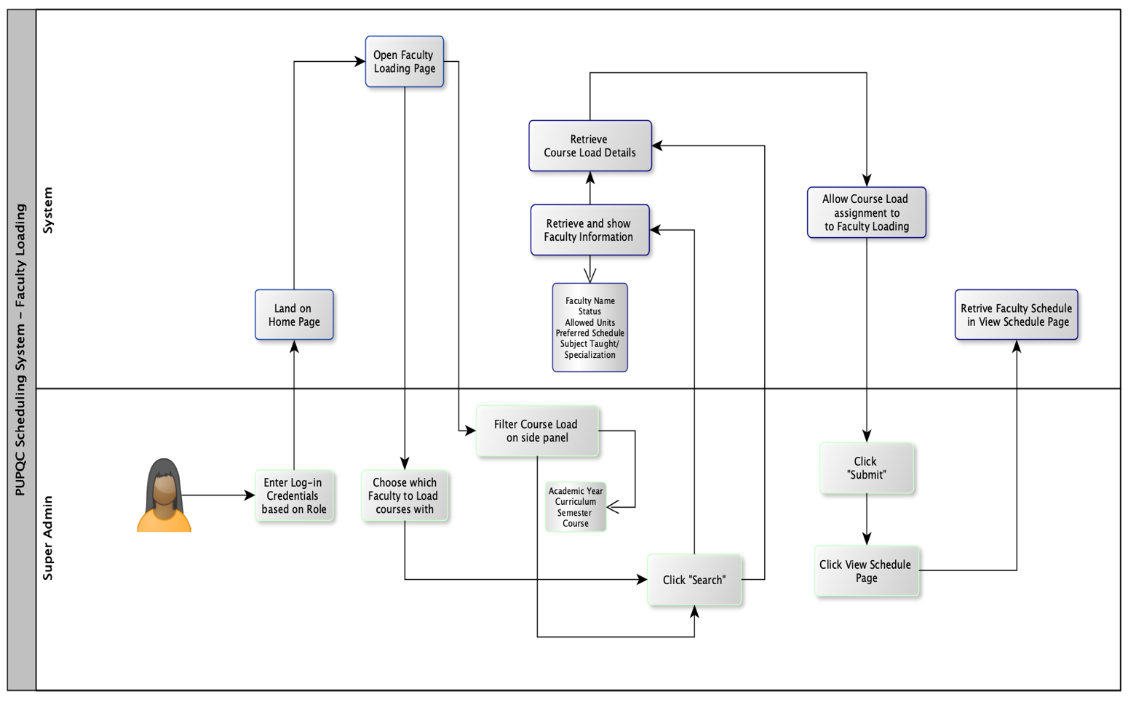

Figure 7. Business Process: Faculty Loading for Courses

The figure above shows the faculty loading process which primarily assigns the Faculty/Instructors to courses according to their preferred schedule, and courses taught to align the class schedules consisting of courses and the faculty handling the class for that course loaded to them. This allows the administrator to simply assign the courses to professors or instructors for their schedule corresponding to the semester of that academic year.

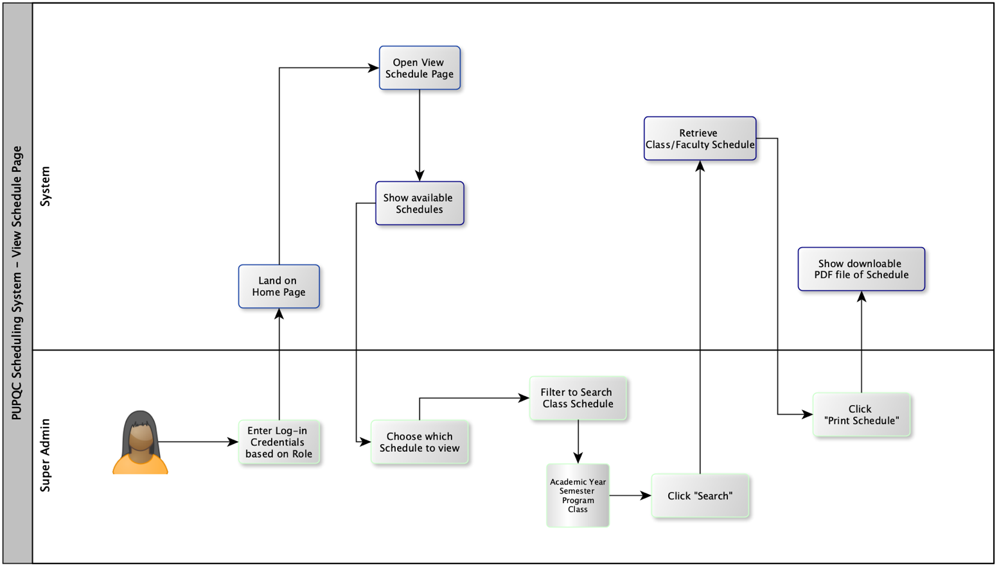

Figure 8. Business Process: View Class & Faculty Schedule

The figure provides an overview of all generated schedules made in the PUPQC Scheduling system. This starts with the process of retrieving the schedule by filtering the Academic Year, Semester, Program, and Class to display the schedule of each class. The system also allows the display of schedules in the form of a PDF file and downloads them as printable schedules to be used later on in announcing and placing them outside the facilities.

## 5.3 Alignment of Integrated System with Business Processes

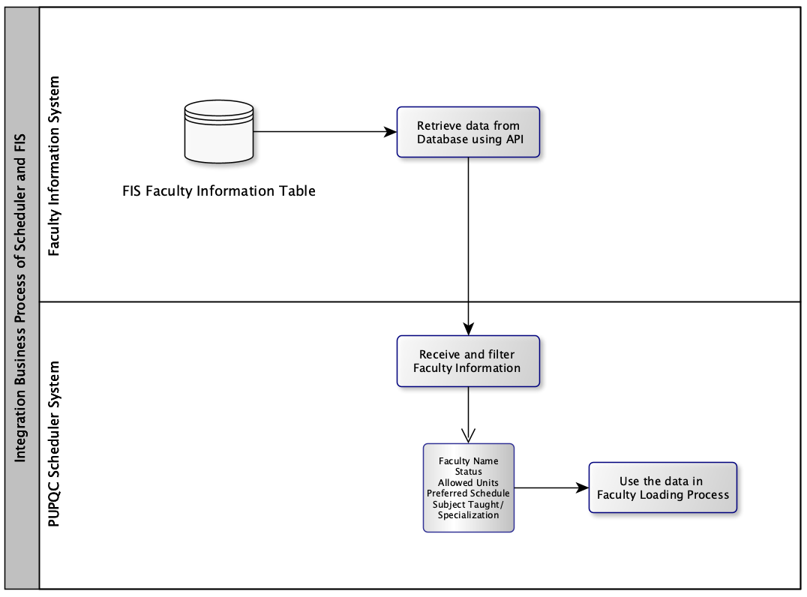

Figure 9. Integration Business Process: Faculty Information System & Scheduler

Integrating with the FIS or Faculty Information System allows the Scheduling System to retrieve Faculty Information necessary for the faculty loading process. The figure above shows the relation and retrieval process of the data from their database through API which is essential in the deployment process of the system.

# Application Architecture

## 6.1 Components of Application Architecture

The PUPQC Scheduler System's application architecture is meticulously designed to address the intricate demands of academic scheduling. The key components are strategically integrated to create a seamless and efficient scheduling environment in Polytechnic University of the Philippines, Quezon City.

## 6.1.1 Manage Schedule Module

The main idea of the system, the Manage Schedule Module, employs advanced algorithms to facilitate the automated process of classroom assignment, considering factors like timing, instructors’ preferred schedules, and classroom allocation. This component ensures optimal resource utilization and minimizes scheduling conflicts inside the university.

## 6.1.2 User Interface

The User Interface component provides a user-friendly platform for administrators to interact with the system. It encompasses login functionalities, system configuration options, and intuitive interfaces for adding curriculum, scheduling classes, and viewing generated schedules. The design prioritizes simplicity and accessibility for the administrators lowering the need for manual input of schedules and inconsistent arrangement of schedule in the system.

## 6.1.3 Database Management

A robust Database Management component stores and manages critical data related to academic years, semesters, courses, classes, faculty, and room allocations. The integration of this component with the Scheduler itself ensures data accuracy and real-time synchronization.

## 6.1.4 Integration Module

This component facilitates seamless integration with external systems, such as the Faculty Information System (FIS). Through API connections, it retrieves faculty information, supporting the faculty loading process and enhancing overall system functionality.

## 6.2 System Architecture Diagram

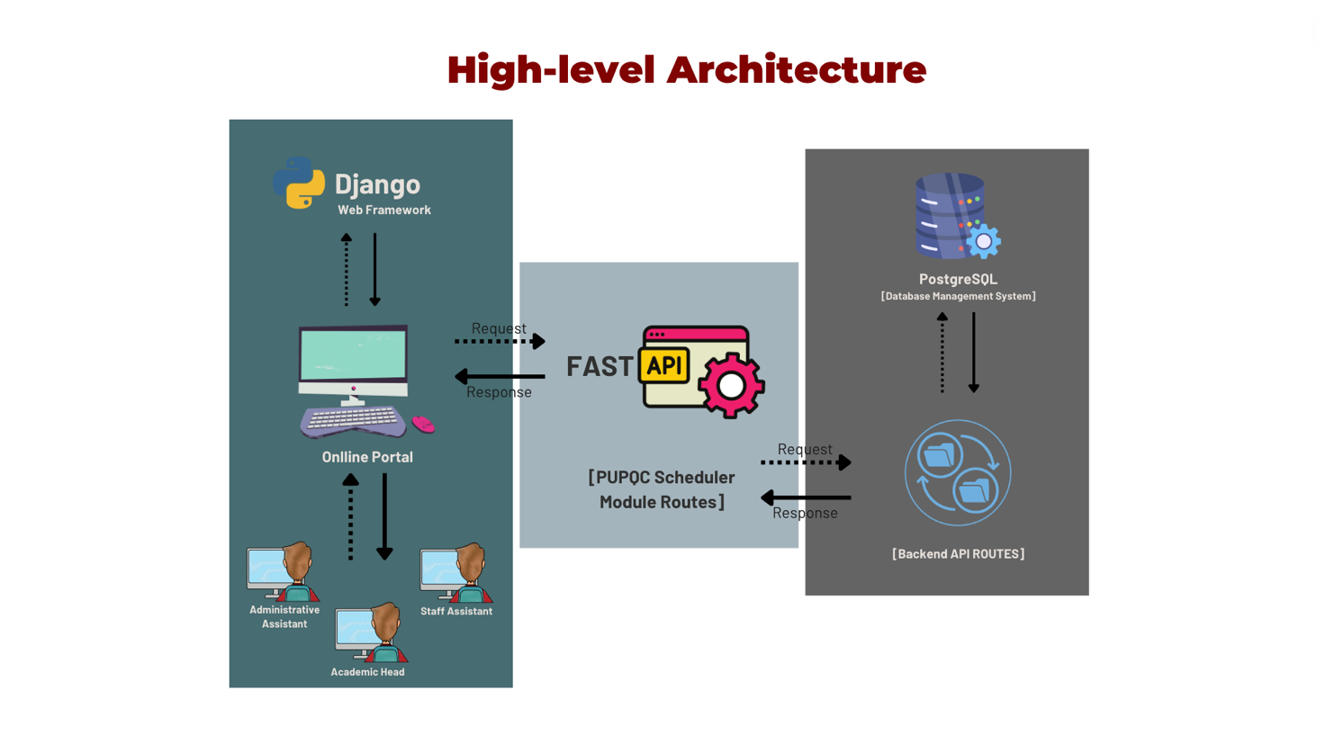

Figure 10. Top-level System Architecture

The diagram showcases the top-level architecture of the PUPQC Scheduler System, highlighting the interconnectedness of key components and their roles in the scheduling process. The user will be viewing the client side of the system, wherein the user is prompted to log in, and then will be authenticated with JWTtoken Authentication. After user authentication, will arrive at the Home Page. From there, they will have access to the system modules depending on the authorization varying from the user role. As indicated in the diagram, there are multiple pages the users can access: Log-in Services, Home Pages, View Schedule, Manage Schedules, Curriculum Configurator, Faculty Loading, Faculty Information, and System Configurator. The server is composed of API as middleware, using Python Uvicorn as the main programming language, and PostgreSQL as the database management system.

## 6.3 Faculty Information System (FIS) Integration

The system integrates with the Faculty Information System, leveraging APIs to retrieve faculty information. This integration streamlines the faculty loading process, ensuring accurate and up-to-date data. The Scheduler System is closely integrated with the FIS which provides the Scheduler with necessary faculty information used in the faculty loading process.

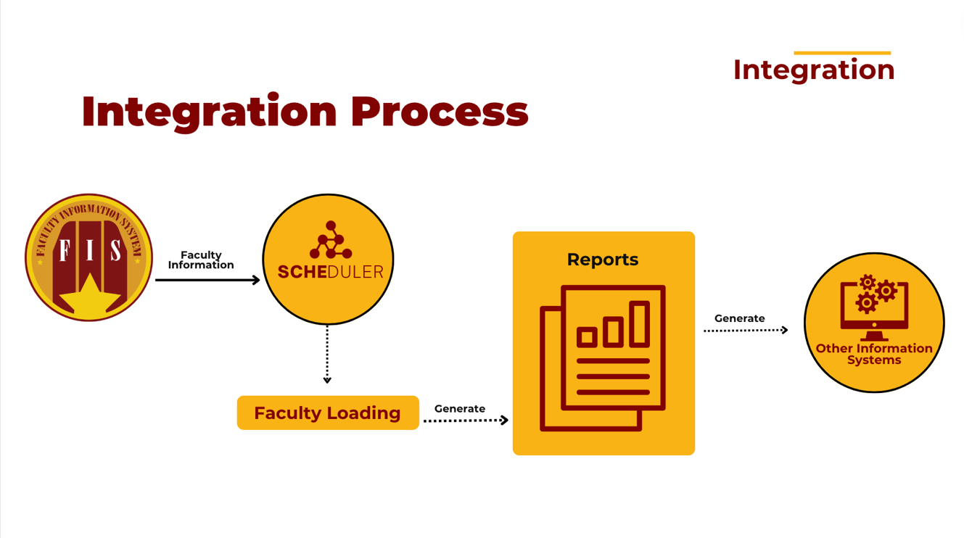

The process of integration starts with the Faculty Information System wherein we're fetching faculty information and is then reflecting real-time on the Faculty Information module found in the Scheduler system. All data fetched will be used during the faculty loading process for assigning faculty schedules and will then generate reports in the view faculty schedules.

## 6.3.1 Local Network Deployment

For immediate utilization before the second semester of S.Y 2023-2024, the system is also designed for local network deployment. This allows the scheduling process to be hosted on a local server, ensuring accessibility and responsiveness with all connected devices in the same network stationed in one office.

## 6.4 Communication and Interaction Patterns

Effective communication and interaction patterns are vital for a collaborative and responsive system. The PUPQC Scheduler System employs the following patterns:

## 6.4.1 Iterative Communication (Agile Scrum)

The Agile Scrum methodology guides the development process, emphasizing iterative communication through sprints. This approach fosters adaptability and collaboration within the development team, ensuring quick responses to evolving requirements.

## 6.4.2 API-Based Communication

The integration module utilizes API-based communication to interact with external systems. This pattern ensures a standardized and secure data exchange process, supporting the seamless retrieval of faculty information from the Faculty Information System.

# Data Architecture

The data architecture of the PUPQC Scheduler System is a foundational pillar essential for conceptualizing a seamless and efficient academic scheduling process within the Polytechnic University of the Philippines, Quezon City. Rooted in diverse data sources, this architecture integrates academic records, faculty details, room allocations, and curriculum specifics. The data sources fuel a dynamic scheduling algorithm to generate conflict-free class schedules. Employing PostgreSQL as the relational database management system, the system ensures structured storage and efficient retrieval of critical information. Data flow diagrams visually articulate the movement and transformation of information, providing insights into the intricate data handling processes within the system. Synchronization mechanisms, particularly with external systems like the Faculty Information System, underscore the commitment to real-time and accurate data exchange. Aligned with enterprise architecture principles, the data architecture not only supports the core scheduling functionalities but also contributes to the holistic optimization of academic processes, fostering adaptability, scalability, and efficient information exchange across the university's academic landscape.

## 7.1 Data Sources and Types

The data sources for the PUPQC Scheduler System are diverse and integral to the successful implementation of an efficient scheduling process. The primary data sources include academic records, faculty information, room allocations, and curriculum details. These sources provide essential information for the scheduling algorithm, allowing the system to generate conflict-free class schedules. Data types encompass academic years, semesters, courses, classes, faculty details, and room specifications. The system relies on PostgreSQL’s structured database management system to store and manage these diverse data types, ensuring data integrity and real-time accessibility.

## 7.1 Data Sources and Types

|  |  |  |
| --- | --- | --- |
| Data Sources | Data Input from User | Data Type |
| Academic Year | A.Y 2023-2024 | UUID |
| Curriculum Year | C.Y 2018-2019 | UUID |
| Semester | First Semester | UUID |
| Year Level | First Year | UUID |
| Program | Bachelor of Science in Information Technology | UUID |
| Section | First Section | UUID |
| Class | BSIT 1-1 | UUID |
| Room | A.B 101 | UUID |
| Course Code | GEED 20033 | String |
| Course Description | Computer Programming 1 | String |
| Pre-requisite | GEED 20023 | String |
| Co-requisite | - |  |
| Lecture Hours | 2 | Integer |
| Lab Hours | 3 | Integer |
| Credit Units | 3 | Integer |
| Tuition Hours | 5 | Integer |
| Faculty Name | Leandro Avena IV | String |
| Rank | Instructor I | String |
| Remarks | System Administration | String |
| Units Allowed | 12 | String |
| Preferred Schedule | Wednesday to Friday: 8:30 AM - 3:30 PM | String |
| Day | Monday | String |
| Start Time | 11:00 Am | Time |
| End Time | 01:00 PM | Time |
| Schedule | Monday: 11:00 AM - 01:00 PM | String |

Table 7. Data Sources and Types.

The data sources for the PUPQC Scheduler System are diverse and integral to the successful implementation of an efficient scheduling process. The primary data sources include academic records such as all curriculums, faculty information, room allocations, and curriculum details. These sources provide essential information for the scheduling algorithm, allowing the system to generate conflict-free class schedules. Data types encompass academic years, semesters, courses, classes, faculty details, and room specifications. The system relies on PostgreSQL’s structured database management system to store and manage these diverse data types, ensuring data integrity and real-time accessibility.

## 7.2 Data Flow and Diagrams

Data flow diagrams illustrate the movement and transformation of data within the PUPQC Scheduler System. The diagrams depict the flow of information from data sources to the scheduling algorithm and back to the user interface. The key processes involve data retrieval from academic records, faculty information systems, and system configurations, followed by the scheduling algorithm's processing. The generated schedules are then stored in the database and made accessible through the user interface for administrators. These diagrams provide a visual representation of how data moves through the system, aiding in understanding its core functionalities.

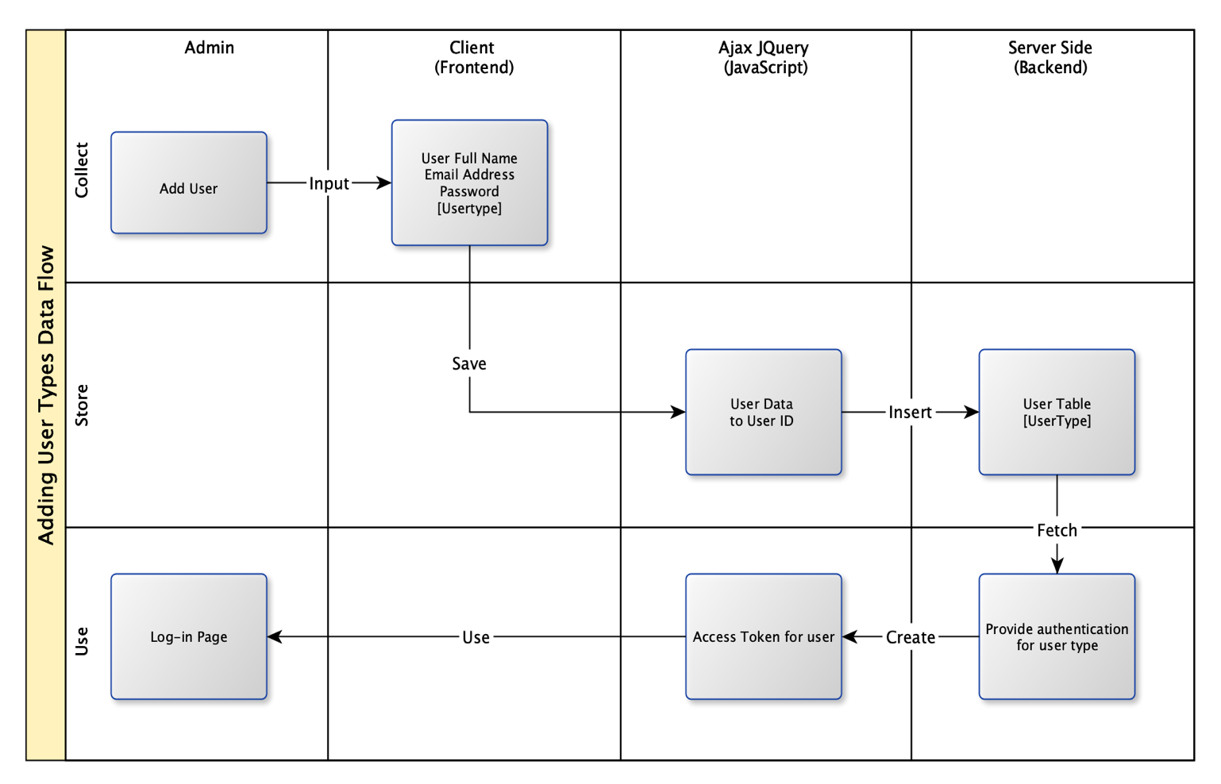

Figure 12. Add User Type Data Flow

Figure 12 discusses the data flow done in creating a user in the Scheduler System. This action is only authorized to the Super Admin who can create accounts for users and assign user roles to increase security inside the system.

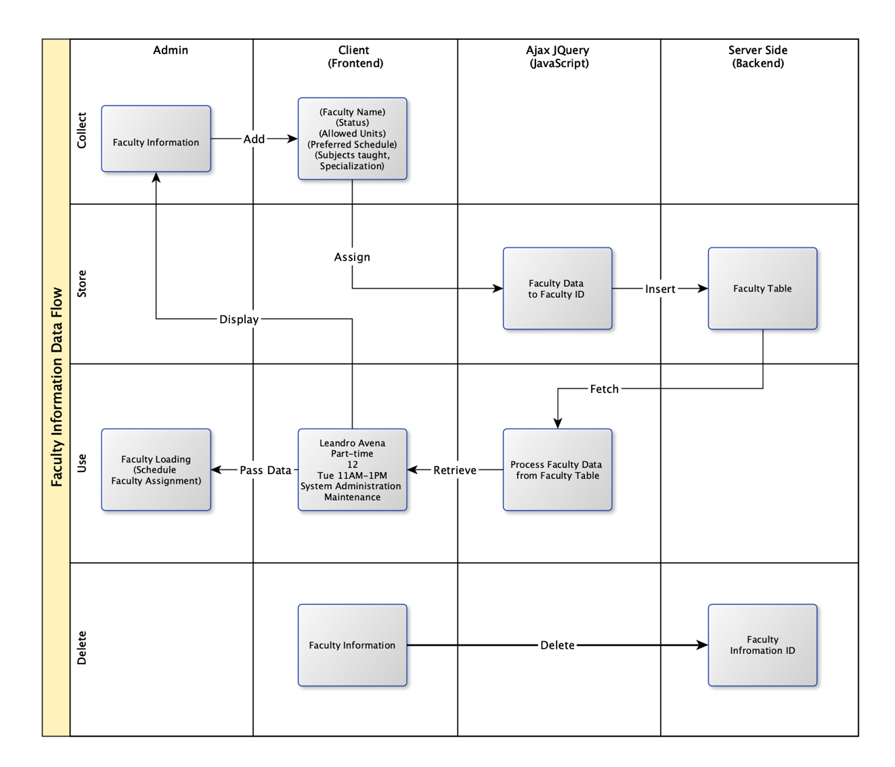

Figure 13. Faculty Information Data Flow Diagram

During the faculty loading process, faculty information is first fetched from the Faculty Information System. This diagram shows the relative passing and storing of information of the faculty members employed in the university. The faculty information includes the faculty’s status, allowed units, preferred schedule, and subjects taught which are all relevant in the faculty loading process.

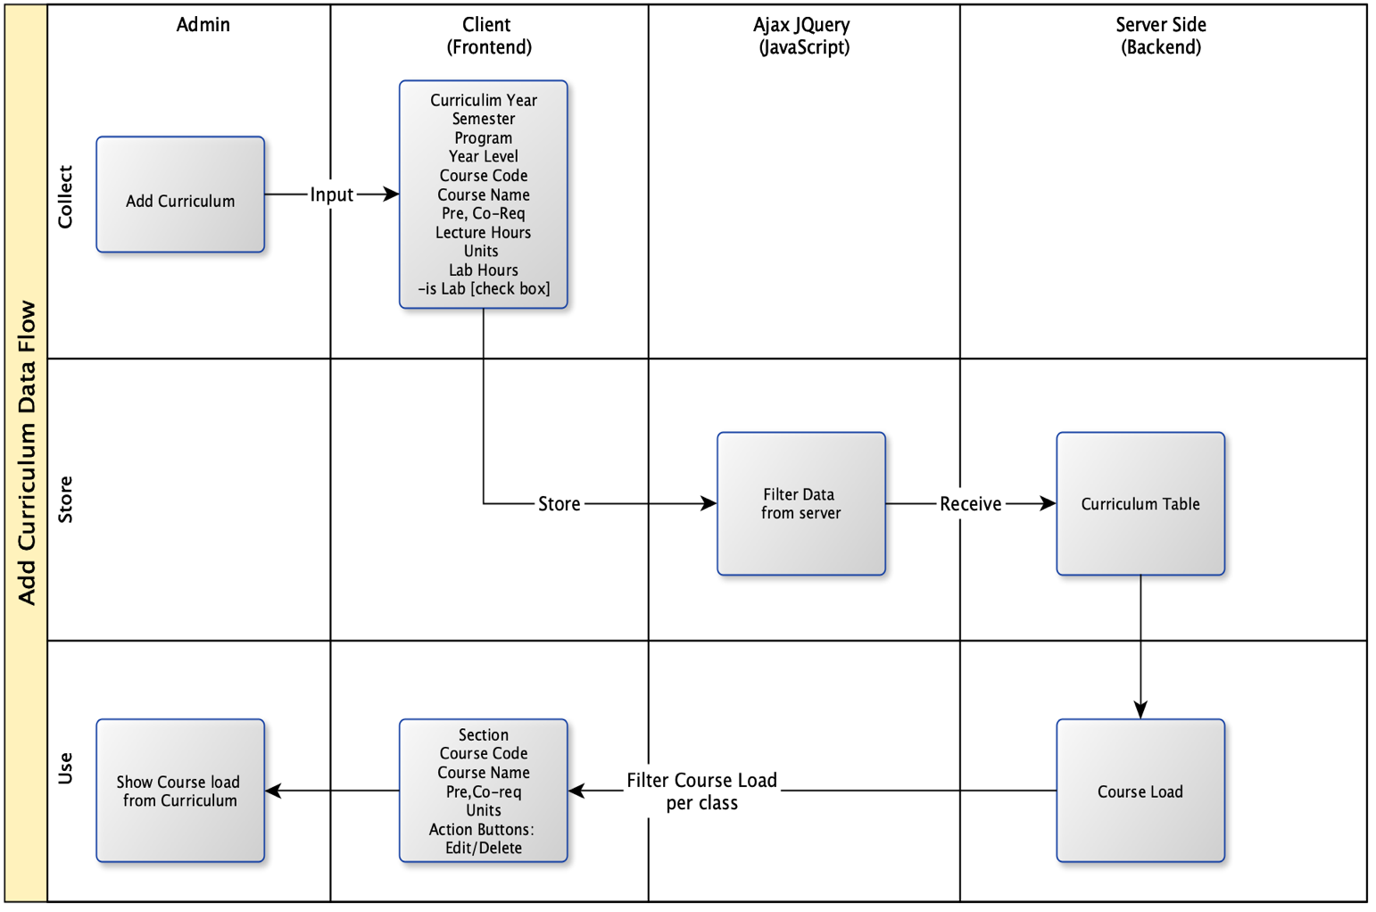

Figure 14. Add Curriculum Data Flow

All relevant course information that is entered in the Add Curriculum section of the system is necessary in the scheduling process. Course information are then stored to be retrieved per curriculum year, year level, and semester. These courses are assigned to classes and are requirements throughout the managing the schedule.

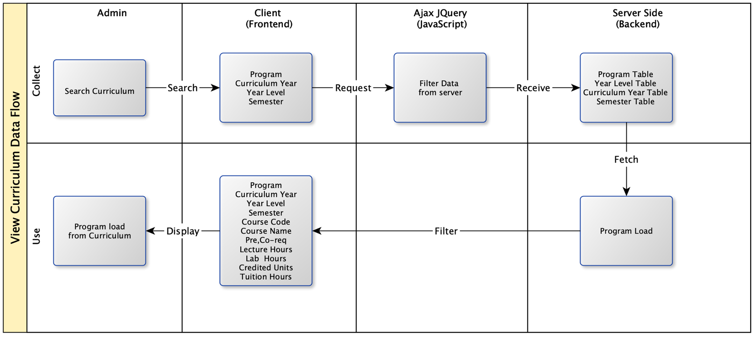

Figure 15. View Curriculum Data Flow

The figure shown above focuses on the filtering process of curriculum per year that was previously entered in the system. This primarily provides an overview of the past curriculums used and followed in creating the academic year course loads for all programs in PUPQC. The curriculums are displayed by filtering program, curriculum year, year level, and semester.

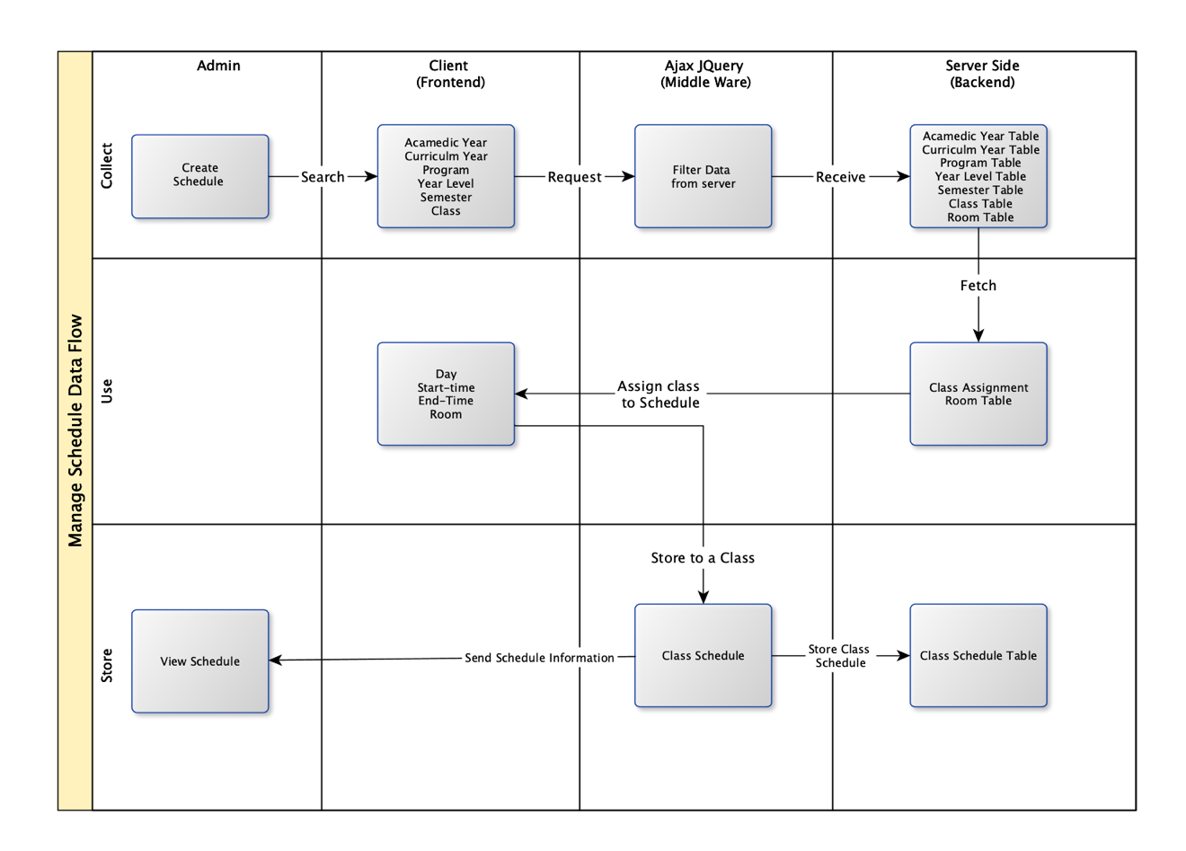

Figure 16. Manage Schedule Data Flow Diagram

As the primary module of the system, the manage schedule module comes with a rule-based algorithm for assigning course schedules per class. The diagram above shows the data flow that occurs in the scheduling process.

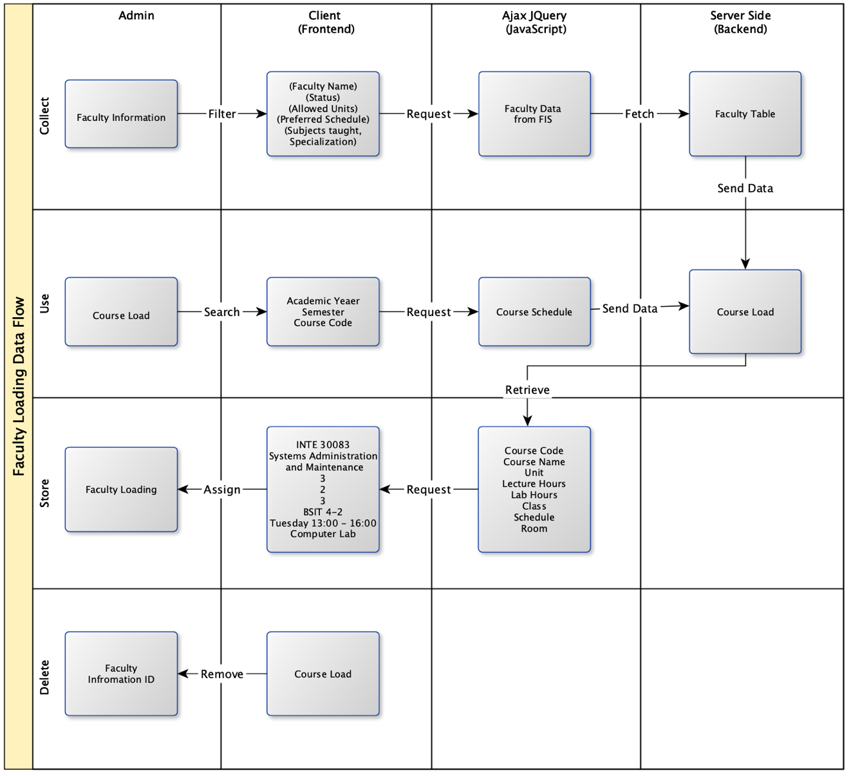

Figure 17. Faculty Loading Data Flow Diagram

Upon creating class schedules, faculty loading follows. The figure discusses the fetching of both faculty information and course loads from the creation of schedules. The data process mechanism in the faculty loading process focuses on assigning the course loads to instructors and then storing them in the database which are then fetched in viewing faculty schedules.

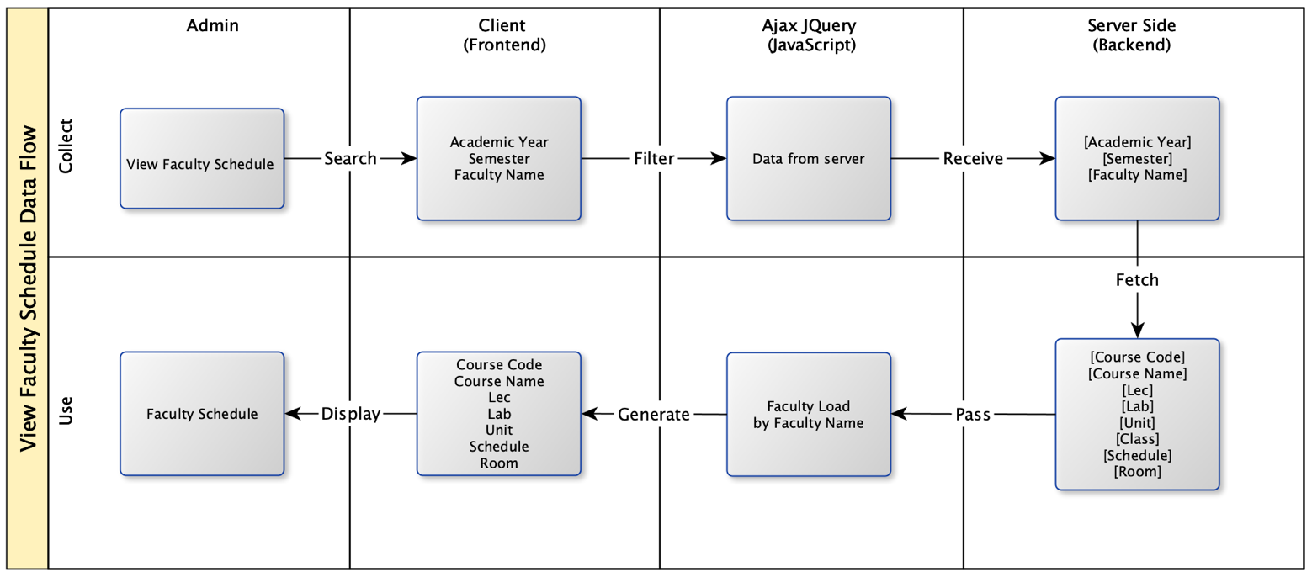

Figure 18. Faculty Schedule Data Flow Diagram.

Figure 18 discusses the filtering of data inside the system to generate the schedules made in the faculty loading process. The data is retrieved by academic year, semester, and faculty name and will generate faculty schedules containing the courses and classes they are assigned to.

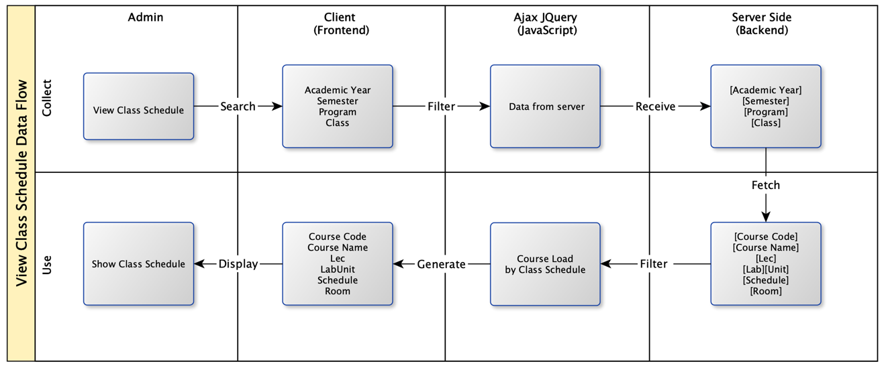

Figure 19. Class Schedule Data Flow Diagram

Figure 19 discusses the data flow in fetching the class schedules containing courses, day, time, and room assignments. This serves as a guide for students to know their schedules all throughout the semester complete schedule information all necessary for the academic year handling in the university.

## 7.3 Data Storage and Management

The core of the PUPQC Scheduler System's data architecture lies in its robust database management. PostgreSQL is employed as the relational database management system, storing critical data related to academic years, semesters, courses, classes, faculty, and room allocations. The data is organized and indexed for efficient retrieval, ensuring optimal performance during the scheduling process. Regular backups and data integrity checks are implemented to safeguard against potential data loss and inconsistencies. Additionally, the system incorporates encryption measures to secure sensitive information, aligning with best practices for data management in academic institutions.

## 7.4 Data Synchronization Across Systems

Achieving seamless data synchronization is paramount for the success of the PUPQC Scheduler System, especially in its integration with external systems like the Faculty Information System (FIS). The system retrieves faculty information from the FIS through API-based communication, ensuring that faculty loading is based on accurate and up-to-date data. This integration also aligns with enterprise architecture concepts, emphasizing interoperability and real-time data exchange. Periodic reviews and updates of the integration process are conducted to address any changes in external systems, maintaining a synchronized and reliable flow of information.

## 7.5 Alignment of Integrated System with Business Processes

Enterprise architecture principles guide the alignment of the integrated PUPQC Scheduler System with business processes. The system ensures holistic alignment by considering the entire university ecosystem, including academic processes, curriculum flows, and schedule management. Scalability and adaptability are prioritized to accommodate changing requirements, allowing the system to evolve alongside the university. Interoperability with existing university databases and information systems, such as the faculty information system, is seamlessly achieved, promoting efficient information exchange across departments. The alignment with business processes extends to optimizing classroom assignments, considering factors like teacher availability and overall classroom allocation, ultimately enhancing the efficiency of academic operations.

The data architecture of the PUPQC Scheduler System encompasses diverse data sources, efficient data flow, robust storage and management, synchronized integration with external systems, and alignment with overarching business processes. These components collectively contribute to the system's ability to automate scheduling processes, provide flexibility for stakeholders, and enhance the overall scheduling experience within the academic environment.

# 8. Technology Architecture

## 8.1 Technology Stack and Infrastructure.

The technology stack chosen for the development of the PUPQC Scheduler System encompasses a set of frameworks and tools carefully selected to ensure optimal performance, scalability, and maintainability.

|  |  |
| --- | --- |
| **Tools/ Framework** | **Description** |
| Django | Django serves as the primary web framework, providing a robust and scalable foundation for the PUPQC Scheduler System. Its adherence to the Model-View-Controller (MVC) architectural pattern facilitates modular development and efficient handling of data models, views, and controllers. |
| FastAPI | FastAPI, chosen for its speed and simplicity, complements Django by facilitating the creation of APIs with minimal code. Its asynchronous capabilities contribute to enhanced performance and responsiveness, especially in handling concurrent requests. |
| Ajax jQuery | Ajax jQuery is employed for asynchronous data exchange between the frontend and backend, enabling seamless and dynamic updates to the user interface without requiring full page reloads. This enhances the overall user experience by providing real-time feedback. |
| PostgreSQL | PostgreSQL, a powerful open-source relational database management system, is selected for its reliability and advanced features. Its support for complex queries and efficient data storage aligns with the data-intensive requirements of the PUPQC Scheduler System. |
| Tabler | A frontend framework contributes to the system's user interface design. Its responsive and customizable components facilitate the creation of a modern and intuitive user experience for both administrators and end-users. |

Table 8. Technology Stack and Infrastructure.

## 8.2 Network Topology and Configuration

The network topology and configuration of the PUPQC Scheduler System are designed to ensure accessibility, reliability, and scalability.

|  |  |
| --- | --- |
| **Section** | **Description** |
| Render | Render is utilized as a cloud platform to host the PUPQC Scheduler System, providing scalable infrastructure and secure hosting. Its simplicity in deployment and integration aligns with the project's emphasis on efficiency. |
| Heroku | Heroku serves as an additional cloud platform, offering a flexible and scalable environment for hosting and managing the application. Its seamless integration with Django and FastAPI streamlines the deployment process. |
| GitHub | GitHub, a widely adopted version control platform, is employed for collaborative development and version management. Its branching and merging capabilities facilitate efficient collaboration among development team members. |
| Software Technologies | A diverse set of software technologies is employed throughout the development and maintenance processes of the PUPQC Scheduler System. |
| Visual Studio Code | Visual Studio Code (VS Code) serves as the primary integrated development environment (IDE), providing a lightweight and extensible platform for coding, debugging, and version control. Its rich set of extensions enhances developer productivity. |
| YED | YED (Yet Another Diagram) is utilized for creating clear and comprehensive visual representations of system architecture, data flow, and other diagrams. Its intuitive interface supports effective communication of complex concepts. |
| Word | Microsoft Word is employed for the creation of project documentation, ensuring consistency and professionalism in presenting detailed information about the PUPQC Scheduler System. |
| PyCharm | PyCharm serves as an alternative IDE, offering a comprehensive set of features tailored for Python development. Its intelligent code completion and debugging tools contribute to efficient coding practices. |
| Browsers | Both Microsoft Edge and Brave browsers are used for testing and validating the system's compatibility across different web browsers, ensuring a consistent user experience for all users. |
| Python 3.10.6 | The PUPQC Scheduler System is developed using Python version 3.10.6, leveraging the latest features and enhancements available in the language for efficient and modern coding practices. |
| Navicat | Navicat is employed as a graphical database management tool for the local development environment. Its user-friendly interface facilitates database administration, schema design, and data manipulation during the development phase. |
| Laragon | Laragon is utilized as a local development environment for hosting and testing the PUPQC Scheduler System. Its simplicity in setting up a web server, database server, and development environment streamlines the local development process. |

Table 9. Network Topology and Configuration

## 8.4 Scalability and Performance Considerations.

Scalability and performance are critical considerations in the architecture of the PUPQC Scheduler System to ensure its responsiveness and efficiency, especially as user demand increases.

|  |  |
| --- | --- |
| **Section** | **Description** |
| Load Balancing | To enhance system scalability, load balancing strategies will be implemented to distribute incoming traffic evenly across multiple servers. This ensures that no single server becomes a bottleneck, optimizing the overall performance of the system. |
| Caching Mechanisms | Caching mechanisms will be employed to store frequently accessed data temporarily. This reduces the need for redundant database queries, improving response times and minimizing the load on the database server. |
| CDN | The use of a Content Delivery Network (CDN) will be considered to distribute static assets, such as images and stylesheets, across multiple servers geographically. This minimizes latency and accelerates the loading of these assets for users globally. |

Table 10. Scalability and Performance Considerations

These scalability and performance considerations aim to provide an efficient and responsive scheduling system, ensuring a positive user experience even under high demand scenario

# 9. Development Process

The development process of the PUPQC Scheduler System is structured around the principles of the Agile Scrum methodology, ensuring adaptability, collaboration, and incremental progress.

## 9.1 Agile Scrum Roles and Responsibilities

The Agile Scrum framework defines distinct roles, each with specific responsibilities, contributing to the overall success of the development process.

|  |  |  |
| --- | --- | --- |
| **Section** | **Description** | **Assigned** |
| Scrum Master | As the facilitator of the Scrum process, the Scrum Master plays a pivotal role in ensuring that Agile principles are adhered to. Responsibilities include removing impediments, fostering a collaborative team environment, and promoting adherence to Scrum practices. | Pajela, Jane Samer B. |
| Product Owner | The Product Owner represents the stakeholders and is responsible for prioritizing the product backlog. They define the features and functionalities that provide the most business value, ensuring the development team focuses on high-priority items. | Monzon, Demelyn  Gutierrez, Jaime  Bataller, Ednalyn |
| Development Team | The cross-functional Development Team is responsible for implementing features and functionalities during each sprint. Team members collaborate closely, contributing their expertise to achieve sprint goals. The team collectively owns the success of the project. | Bacani, Alexa Leinor Rose J.  Camania, John Kyle Bryan A. |

Table 11. Agile Scrum Roles and Responsibilities

## 9.2 Sprint Planning and Backlog Management

Sprint planning is a crucial aspect of the Agile Scrum methodology, involving collaborative sessions to determine the scope of work for the upcoming sprint.

## 9.2.1 Sprint Planning

During the Sprint Planning sessions, the collaborative efforts of the Product Owner, Scrum Master, and Development Team led to the following key accomplishments:

|  |  |
| --- | --- |
| **Activity** | **Description** |
| Definition of Sprint Objectives | The team worked together to clearly define the objectives for each sprint. These objectives were closely aligned with the broader project goals, ensuring a focused and strategic approach to development. |
| Prioritization of Product Backlog | Active participation from team members resulted in the prioritization of items within the product backlog. This collaborative effort allowed the team to strategically select features and functionalities to be included in each sprint based on their business value. |
| Creation of Sprint Backlog | A detailed sprint backlog was meticulously crafted, outlining specific tasks, user stories, and features to be addressed during the sprint. This comprehensive document served as a guide for the Development Team throughout the sprint duration, fostering a shared understanding of the tasks to be completed. |

Table 12. Sprint Planning

These actions collectively ensured that the Sprint Planning sessions were productive, fostering a shared understanding among team members and a clear direction for the upcoming development cycle.

## 9.2.2 Backlog Management

The management of the product backlog has been an ongoing and iterative process, marked by the following tangible achievements.

|  |  |
| --- | --- |
| **Activity** | **Description** |
| Continuous Refinement | The product backlog underwent continuous refinement, with regular reviews and updates based on feedback from stakeholders, changing project requirements, and shifting priorities. This iterative process ensured that the backlog remained relevant and aligned with project objectives. |
| Dynamic Prioritization | The Product Owner actively engaged in dynamic prioritization, reassessing the importance of backlog items based on evolving business needs. This flexibility allowed the team to respond promptly to changing circumstances and maximize the delivery of business value. |
| Feedback Integration | Feedback from sprint reviews and stakeholder interactions was systematically integrated into the product backlog management process. This adaptive approach facilitated the incorporation of valuable insights and lessons learned from each development cycle. |

Table 13. Backlog Management

The proactive involvement of the Product Owner in prioritizing backlog items ensured that the team consistently focused on delivering features with the highest impact on the project's success. This dynamic approach to backlog management contributed to the agility and responsiveness of the development process.

## 9.3 Sprint Execution and Deliverables

Sprint execution involves the implementation of features and functionalities defined in the sprint backlog, resulting in tangible deliverables.

|  |  |
| --- | --- |
| **Activity** | **Description** |
| Daily Scrum Meeting | Daily Scrum meetings are short, daily sessions where the Development Team shares progress, discusses challenges, and plans for the day ahead. These meetings foster open communication, early issue identification, and a collaborative team environment. |
| Sprint Review | At the end of each sprint, a sprint review is conducted to showcase completed work to stakeholders. This session provides an opportunity for feedback, ensuring alignment with changing demands and driving ongoing improvement. |
| Sprint Retrospective | The sprint retrospective occurs post-sprint, focusing on the team's processes and identifying areas for improvement. It serves as a platform for team members to discuss successes, challenges, and strategies for enhancing efficiency in the next sprint. |

Table 14. Sprint Execution and Deliverables

## 9.4 Challenges Faced in the Development Process

While implementing the Agile Scrum methodology, the development team encountered several challenges inherent in the dynamic nature of software development.

|  |  |
| --- | --- |
| **Challenge** | **Description** |
| Requirement Changes | Frequent changes in requirements, although aligned with Agile principles, posed challenges in maintaining a stable development environment. The team adapted by emphasizing clear communication and implementing effective change management processes. |
| Time Constraints | The project faced time constraints, requiring the team to prioritize features and functionalities based on business value. Agile principles allowed for flexible adjustments to sprint plans, enabling the team to meet critical deadlines. |
| Communication | Maintaining effective communication among team members, especially during remote work scenarios, proved challenging. The team addressed this by leveraging collaboration tools and scheduling regular virtual meetings to enhance communication and coordination. |
| Technical Complexities | Technical complexities arose during the implementation of certain features, requiring additional research and problem-solving efforts. The team embraced a collaborative approach, sharing knowledge and expertise to overcome technical challenges. |

Table 15. Challenges Faced in the Development Process

These challenges, although inherent in the development process, were effectively managed through the iterative and adaptive nature of the Agile Scrum methodology, ensuring the successful progression of the PUPQC Scheduler System development.

# 10. Implementation

## 10.1 Technical Implementation Details

In delving into the technical implementation of our project, a meticulous approach was taken to ensure a cohesive and efficient system. The high-level architecture, visualized through detailed diagrams, provided a comprehensive understanding of how individual components interacted. PostgreSQL was a deliberate choice for our database, offering reliability and scalability. Best practices, such as data normalization and strategic indexing, were implemented to optimize query performance and enhance overall database efficiency.

## 10.2 Tools and Technologies Used

Our project's success hinged on strategic selections in tools and technologies. GitHub served as the cornerstone for version control, fostering collaboration and streamlined code review processes. Integrated development environments (IDEs) like Visual Studio and PyCharm were chosen for their robust features and dedicated support for Python development. Build tools, including Poetry or Pipenv, facilitated efficient dependency management, particularly in the Python and FastAPI environment. Deployment processes were streamlined through Render for the frontend and Heroku for the backend, both chosen for their simplicity and scalability.

## 10.3 Code Integration and Interoperability

Seamless code integration and interoperability were achieved through integration with the Faculty Information API. This integration facilitated the smooth retrieval of essential data for the faculty loading module. Challenges encountered during integration delays, stemming from data creation on the external end, were met with proactive solutions. Fallback mechanisms and improved communication channels were implemented to enhance overall interoperability.

## 10.4 Integration Testing and Debugging

A robust testing strategy, encompassing unit tests, integration tests, and end-to-end tests, ensured the smooth interaction of diverse components within the system. Continuous integration, facilitated by GitHub Actions or Travis CI, automated build and testing processes, fostering a reliable and error-free codebase. Debugging practices, employing logging and tools such as the PyCharm Debugger, were integral for effective error tracking and resolution. These measures collectively contributed to the project's stability and reliability throughout the integration and debugging processes, ensuring a resilient and well-functioning system.

# 11. Testing and Quality Assurance

Testing and Quality Assurance form the groundwork of the software development lifecycle, ensuring that the delivered software meets the highest standards of functionality, reliability, and user satisfaction. In the context of the PUPQC Scheduler System, testing plays a pivotal role in validating the system's capabilities and identifying any potential issues or discrepancies. Quality Assurance, on the other hand, involves a comprehensive set of practices aimed at maintaining and improving the overall quality of the software throughout its development. Testing encompasses various strategies and methodologies, from unit testing to acceptance testing, each serving a distinct purpose in the verification and validation process. It involves systematically executing predefined test cases, assessing the system's performance, and meticulously documenting test results and bug reports. Quality Assurance, as a broader discipline, extends beyond testing and involves proactive measures to prevent defects and enhance the development process. Adherence to coding standards, regular code reviews, and the establishment of robust development and deployment pipelines contribute to a culture of continuous improvement. In the subsequent sections, we delve into the specific testing strategies, methodologies, test cases, and quality assurance measures employed in the development of the PUPQC Scheduler System. These practices collectively aim to deliver a reliable, error-free, and user-friendly scheduling solution that aligns seamlessly with the academic requirements of Polytechnic University of the Philippines, Quezon City.

## 11.1 Testing Strategies and Methodologies

The testing phase of the PUPQC Scheduler System is crucial to ensure the reliability and functionality of the software. Employing an Agile Scrum methodology in our software development process dictates an iterative approach, making testing an ongoing and integral part of each sprint. The testing strategies include unit testing, integration testing, system testing, and acceptance testing.

Unit testing focuses on validating individual components or functions of the system to ensure they work as intended. Integration testing assesses the interaction between these components, verifying that they collaborate seamlessly. System testing involves evaluating the entire system's functionality, while acceptance testing ensures that the software meets the specified requirements and gains approval from stakeholders.

## 11.2 Test Cases, Test Data, And Test Results

To conduct thorough testing, a comprehensive set of test cases has been developed, covering various scenarios and functionalities. For instance, test cases will include scenarios related to creating class schedules, updating academic years, assigning faculty, and managing room allocations. Test data will consist of sample academic records, faculty information, room allocations, and curriculum details to simulate real-world scenarios.

Each test case will have predefined expected outcomes, allowing for systematic validation of the software's performance. These test cases will be continually updated and expanded throughout the development process to adapt to evolving functionalities. During testing, detailed records of test results and bug reports will be maintained. If any discrepancies or issues arise, they will be documented, including information about the specific scenario, steps to reproduce the problem, and the expected versus actual outcomes. This documentation will facilitate effective communication between the development and testing teams and aid in resolving issues promptly. Regular test result reviews and bug triage sessions will be conducted, prioritizing critical issues and addressing them in subsequent sprints. Continuous improvement in the testing process is essential to ensure the reliability and stability of the PUPQC Scheduler System.

## 11.2.1 Test Cases, Test Data, And Test Results Tables

|  |  |
| --- | --- |
| Test Case ID | CASE001 |
| Description | Verify the creation of every Curriculum year in the System. |
| Preconditions | The user must be authenticated and logged in as an Academic Head Administrator. The system is in a stable state. |
| Steps | 1. Navigate to the "Curriculum" module. 2. Click the “Add Curriculum” button. 3. Input the Curriculum details such as *Curriculum Year, Program, Year Level, Semester, Course Code, Course Description, pre & co-req, lecture hours, credited units, and tuition hours.* 4. Click on the “Submit” button. |
| Expected Result | A screenshot of a computer  Description automatically generatedThe system should create the curriculum load successfully without errors. |
| Postconditions | The curriculum should be available to view by filtering in the Curriculum Module. |

Table 16. Test Case for Add Curriculum Module

|  |  |
| --- | --- |
| Test Case ID | CASE002 |
| Description | Verify the viewing of created curriculum inputs per semester. |
| Preconditions | The user must be authenticated and logged in as an Academic Head Administrator. The system is in a stable state. |
| Steps | 1. Navigate to the "Curriculum" module. 2. Filter Curriculum with *Program, Curriculum Year, Year Level, Semester.* 3. Click on the “Search” button. |
| Expected Result | A screenshot of a computer  Description automatically generatedThe system should generate the curriculum load successfully without errors. |
| Postconditions | The curriculum should be available to be filtered in the Manage Schedule Module in creating class schedules. |

Table 17. Test Case for View Curriculum Module

|  |  |
| --- | --- |
| Test Case ID | CASE003 |
| Description | Verify the ability to create a new class schedule in the system. |
| Preconditions | The user is logged in as an Academic Head Administrator. The system is in a stable state. |
| Steps | 1. Navigate to the "Manage Schedules" module. 2. Filter on class schedules with *Academic Year, Curriculum Year, Program, Year Level, Semester, and Class Name*. 3. Click on the “Filter” button. 4. Fill in the required details such as Day, Start Time, End Time, and Room Assignment. 5. Validate each course loading before submitting it to confirm schedule conflicts. 6. Use the side panel as a guide to confirm conflicting schedules being made. 7. Click “Submit”. |
| Expected Result | A screen shot of a computer  Description automatically generatedThe system should create a new class schedule successfully without errors. |
| Postconditions | The new class schedule should be visible in the View Schedules module -- > View Class Schedules to view the Class Load. |

Table 18. Test Case for Creation of Class Schedule Module

|  |  |
| --- | --- |
| Test Case ID | CASE004 |
| Description | Test the ability to load faculty schedules by course load. |
| Preconditions | The user must be authenticated and logged in as an Academic Head Administrator. The system is in a stable state. |
| Steps | 1. Navigate to the "Faculty Loading" module. 2. Search Faculty Member by Faculty Name. 3. Click on the “Search” button. 4. Search Course Load by Curriculum Year, Semester, and Subject Code. 5. Click on the “Search” button. 6. Find courses to assign to Faculty. 7. Click the “Assign” button |
| Expected Result | A screenshot of a computer  Description automatically generatedThe system should submit the faculty load successfully without errors. |
| Postconditions | The faculty load should generate each faculty schedule in the View Faculty Schedule module. |

Table 19. Test Case for Faculty Loading Module

|  |  |
| --- | --- |
| Test Case ID | CASE005 |
| Description | Verify the viewing of created class schedule inputs per class. |
| Preconditions | The user must be authenticated and logged in as an Academic Head Administrator. The system is in a stable state. |
| Steps | 1. Navigate to the "View Schedule" module. 2. Click on the "View Class Schedule". 3. Select Class Schedule with *Curriculum Year, Semester. Program, and Class.* 4. Click on the “Search” button. |
| Expected Result | A white sheet with black text  Description automatically generatedThe system should generate the class schedule successfully without errors. |
| Postconditions | The class schedule should be available to be downloaded as a PDF. |

Table 20. Test Case for View Class Schedule Module

|  |  |
| --- | --- |
| Test Case ID | CASE005 |
| Description | Verify the viewing of created class schedule inputs per class. |
| Preconditions | The user must be authenticated and logged in as an Academic Head Administrator. The system is in a stable state. |
| Steps | 1. Navigate to the "View Schedule" module. 2. Click on the "View Faculty Schedule". 3. Select Faculty Schedule with *Academic Year, Semester, and Faculty Name.* 4. Click on the “Search” button. |
| Expected Result | A screenshot of a computer  Description automatically generatedThe system should generate the instructor’s schedule successfully without errors. |
| Postconditions | The faculty’s schedule should be available to be downloaded as a PDF. |

Table 21. Test Case for View Faculty Schedule Module

## 11.3 Quality Assurance Measures

Quality assurance measures are implemented to guarantee the overall quality of the PUPQC Scheduler System. This involves adherence to coding standards, regular code reviews, and the use of automated testing tools. Code reviews will be conducted by experienced team members to identify potential issues, enhance code readability, and ensure compliance with established guidelines.

Additionally, continuous integration and deployment (CI/CD) pipelines will be established to automate the testing and deployment processes. This reduces the risk of introducing errors during software updates and accelerates the development cycle.

User acceptance testing (UAT) will be performed to gather feedback from stakeholders and ensure the system aligns with their expectations. Feedback from UAT will be used to make necessary adjustments and improvements before the final deployment. By implementing these testing and quality assurance measures, the PUPQC Scheduler System aims to deliver a robust, error-free, and user-friendly solution that addresses the scheduling challenges faced by the university, ultimately enhancing the academic experience for students and faculty members.

# 12. Results and Evaluation

## 12.1 Project Outcomes and Deliverables

The development of the PUPQC Scheduler System has yielded significant outcomes and deliverables aligned with the project's overarching objectives. The system successfully automates the complex process of class scheduling, addressing the challenges posed by manual methods.

## 12.1.1 Key deliverables

1. Automated Scheduling Processes

The system employs advanced algorithms within the Manage Schedule Module to automate classroom assignments, considering various constraints such as timing, instructor preferences, and room allocations.

1. User-Friendly Interface

The User Interface component provides administrators with a seamless platform for interacting with the system. It ensures simplicity and accessibility, reducing the need for manual input and enhancing overall user experience.

1. Database Management

The robust Database Management component stores and manages critical data related to academic years, semesters, courses, classes, faculty, and room allocations. This integration ensures data accuracy and real-time synchronization.

1. Integration with External Systems

The system successfully integrates with the Faculty Information System (FIS) through API connections, streamlining the faculty loading process and enhancing overall functionality.

1. Efficient Communication Patterns

The integration of communication patterns, such as Agile Scrum methodology and API-based communication, ensures effective collaboration and standardized data exchange.

## 12.2 Alignment with Project Objectives

The outcomes and deliverables of the PUPQC Scheduler System align seamlessly with the initial project objectives. The system effectively addresses the challenges posed by manual scheduling processes, providing a streamlined, conflict-free, and user-friendly scheduling environment.

## 12.2.1 Key Objectives Achieved

1. Automation of Scheduling Processes

The system successfully automates the scheduling process, reducing the time and effort required for manual assignments.

1. Flexibility for Stakeholders

Stakeholders, including the Academic Head Administrator and the university's Branch Director, have gained flexibility in adjusting class schedules as needed.

1. Seamless Integration with Class Schedules

The system integrates seamlessly with the synchronizing class schedules per semester, ensuring efficient coordination across academic programs.

## 12.3 Stakeholder and User Feedback

Throughout the development and testing phases, stakeholders and users actively engaged in providing feedback, resulting in iterative improvements. The feedback mechanisms, including surveys, feedback forms, and regular sessions, facilitated continuous refinement of the system.

1. Positive User Experience

Users, including the Academic Head, reported a positive experience during testing sessions, highlighting the system's intuitive interface and functionality.

1. Effective Collaboration

Stakeholders appreciated the collaborative design sessions and involvement in user testing, fostering a sense of ownership and understanding of the system's capabilities.

1. Timely Communication

The communication plan, including regular meetings and progress reports, contributed to a transparent and timely flow of information between the development team and stakeholders.

## 12.4 Lessons Learned

The development journey of the PUPQC Scheduler System imparted valuable lessons that stand as guiding principles for future project undertakings. The application of the Agile Scrum methodology demonstrated its effectiveness in adapting to frequent requirement changes, highlighting the pivotal role of clear communication and robust change management processes in ensuring project success. In the face of time constraints, the necessity of prioritizing features based on business value became apparent, with Agile principles providing the flexibility needed to make adjustments and meet critical deadlines. The challenges encountered in maintaining effective communication during remote work scenarios emphasized the significance of leveraging collaboration tools and scheduling regular virtual meetings to foster enhanced communication within the project team. These lessons learned serve as a foundation for continuous improvement and knowledge integration into future endeavors.

# 13. Conclusion

## 13.1 Key Takeaways and Summary

The culmination of the PUPQC Scheduler System development marks a significant stride towards enhancing efficiency and user experience within academic scheduling. The following key takeaways encapsulate the essence of the project: The introduction of automation has greatly diminished manual efforts, addressing inefficiencies and conflicts in class and faculty schedules. The system's user-centric design, characterized by a friendly interface and continuous feedback loops, ensures a positive experience that aligns seamlessly with the diverse needs of stakeholders and end-users. Moreover, the emphasis on effective integration, demonstrated through seamless connections with external systems and adherence to communication patterns, has fortified the overall functionality and reliability of the system.

## 13.2 Project Achievements and Contributions

The PUPQC Scheduler System stands as a testament to substantial accomplishments and contributions within the academic scheduling domain. The notable achievements and contributions encompass the successful streamlining and automation of scheduling processes, effectively overcoming challenges inherent in manual methods. Enhanced collaboration, facilitated through robust engagement with stakeholders and users, has fostered effective communication, resulting in a system finely attuned to the university's diverse needs. The integration with external systems, notably the Faculty Information System, ensures real-time and accurate data exchange, reinforcing the system's reliability and utility.

## 13.3 Future Work and Enhancements

While the PUPQC Scheduler System has met its primary objectives, avenues for future work and enhancements present themselves. Future iterations could encompass the expansion of features, incorporating elements such as predictive scheduling, resource optimization, and deeper integration with university systems. Scalability considerations, imperative as the user base grows, warrant continuous evaluation and optimization of load balancing and caching mechanisms. Establishing mechanisms for continuous feedback integration is paramount, as it promises to further enhance the system's adaptability to evolving user needs and preferences.

## 13.4 Closing Remarks

The collaborative endeavor that underpins the development of the PUPQC Scheduler System has yielded a valuable tool for academic scheduling. As this capstone project concludes, anticipation surrounds the positive impact it is poised to have on the daily operations of Polytechnic University of the Philippines, Quezon City. Beyond immediate applications, this project emphasizes the pivotal role of technology in optimizing educational processes and lays the groundwork for future advancements in the dynamic realm of academic scheduling.

# 14. References

Al-Negheimish , S., Alnuhait , F., Albrahim, H., Al-Mogherah , S., Alrajhi, M., Hosny, M. (2018). an Intelligent Bio-Inspired Algorithm for the Faculty Scheduling Problem. International Journal of Advanced Computer Science and Applications, Vol. 9, No. 5, 2018.

Al-Saqqa, S., Sawalha, S., & Abdelnabi, H. (2020). Agile Software Development: Methodologies and Trends. Int. J. Interact. Mob. Technol., 14, 246-270.

Disadvantages of Rule-Based Classifiers. (2021, December 28). Advantages and Disadvantages of Rule-Based Classifiers. http://www.shikhadeep.com.np/2021/12/advantages-and-disadvantages-of- rule.html

Caiado, R. G. G., Scavarda, L. F., Gavião, L. O., Ivson, P., Nascimento, D. L. D. M., & Garza-Reyes, J. A. (2021). A fuzzy rule-based industry 4.0 maturity model for operations and supply chain management. International Journal of Production Economics, 231, 107883. https://doi.org/10.1016/j.ijpe.2020.107883

Chen, X., Yue, X.-G., Li, R. Y. M., Zhumadillayeva, A., & Liu, R. (2021). Design and Application of an Improved Genetic Algorithm to a Class Scheduling System. International Journal of Emerging Technologies in Learning (iJET), 16(01), pp. 44–59. <https://doi.org/10.3991/ijet.v16i01.18225>

Chovanova, H. H., Husovic, R., Babcanova, D., & Makysova, H. (2020, November). Agile Project Management―What is It?. In 2020 18th International Conference on Emerging eLearning Technologies and Applications (ICETA) (pp. 167-175). IEEE.

Edison , H., Wang, X. and Conboy, K. (2022) "Comparing Methods for Large-Scale Agile Software Development: A Systematic Literature Review," in IEEE Transactions on Software Engineering, vol. 48, no. 8, pp. 2709-2731, 1 Aug. 2022, doi: 10.1109/TSE.2021.3069039.

Examining Rules-Based and Intent-Based Personalization. https://www.cmswire.com/digital-marketing/understanding-rules-vs-intent-based- marketing-personalization/

Guirre, R. S., & De Alba, B. R. B. n.d. Development of a Computerized Faculty Loading, Room Utilization, Subject and Student Scheduling System for Bulacan Polytechnic College.

Hayat, F., A., Rehman U., Arif, K. S., Wahab, K. and, Abbas M.(2019). "The Influence of Agile Methodology (Scrum) on Software Project Management," 2019 20th IEEE/ACIS International Conference on Software Engineering, Artificial Intelligence, Networking and Parallel/Distributed Computing (SNPD), Toyama, Japan, 2019, pp. 145-149, doi: 10.1109/SNPD.2019.8935813.

Hema, V., Thota, S., Kumar, S. N., Padmaja, C., Krishna, C. B. R., & Mahender, K. (2020, December). Scrum: An effective software development agile tool. In IOP Conference Series: Materials Science and Engineering (Vol. 981, No. 2, p. 022060). IOP Publishing.

Miranda, J. (2010). eClasSkeduler: a course scheduling system for the executive education unit at the Universidad de Chile. Interfaces, 40(3), 196-207.

Obergfell, Y. (2019, November 19). What is Scrum? - International Scrum Institute. International Scrum InstituteTM. https://www.scrum-institute.org/What_Is_Scrum.php

Olivia. (2022). Advantages And Disadvantages of The Rule-Based Approach To Corporate Governance. Ground Water Governance.

Team, Q. E. (2020). Differences Between Rule-Based and Machine Learning Systems. https://qualitastech.com/image-processing/differences-between-machine-learning- and-rule-based-systems/

The ontology-driven approach to support the requirements engineering process in Scrum framework - Scientific Figure on ResearchGate. Available from: https://www.researchgate.net/figure/The-basic-elements-of-the-Scrum-framework_fig2_327922567 [accessed 10 Jan, 2024]

Upadhyay. (2023). What Is an Algorithm? Characteristics, Types and How to write it | Simplilearn. https://www.simplilearn.com/tutorials/data-structure-tutorial/what-is- an-algorithm

Vashishtha, S., & Susan, S. (2019). Fuzzy rule based unsupervised sentiment analysis from social media posts. Expert Systems with Applications, 138, 112834. https://doi.org/10.1016/j.eswa.2019.112834

Wang, C., Li, X., Wan, A. and Zhou, X., "A Classroom Scheduling Service for Smart Classes," in IEEE Transactions on Services Computing, vol. 10, no. 2, pp. 155-164, 1 March-April 2017, doi: 10.1109/TSC.2015.2444849.

Wilkins. (2021). JavaScript If-Else and If-Then – JS Conditional Statements. https://www.freecodecamp.org/news/javascript-if-else-and-if-then-js-conditional- statements/

# 15. Appendices – Technical Documentation

This part of the documentation covers the technical components of the capstone project. This will include the system architecture, integrated information systems, application design and development, database schema and management and all other elements involved in the development of the system.

## 15.1 System Architecture

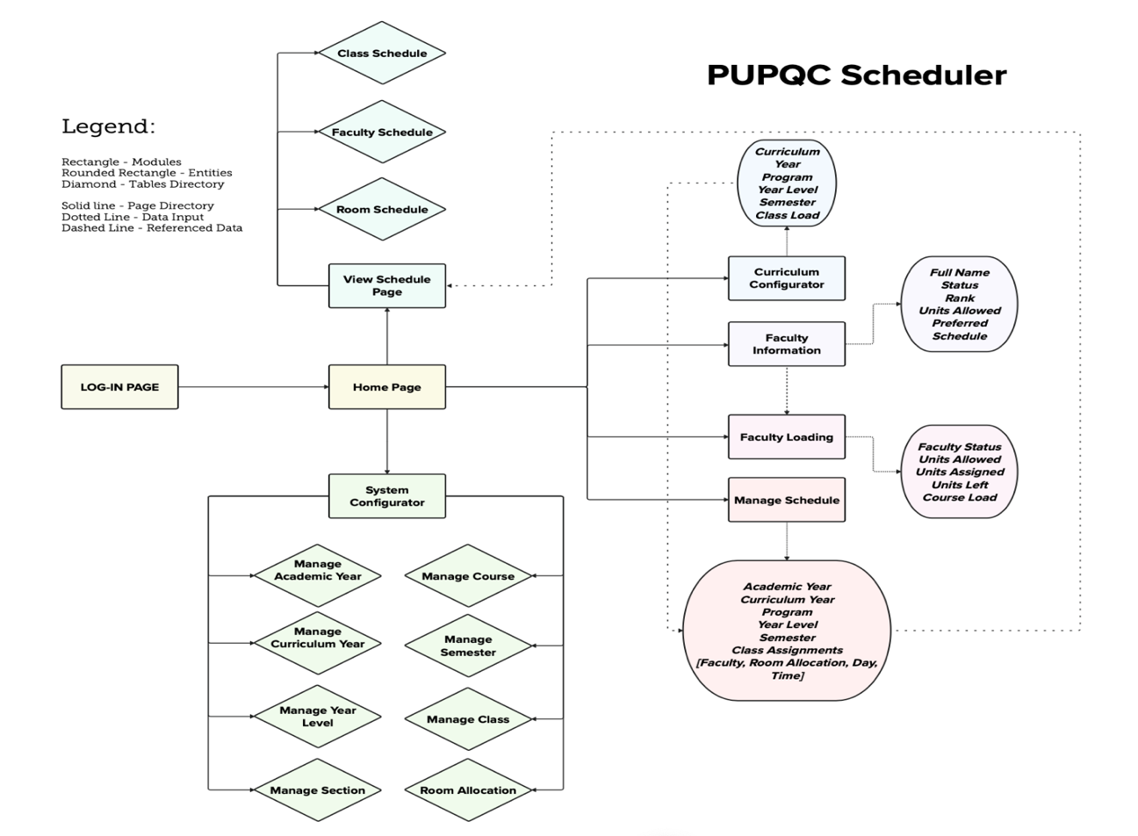

Figure 20. System Software Architecture

The System Software Architecture diagram shown above showcases modules that can be navigated in the PUPQC Scheduler System. It starts on the log-in page, wherein if the user is authenticated, will then be directed to the home page. The home page comprises hyperlinks leading to all modules in the system. The View Schedule Page, System Configurator, Manage Schedule, Curriculum Configurator, Faculty Information, and Manage Schedule Module, which is the primary module used in the system. The system configurator focuses on the creation of columns for academic years, curriculum years, programs, courses, semesters, classes, sections, and room allocations available in the university. These are the base information that are used to filter and identify the efficient scheduling process. In the curriculum configuration, the user can add the curriculum information containing all data necessary for all courses in a curriculum year. After that, users can then manage the schedules in the manage schedule module. They can assign the course load with day, start time, end time, and room assignments for each class. Users are able to validate prior to submitting and validating again upon clicking the submit button. With this, the users of the scheduling system can avoid scheduling classes with conflicts. After the class load is done, faculty loading comes next in the process. Faculty loading focuses on assigning the instructors to course loads with their desired schedules. The users are then to view and generate all schedules made which can be found in the   
View Schedule Module, where they can find class, faculty, and room schedules available for display and download as PDF files.

## 15.2 Information Systems Integration

Part of the developmental process of the system is to integrate with the systems in the ongoing development of ISKONECT website needing faculty and class schedules. This also involves the integration with the Faculty Information system where the primary integration with the scheduler system starts.

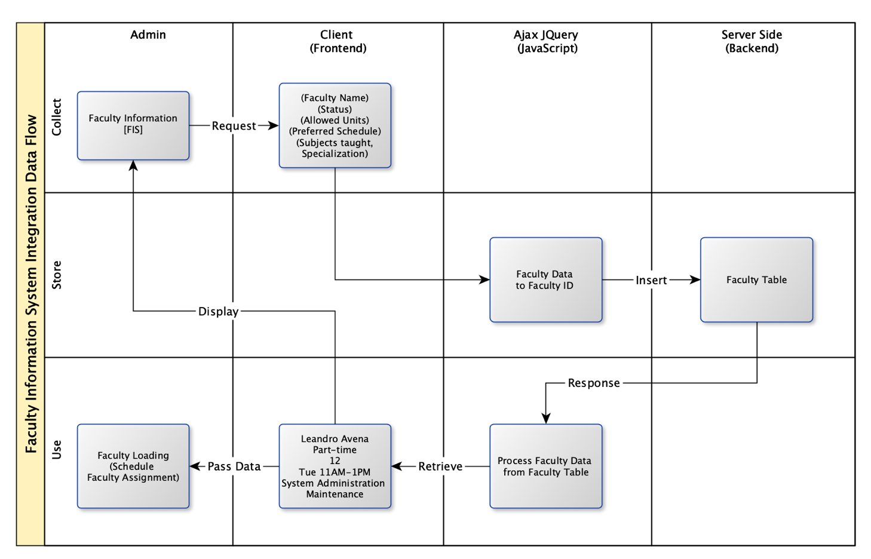Figure 21. Data flow Integration with the Faculty Information System

This diagram shows the integration points between the FIS and the Faculty &   
Class Scheduler System. The integration starts from fetching faculty information from the FIS and then assigning course loads to faculty members referencing from the integrated system. After fetching data from the FIS and the assignment of course loads, we can then view the schedule made for faculty members consisting of schedule made per class and course loads.

## 15.3 Application Design and Development

## 15.3.1 Software Modules

|  |  |
| --- | --- |
| System Modules | Description |
| Log in | The login page allows the authentication of user credentials and authorization according to user roles to specific pages they can access. |
| Home page | The home page of the system provides hyperlinks across the modules available in the system. This page also serves as the landing page after logging in into the scheduler system. |
| View Schedule | This module provides all output schedules created in the scheduling system. It has three sub-modules: View class, faculty, and room schedules. The view schedule module also provides printable pdf-generated schedules per sub-modules all providing necessary information for every class load. |
| Manage Schedule | The manage schedule module is the primary module of the scheduler system. This module provides the users with a system logic that avoids conflict of schedules for every corresponding course load. |
| Curriculum Configurator | The curriculum configurator allows the users to add existing and new curriculums used to create academic year course loads for every program which is referenced to use per year level according to the assigned curriculum used per program available in the university. |
| Faculty Loading | The faculty loading system allows the assignment of scheduled course load with respective faculty members that are assigned to specific courses according to their subject specialty or courses taught. |
| Faculty Information | The faculty information system only shows the overview of all faculty information retrieved from the Faculty Information System integrated with the Scheduler System. |
| System Configurator | The system configurator allows the access of modifying system entities and dropdown references for the major modules of the system. |

Table 22. Software Modules

## 15.3.2 System Code Snippets

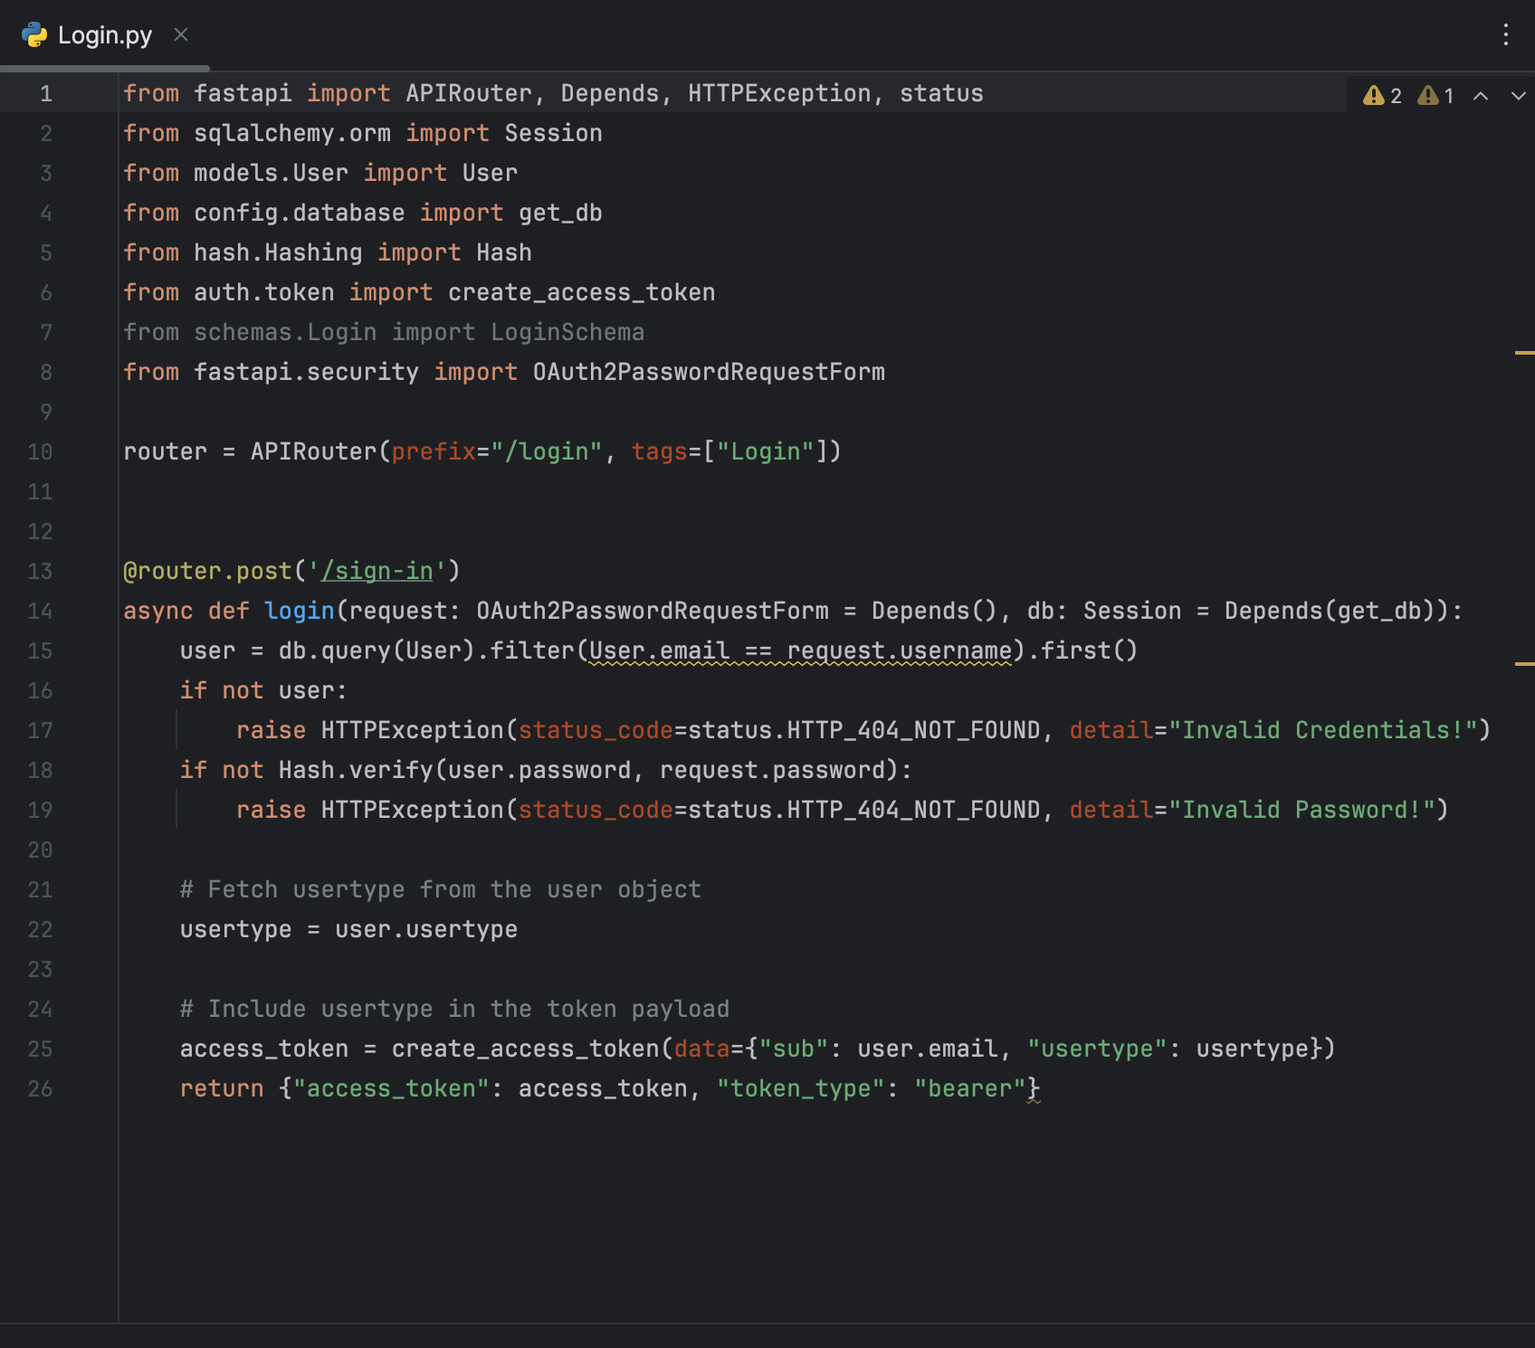

Figure 22. Login Page Server’s end

Figure 22. shows a FastAPI endpoint for user authentication. The Login function, triggered by an HTTP POST request to "/Login," validates user credentials using a hashed password stored in a database. If the credentials are valid, it generates and returns an access token with the user's email and user type included in the token payload. The code utilizes FastAPI, SQLAlchemy, and OAuth2PasswordRequestForm for handling authentication and authorization processes.

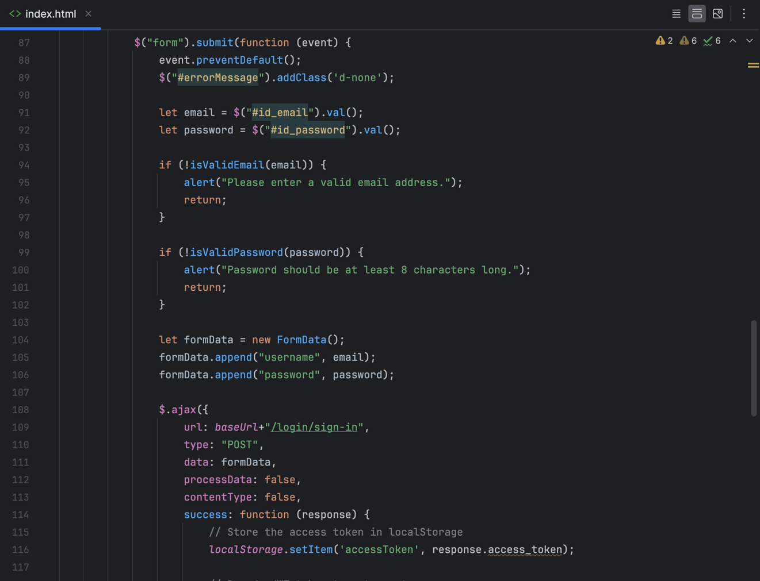

Figure 23. Login Page Client’s end

The block of code showed in Figure 23 represents a form submission using jQuery. It prevents the default form submission behavior, validates the email and password inputs, and sends an AJAX POST request to a login endpoint. If successful, it stores the received access token in the browser's local storage using **localStorage.setItem('accessToken', response.access_token)**. The code also includes basic error handling, such as displaying an alert for invalid email formats or passwords less than 8 characters long.

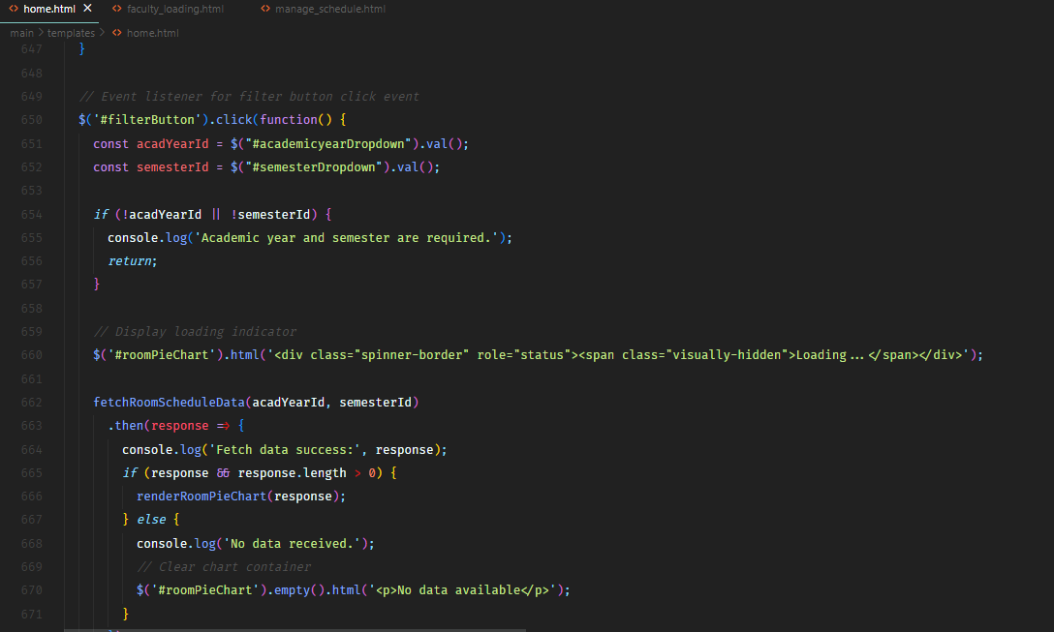

Figure 24. Home Page Client’s end

The jQuery code showed in Figure 24 handles a click event on an element with the ID 'filterButton.' It retrieves values from dropdowns for academic year and semester, logs an error if both values are not selected, and triggers the fetching of room schedule data using the function *fetchRoomScheduleData(acadYearId, semesterId).*Upon successful data retrieval, it logs the success, checks if the response has data, and either renders a pie chart using renderRoomPieChart(response) or displays a message indicating no data. It also includes a loading spinner while the data is being fetched.

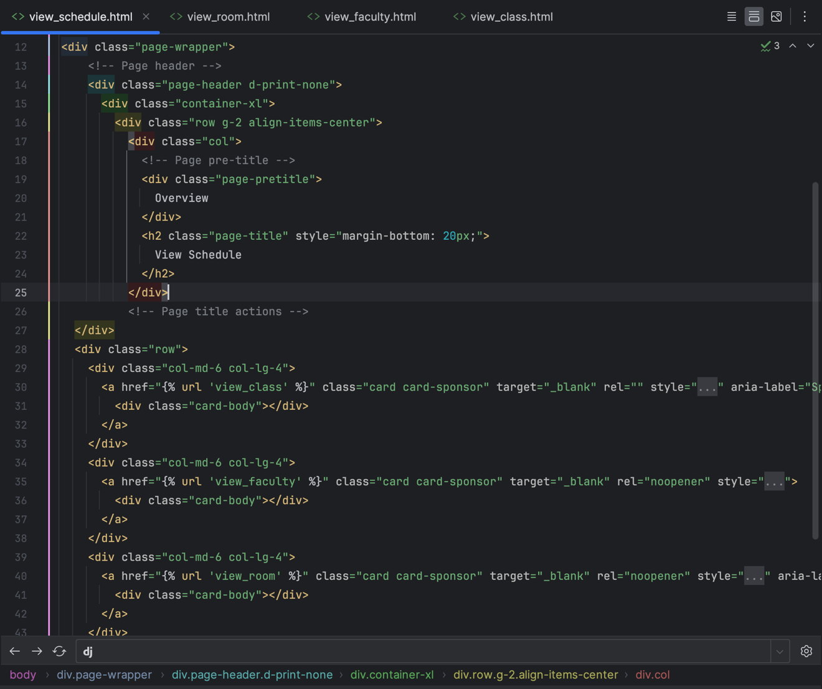

Figure 25. View Schedule Page Client’s end

The HTML code in Figure 25 for View Schedule Page represents a page layout with a header section and three cards, each containing a link. The page header includes a pre-title "Overview" and a main title "View Schedule." The cards are structured with links (href) leading to different pages (view_class, view_faculty, and view_room). Each card has a designated area for content within the "card-body" div.

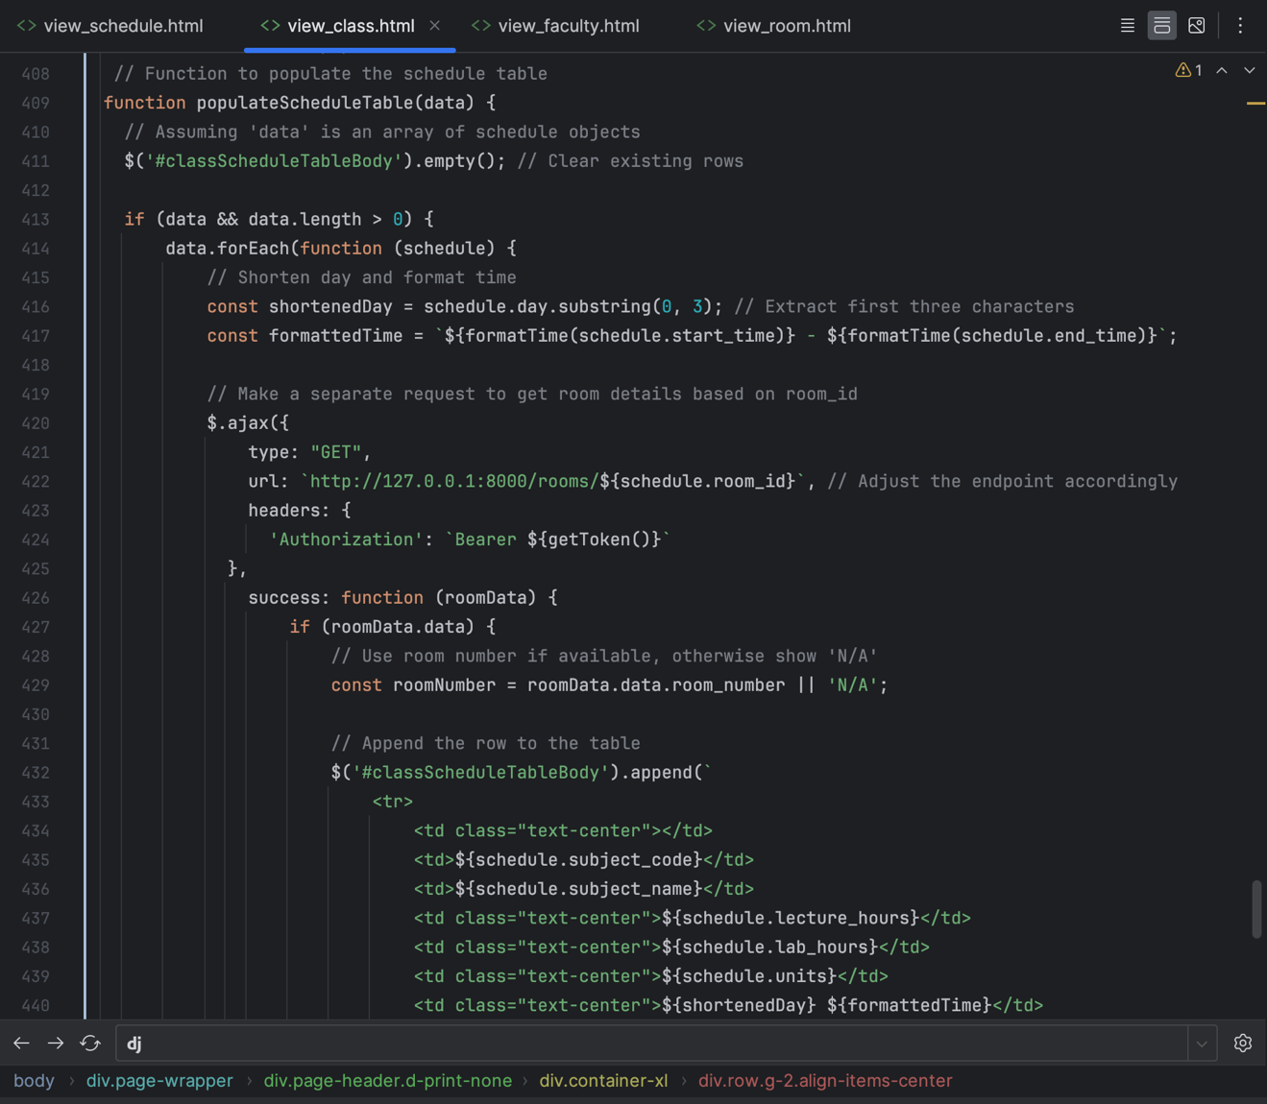

Figure 26. View Class Schedule Page Client’s end

The JavaScript code shown in Figure 26 defines a function populateScheduleTable(data) for populating a class schedule table on a web page. It clears existing rows from the table and iterates over an array of schedule objects (data). For each schedule, it shortens the day, formats the time, and makes an AJAX GET request to fetch room details based on the room ID. Upon success, it extracts room information, including the room number, and appends a new row to the table with various schedule details like subject code, name, lecture and lab hours, units, day, and time. The code also includes some formatting and dynamic data insertion into the HTML table structure.

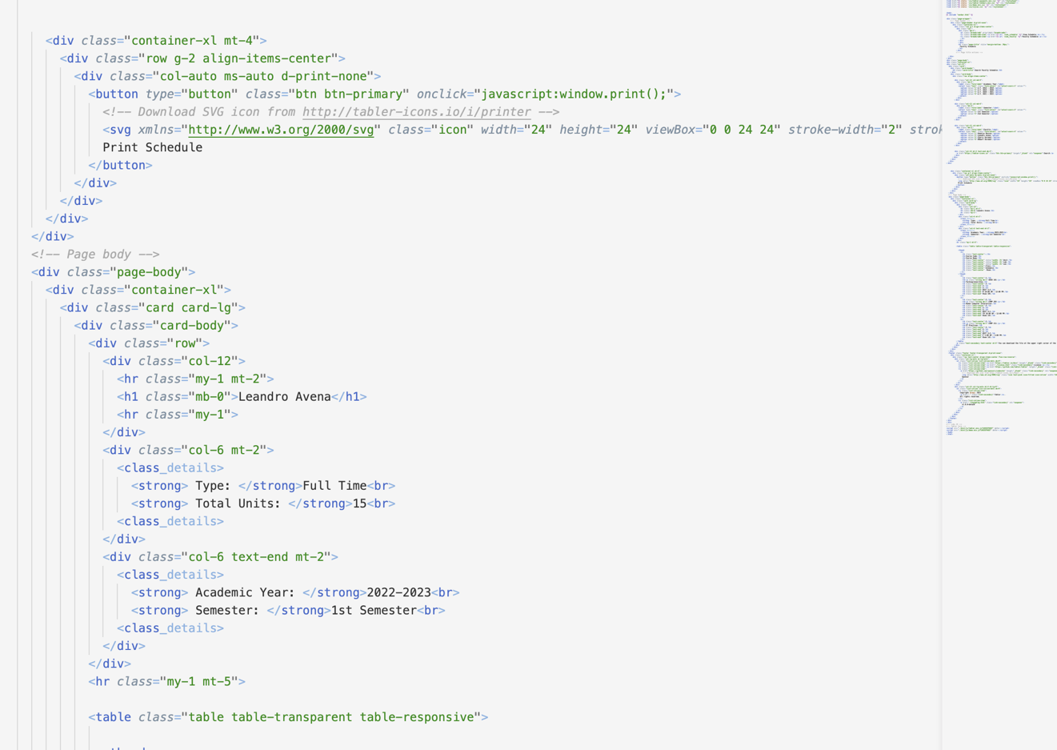

Figure 27. View Faculty Schedule Page Client’s end

Figure 27 shows the structure of Faculty Schedule should be displayed which consists of Faculty name, Faculty Type, Total Units, Academic Year, and Semester.

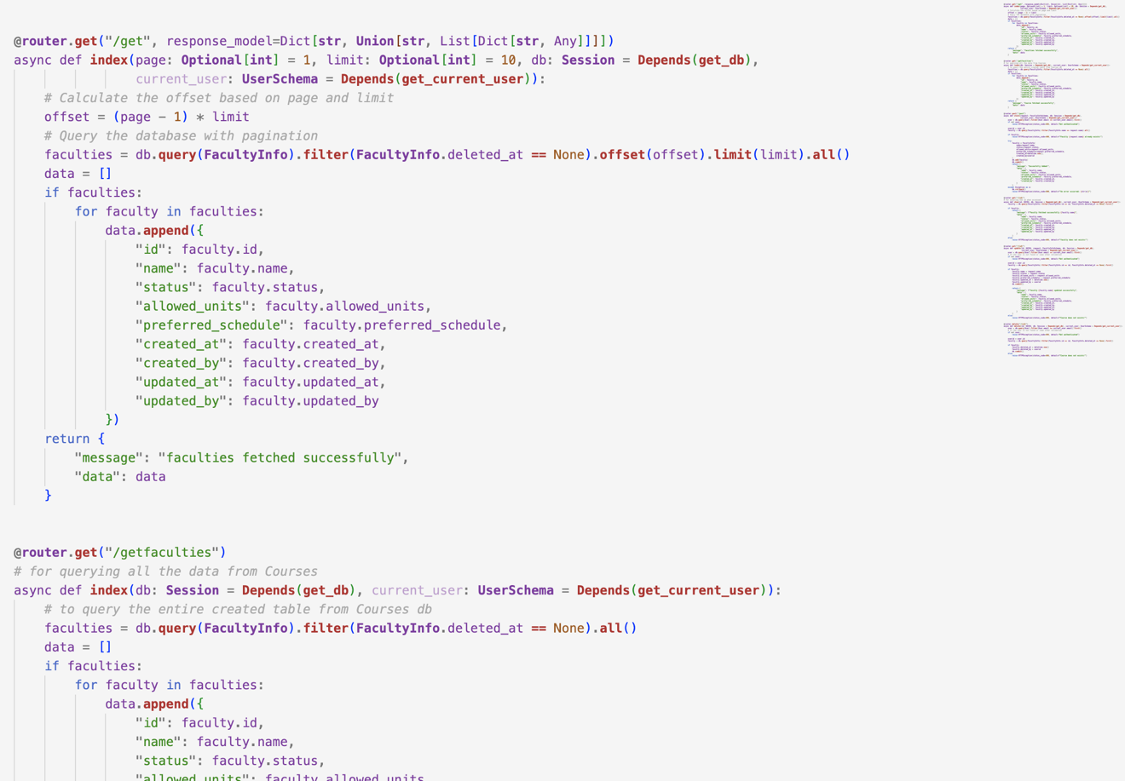

Figure 28. View Faculty Schedule Page Server’s end

The provided FastAPI code consists of two endpoints. The first one (/get) supports pagination, allowing retrieval of a specified number of faculties from the database. It utilizes parameters for page number and limit, calculates the offset, and returns a JSON response with the fetched faculties. The second endpoint (/getfaculties) retrieves all faculties from the database without pagination and returns a JSON response containing the collected faculty information. Both endpoints make use of FastAPI's dependency injection to access the database session and respond with the requested data or appropriate messages. Note that there are some typos and formatting issues in the code that need correction for proper functionality.

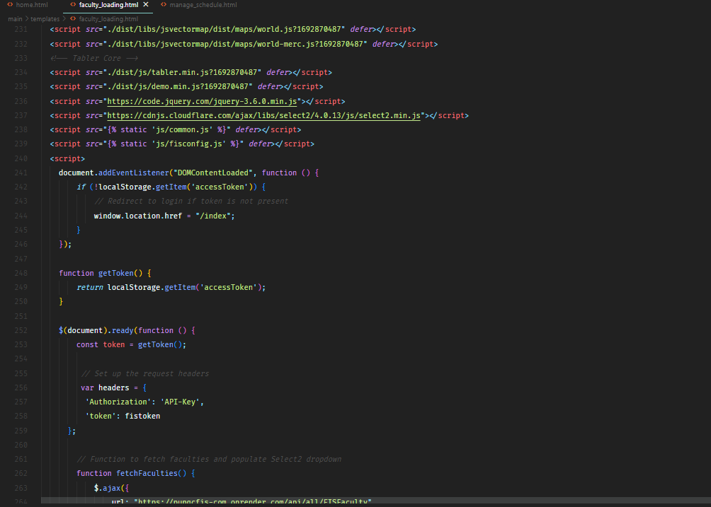

Figure 29. Faculty Loading Page Client’s end

The code shown is Figure 29 loads several JavaScript libraries for a web application, including jsvectormap, Tabler Core, jQuery, Select2, common.js, and Tasconfig.js. It checks for the presence of an access token in the local storage; if absent, it redirects the user to the "/index" page. The getToken function retrieves the access token, and custom headers are set for API requests. Note that there are typos, missing characters, and incorrect URLs that need correction for the code to work as intended.

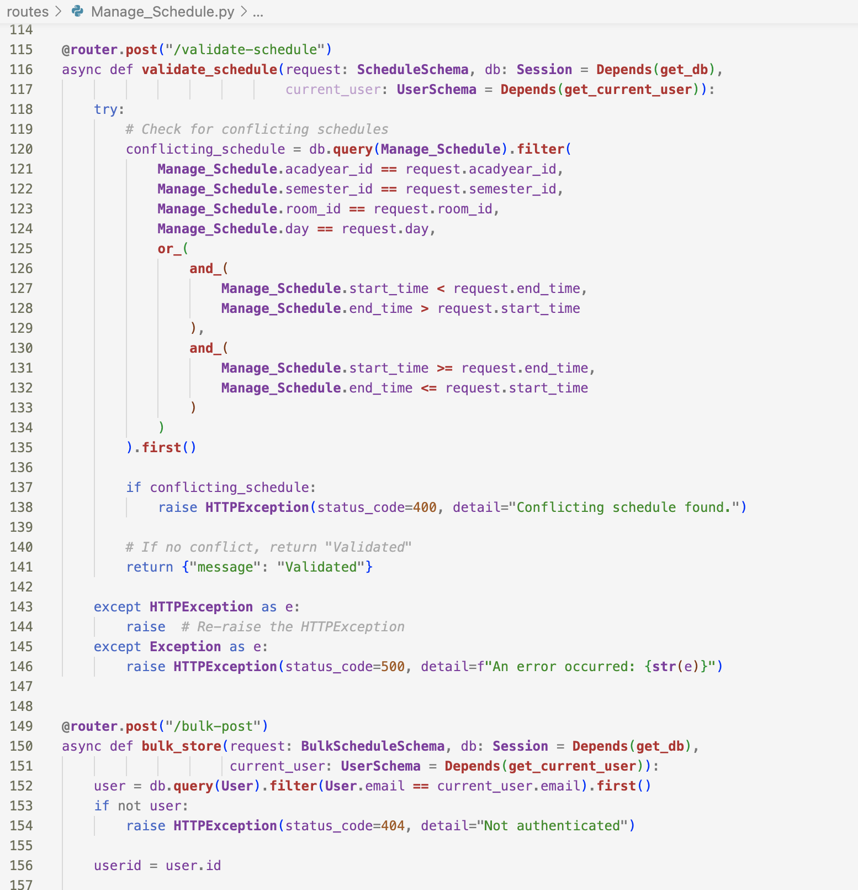

Figure 30. Manage Schedule Server’s end

The provided FastAPI code shown in Figure 30 consists of two POST endpoints within a router. The first endpoint, "/validate-schedule," is designed to validate guest schedules, using a "ScheduleSchema" for input. This validation includes checking for potential conflicts in the database. If a conflict is detected, it raises an HTTPException with a 400 status code and a detailed message; otherwise, it returns a success message. The second endpoint, "/bulk-store," handles the bulk storage of batch schedules using a "BulkScheduleSchema." It attempts to store the schedules in the database and, in case of any exceptions, raises an HTTPException with a 500 status code along with an error message. It's worth noting that there are some typos and formatting issues in the code that should be addressed for proper functionality.

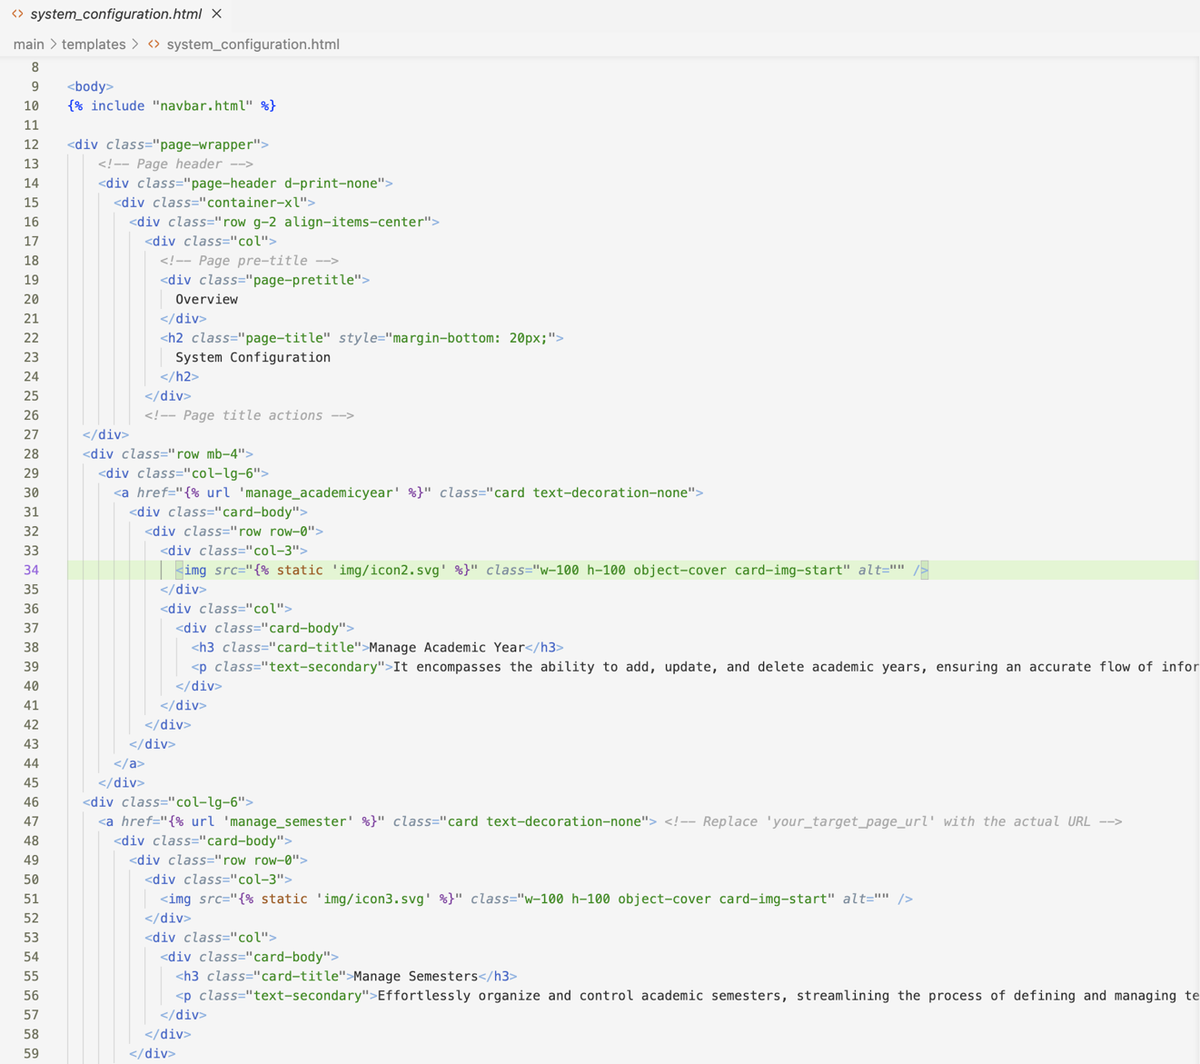

Figure 31. System Configuration Client’s end

The HTML code shown in Figure 31 represents a web page layout for a system configuration section. The page includes a header, "System Configuration," with an overview. It has different categories such as Manage Academic Year, Manage Semester, Manage Year Level, Manage Section, Manage Class, Manage Curriculum Year, and Manage Room.

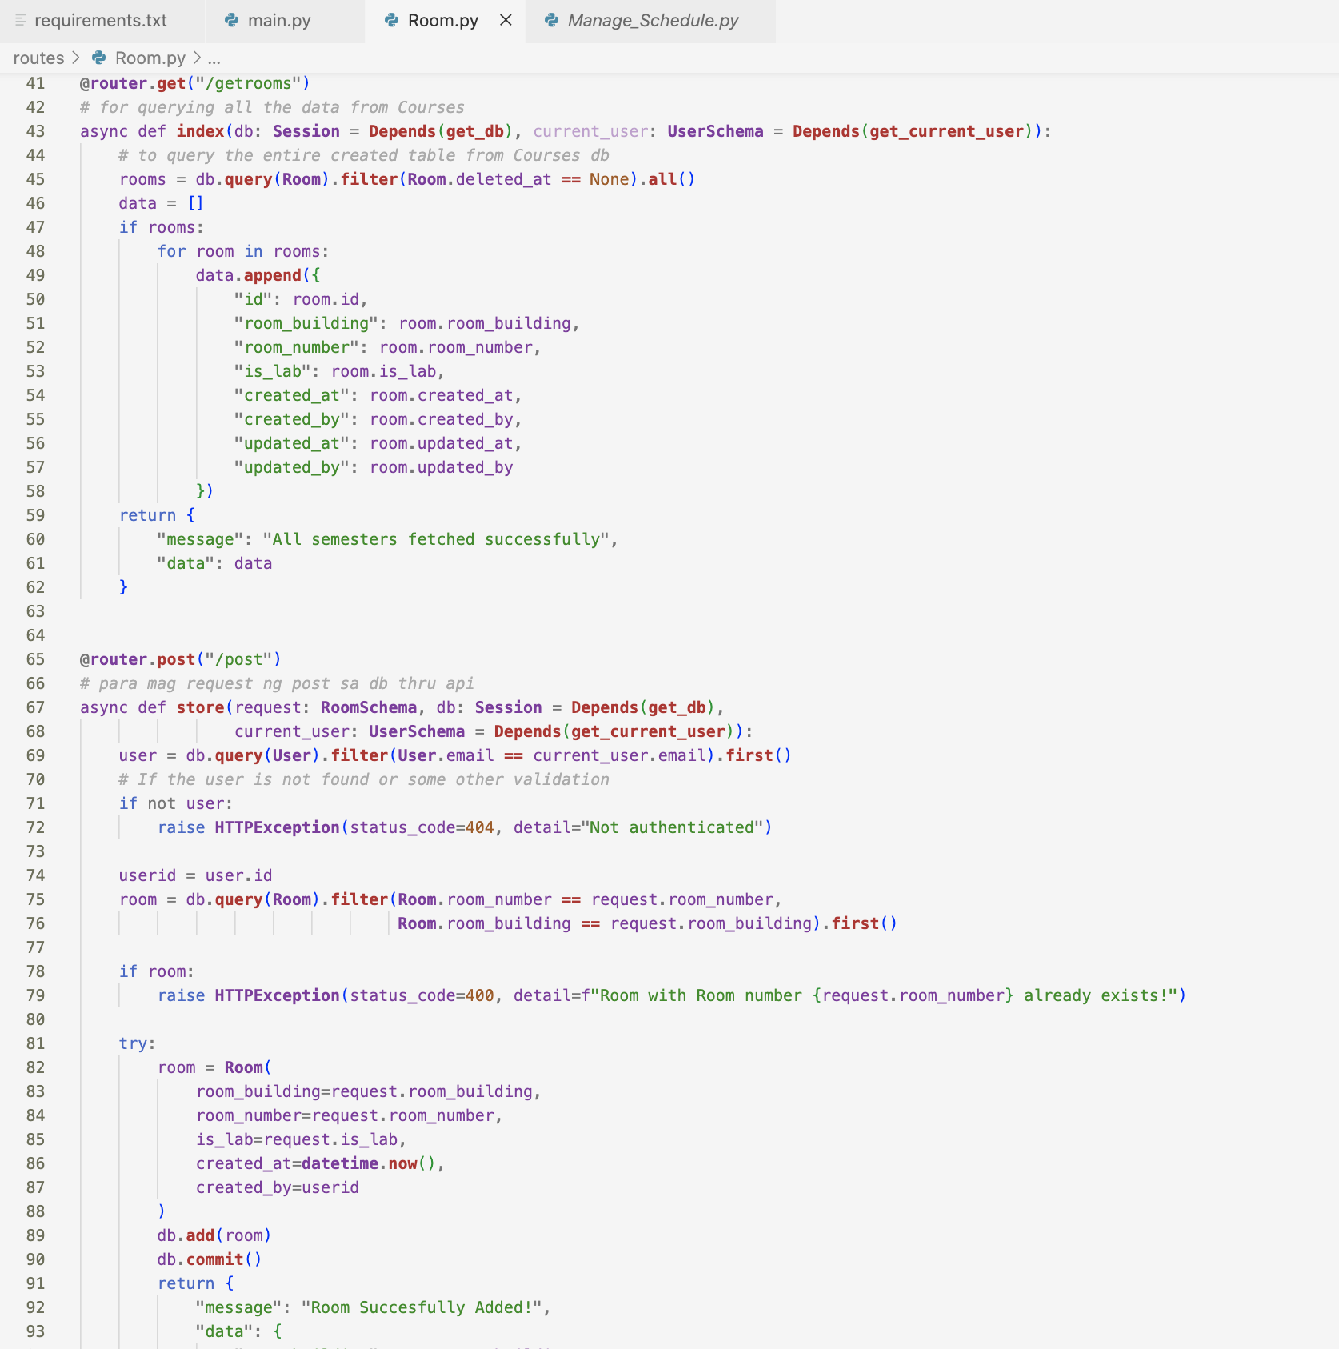

Figure 32. Manage Room Server’s end

Figure 32 provides FastAPI code that defines two endpoints within a router named "greater." The first endpoint, accessed through a GET request ("/get"), retrieves information about all rooms from the database. It queries the "Rooms" table, filters out any deleted records, and returns a JSON response containing details such as room ID, building, number, and creation/update timestamps. The second endpoint, accessed through a POST request ("/post"), handles the addition of a new room to the database. It takes input in the form of a "RoomSchema" through the request body. The code performs validations, checks for authentication, ensures the room does not already exist, and then adds the new room to the database. If successful, it returns a success message. Both endpoints utilize dependencies for accessing the database session and the current user. The code follows an asynchronous pattern, and error handling is implemented using HTTPException for various scenarios, such as authentication failure or attempting to add a room that already exists.

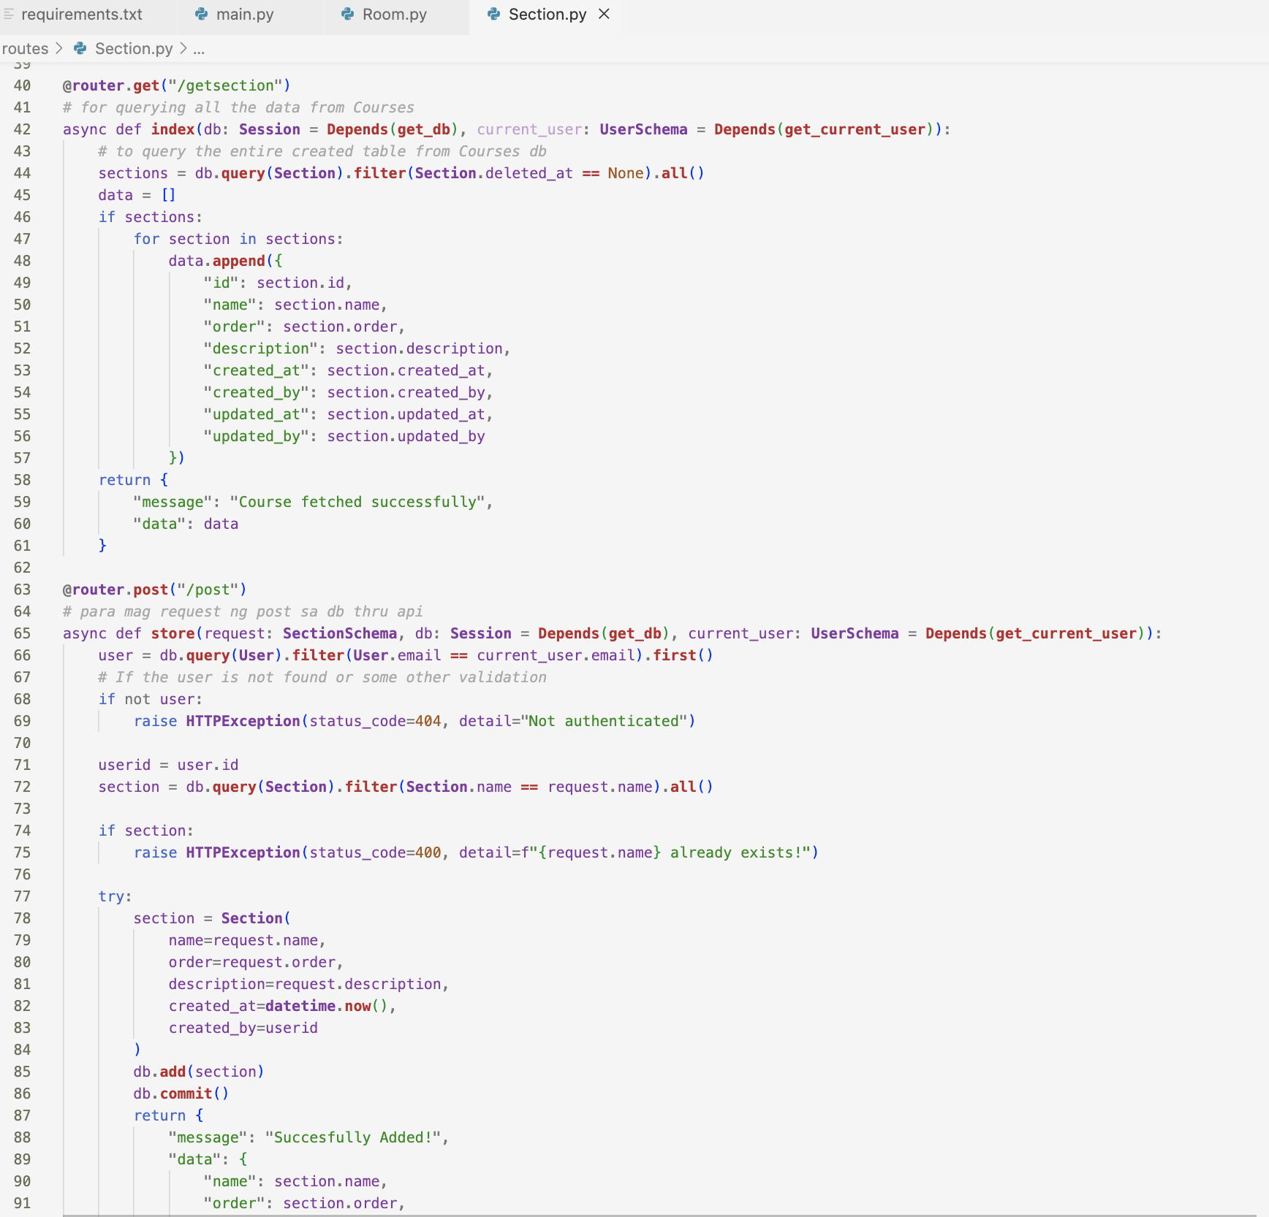

Figure 33. Manage Section Server’s end

Figure 33 includes two endpoints within a router named "Brouter." The first endpoint, accessible through a GET request ("/getsection"), retrieves information about all sections from the database. It queries the "Sections" table, filters out any deleted records, and returns a JSON response containing details such as section ID, name, order, description, and creation/update timestamps. The second endpoint, accessed through a POST request ("/post"), handles the addition of a new section to the database. It takes input in the form of a "SectionSchema" through the request body. The code performs validations, checks for authentication, ensures the section does not already exist, and then adds the new section to the database. If successful, it returns a success message. Both endpoints use dependencies for accessing the database session and the current user. Error handling is implemented using HTTPException for scenarios such as authentication failure or attempting to add a section that already exists. The asynchronous pattern is followed, and the code structure aligns with the FastAPI framework conventions.

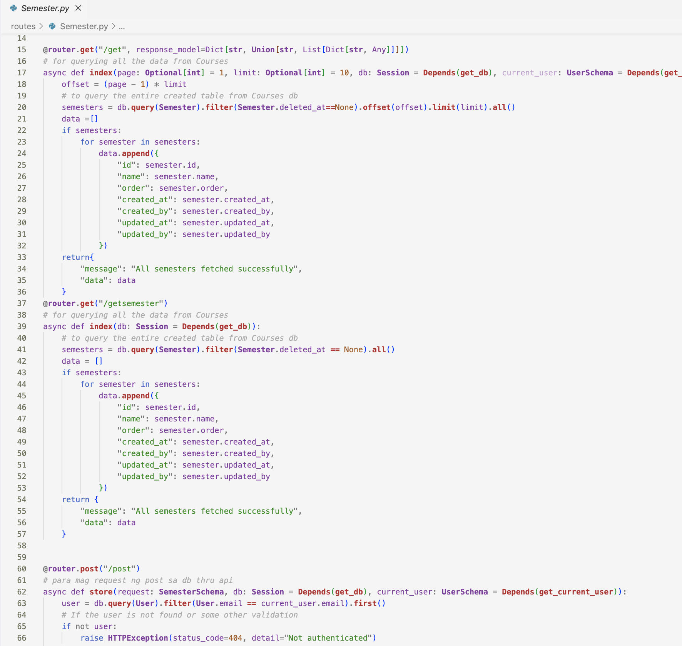

Figure 34. Manage Semester Server’s end

Figure 34 defines three endpoints within a router named "Grouter." The first endpoint, accessed through a GET request ("/get"), retrieves information about semesters from the database, supporting pagination. It queries the "Semester" table, filters out deleted records, and returns a JSON response with details such as semester ID, name, order, creation/update timestamps. The second endpoint ("/getsemester") is similar but retrieves all semesters without pagination. It queries the database, collects semester information, and returns a JSON response with the fetched data. The third endpoint ("/post"), accessed through a POST request, handles the creation of a new semester. It takes input in the form of a "SemesterSchema" through the request body. The code performs validations, checks for authentication, ensures the semester does not already exist, and then adds the new semester to the database. If successful, it returns a success message. All endpoints utilize dependencies for accessing the database session and the current user. Error handling is implemented using HTTPException for scenarios such as authentication failure.

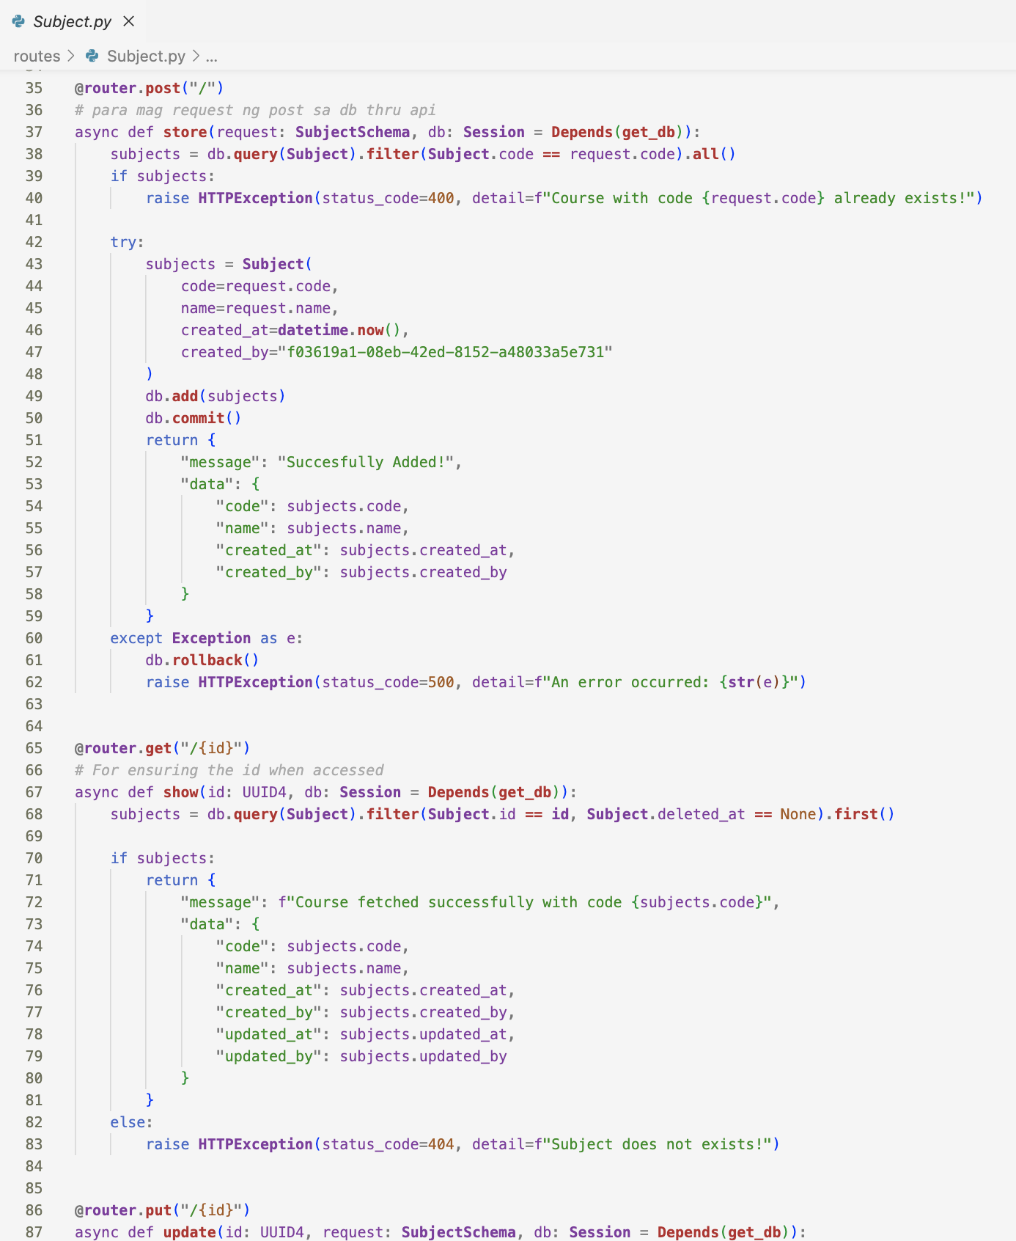

Figure 35. Manage Subject Server’s end

The code presented in Figure 35 defines a set of CRUD (Create, Read, Update, Delete) endpoints within a router for managing subjects. The POST endpoint ("/") enables the creation of a new subject, checking for code uniqueness and handling errors gracefully. The GET endpoint ("/{id}") retrieves details about a subject based on its unique ID, raising an HTTPException if the subject is not found. The PUT endpoint ("/{id}") allows for the update of an existing subject, ensuring the subject's existence and providing error handling. Overall, these endpoints facilitate the comprehensive management of subject entities, incorporating proper validation, database interactions, and error responses in accordance with the FastAPI framework conventions.

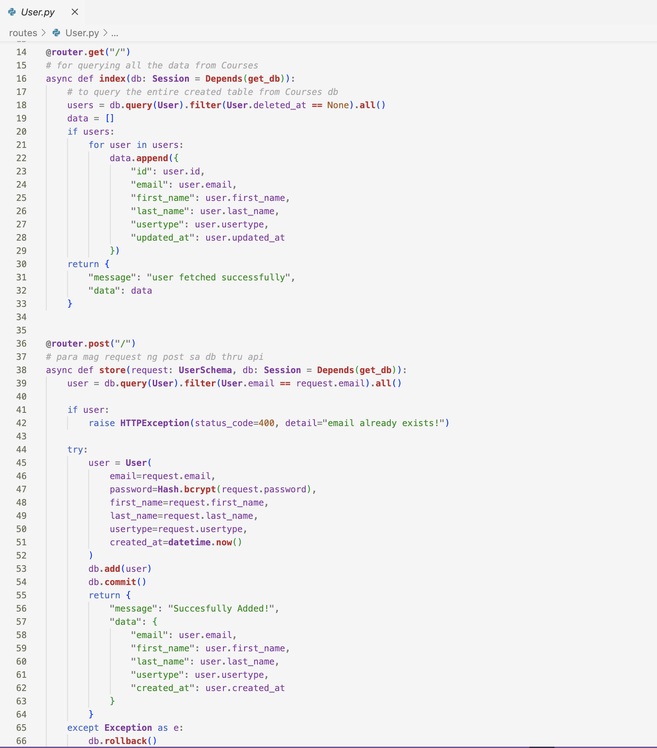

Figure 36. Manage User Server’s end

The snippet shown in Figure 36 contains two endpoints within a router for managing user entities. The first endpoint, accessed through a GET request ("/"), retrieves information about all users from the database. It queries the "User" table, filters out any deleted records, and returns a JSON response with details such as user ID, email, first name, last name, user type, and the timestamp of the last update. The second endpoint, accessible via a POST request ("/"), handles the creation of a new user. It takes input in the form of a "UserSchema" through the request body. The code checks if a user with the provided email already exists and raises an HTTPException if so. If not, it creates a new user with hashed password and other details, adds it to the database, and returns a success message along with the user's email, first name, last name, user type, and creation timestamp.

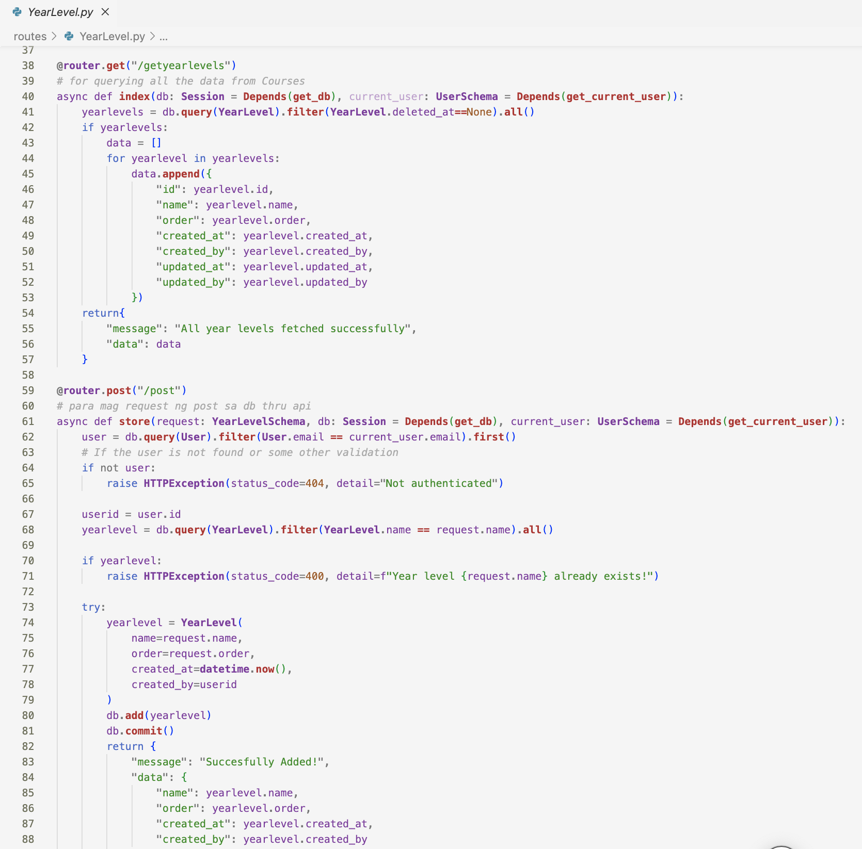

Figure 37. Manage Year Level Server’s end

The first endpoint, accessible via a GET request ("/getyearlevels"), retrieves information about all year levels from the database. It queries the "YearLevel" table, filters out any deleted records, and returns a JSON response with details such as year level ID, name, order, creation timestamp, and creator/updater information. The second endpoint, accessible through a POST request ("/post"), facilitates the creation of a new year level. It takes input in the form of a "YearLevelSchema" through the request body. The code checks for user authentication, ensuring the existence of the current user, and raises an HTTPException if not authenticated. It then validates if the year level with the provided name already exists and raises an exception if so.

## 15.3.3 Algorithms and Data Structures

The PUPQC Scheduler System uses intricate algorithms and well-engineered data structures to simplify the scheduling process at Polytechnic University of the Philippines, Quezon City. The system's primary scheduling algorithm uses a combination of heuristic and optimization algorithms to efficiently assign classrooms, instructors, and resources such as the Rule-based Algorithm in the implementation of functions throughout the system’s logic. The algorithm builds conflict-free class schedules by taking into account several limitations such as timing, instructor availability, and classroom capacity. The system uses a structured data model to represent key components such as academic years, semesters, courses, classes, faculty information, and room specifications. These data structures are intended to render data retrieval, manipulation, and storage more efficient within the PostgreSQL database management system. By structuring data logically and hierarchically, the system ensures scalability, adaptability, and real-time information synchronization among modules.

## 15.3.4 Algorithms and Data Structures

A specially selected mix of required libraries and frameworks is used to help construct the PUPQC Scheduler System, following the standards provided by the advisers following the uniformity to other information systems with each serving a distinct purpose to improve functionality, performance, and maintainability. Combining these modules and frameworks, the PUPQC Scheduler System strikes a compromise between functionality and usability, providing stakeholders with a robust yet user-friendly solution for efficient scheduling and resource management.

**A. Libraries**

1. **Django -** Django serves as the foundational web framework, providing the system with a solid base for developing scalable and modular web applications. Its complete collection of capabilities, which includes built-in authentication, ORM, and a templating engine, speeds up development and encourages code reuse.
2. **FastAPI -** FastAPI complements Django by making API building easier through asynchronous capabilities and automatic documentation generation. Its lightweight and high-performance features make it ideal for processing multiple requests while maintaining responsiveness.
3. **Ajax jQuery -** Ajax jQuery, utilized to perform asynchronous data exchange between the frontend and backend, improves the user experience by allowing dynamic modifications to the user interface without requiring page reloads. This helps to establish a more fluid and dynamic scheduling environment in the Iskonnek Information System.

**B. Frameworks**

1. **Tabler -** The Tabler frontend framework makes it easier to create modern, user-friendly interfaces for administrators and end users. Its responsive and adaptable components offer consistency and accessibility across multiple devices, improving usability and enjoyment.

## 15.4 Database Schema and Data Management

## Schema Design

The PUPQC Scheduler System's database schema has been diligently designed to enable efficient data storage and retrieval, allowing scheduling procedures to run smoothly. Based on relational database principles, the schema includes entities that reflect critical components of academic scheduling, such as academic years, semesters, courses, classes, faculty, and room allocations. Each entity is established with attributes that collect essential details, allowing for more thorough data management.

The schema design follows normalization techniques to reduce data redundancy and maintain data integrity. The design improves storage efficiency and facilitates sophisticated queries for scheduling algorithms by arranging data into well-structured tables and building relationships between entities.

## Entity-Relationship Diagram

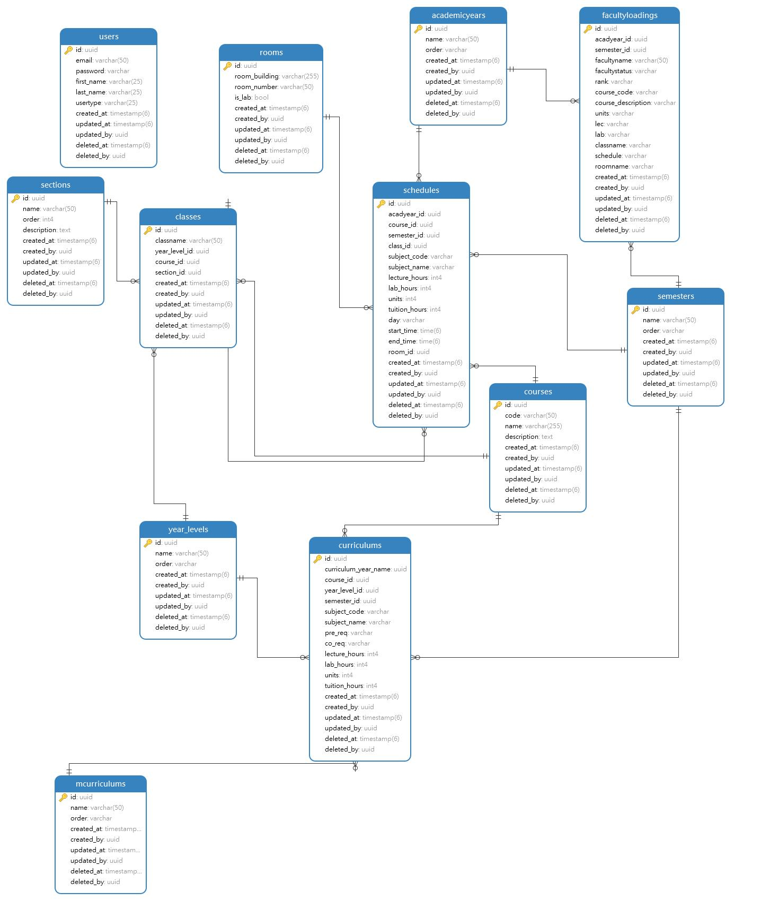

Figure 38. Entity-relationship Diagram for Faculty & Class Scheduler System

The PUPQC Scheduler System's database schema on Figure 38 has been designed to facilitate efficient data storage and retrieval, allowing scheduling procedures to run smoothly. Based on relational database principles, the schema includes entities that reflect critical components of academic scheduling, such as academic years, semesters, courses, classes, faculty, and room allocations. Each entity is established with attributes that collect essential details, allowing for more thorough data management. The schema design follows protocols to reduce data redundancy and maintain data integrity. The design improves storage efficiency and facilitates sophisticated queries for scheduling algorithms by arranging data into well-structured tables and building relationships between entities.

## CRUD Operations

CRUD (Create, Read, Update, and Delete) operations form an essential component of data management in the PUPQC Scheduler System, making it possible for users to interact with the database and alter information as needed. These CRUD operations are managed via application logic and database transactions, which ensure data integrity and consistency throughout the system. The PUPQC Scheduler System enables users to accomplish these key actions, allowing stakeholders to successfully manage academic scheduling processes and adapt to changing needs.

1. **Create** - Users can add new records to the database, such as courses, classes, or faculty profiles. This procedure consists of inserting data into the appropriate tables while complying to data validation criteria and integrity requirements.
2. **Read** - Users can retrieve information from the database by selecting records based on specific criteria. Whether reading class schedules, faculty information, or room allocations, the Read operation enables users to query the database and retrieve important data for decision-making and analysis.
3. **Update** - Users may modify existing records in the database, such as class times, room assignments, and faculty schedules. This operation entails altering data attributes while ensuring data consistency and following business requirements.
4. **Delete** - Users can remove unforeseen records from the database, such as old information or errors. The Delete operation ensures data sanitation and database hygiene by deleting duplicate or irrelevant records.

## Database Schema and Data Management

## Topology

The network configuration of the PUPQC Scheduler System is designed to facilitate communication and data transfer between system components. The system has a client-server design, with clients interacting with the server in order to retrieve and alter scheduling data. The client-side interface gives users, particularly the primary administrator an easy way to engage with the system. Users obtain access to various modules based on their authorization levels using secure authentication mechanisms, which protect data privacy and system security. On the server side, the system is hosted using cloud platforms like Render and Heroku, which provide scalability and stability. The server runs the application logic and database management system, allowing for real-time data synchronization as well as consistent system performance.

## Security Measures

Security measures are critical for protecting sensitive data and maintaining the scheduling system's integrity. The PUPQC Scheduler System employs strong security procedures to reduce potential attacks and vulnerabilities. Firewalls are used to monitor and manage incoming and outgoing network traffic, preventing unauthorized access and destructive activity. Encryption techniques, such as SSL/TLS protocols, are used to secure data transmission between clients and servers, ensuring confidentiality and data integrity. Access control mechanisms are used to enforce user authorization and authentication, allowing only authorized users to access particular system modules depending on their roles and permissions. Role-based access control (RBAC) is used to properly manage user privileges.

Regular security audits and vulnerability assessments are carried out to proactively detect and address potential security flaws. Patch management techniques are established to keep system components up to date with the most recent security patches and updates.

## Protocols

Communication protocols serve an important role in facilitating data flow and interaction within system components. The PUPQC Scheduler System uses established communication protocols to assure interoperability and compatibility. Client-server communication uses the HTTP/HTTPS protocols, which allow for the delivery of hypertext data while also providing safe transmission of information over the network. FastAPIs is also used to define communication interfaces between frontend and backend components, resulting in seamless integration and interaction. API-based communication patterns are used to integrate external systems such as the Faculty Information System (FIS), which uses APIs to securely retrieve and transmit data. This ensures that the scheduling system is compatible with the current university databases and information systems.

## Loading Balance

Load balancing systems are used to uniformly distribute incoming traffic across numerous servers, resulting in optimal performance and scalability. The PUPQC Scheduler System employs load-balancing mechanisms to ensure that no single server becomes a bottleneck, hence improving system responsiveness and resource utilization.

In addition, caching technologies are used to temporarily store frequently accessed data, decreasing the need for duplicate database queries and improving response times. Content Delivery Networks (CDNs) are thought to distribute static materials across numerous servers geographically, reducing latency and speeding up asset download for users in the cloud.

Failover measures are also implemented to ensure system availability in the case of a server loss or interruption. Redundant servers and backup systems are used to provide continuous operation and minimize downtime, allowing for ongoing access to scheduling functions such as local deployment of the system. The PUPQC Scheduler System's load balancing and failover procedures seek to create a dependable, scalable, and high-performance solution that fulfils the university community's scheduling needs aiming for it to be available for use offline by local network deployment.

## Database Schema and Data Management

## 15.6.1 Deployment Strategies

The deployment approach for the Scheduler System was designed to assure seamless integration and efficient deployment. Initially, the system was planned to be deployed on a local network to allow for rapid use before the second semester of the school year. 2023-2024. This local network deployment enabled the scheduling process to be housed on a local server, assuring accessibility and responsiveness for any devices connected to the same network and stationed in the same office. Then, cloud-based deployment methods were considered to improve scalability and accessibility across information systems. Using cloud platforms such as Render and Heroku, the system was installed on scalable infrastructure to ensure optimal performance and secure hosting. The deployment approach stressed dependability, scalability, and accessibility to meet the changing needs of the academic scheduling environment at Polytechnic University of the Philippines, Quezon City.

## 15.6.2 Hardware Specifications

The PUPQC Scheduler System's hardware specs and server configurations were specifically designed to satisfy the needs of efficient scheduling procedures and seamless user interaction. The system was built on scalable architecture, with cloud platforms like Render and Heroku. These platforms provide adaptable and dependable hosting environments, providing peak performance and accessibility. Furthermore, the system used PostgreSQL, a powerful database management system, to record crucial data like academic years, semesters, courses, classes, teachers, and housing assignments. The necessity for stability, scalability, and effective data handling influenced the selection of hardware specifications and server configurations, all of which contributed to the scheduling system deployment's success.

## 15.6.3 Configuration Management

Configuration management was important in maintaining the efficient functioning and maintenance of the PUPQC Scheduler System. Automation tools and scripts were used to simplify configuration procedures, reduce manual intervention, and improve system stability. Continuous integration and deployment (CI/CD) pipelines were created to automate testing and deployment operations, lowering the chance of errors during software upgrades and speeding up the development cycle. Version control platforms such as GitHub were used for collaborative development and version management, allowing development team members to work together more efficiently. Configuration management procedures were applied to assure consistency, dependability, and scalability throughout the deployment environment, resulting in the scheduling system's efficient operation.

## 15.6.4 Scalability

Scalability was an essential requirement in the deployment of the PUPQC Scheduler System, ensuring that it could respond to changing user demands and workload requirements. Load balancing tactics were used to disperse incoming traffic evenly across numerous servers, avoiding a single server from becoming a bottleneck and improving overall system performance. Caching mechanisms were used to temporarily store frequently accessed data, eliminating the need for unnecessary database searches and improving response times. Furthermore, the system was built on scalable infrastructure, utilizing cloud platforms like Render and Heroku to handle changes in user demand and ensure peak performance. The scheduling system's scalability was developed to meet the changing needs of academic scheduling operations, resulting in a dependable and effective solution.

## Database Schema and Data Management

## 15.7.1 Protocols

The PUPQC Faculty and Class Scheduler System was developed and deployed with strict security measures in place to secure sensitive data, prevent unauthorized access, and mitigate any security concerns. The security protocols, authentication and authorization systems, encryption techniques, and incident response procedures were carefully planned and implemented to safeguard the system's integrity, confidentiality, and availability. The security methods used in the PUPQC Scheduler System follow industry standards and best practices for establishing secure communication channels and protecting against network vulnerabilities. The Transport Layer Security (TLS) protocol was used to encrypt data sent between the client and the server, preventing eavesdropping, and tampering with important information. Furthermore, Secure Socket Layer (SSL) certificates were used to verify the server's identity and establish a secure connection with clients, reducing the possibility of man-in-the-middle attacks. These protocols protect the security and integrity of data sent within the system, ensuring a safe and useful information system.

## 15.7.2 Authentication and Authorization

Enhanced authentication and authorization procedures have been established to manage access to system resources and ensure that only authorized users can conduct operations in the PUPQC Scheduler System. User authentication employs a multi-factor authentication (MFA) strategy, requiring users to submit a mix of credentials such as usernames, and passwords also implementing validation and token handling. This improves user account security and reduces the danger of unwanted access via stolen or compromised credentials. On another note, Authorization mechanisms were designed to enforce role-based access control (RBAC), which defines distinct responsibilities and permissions for different user groups in the system. Administrators have higher privileges and access to manage system setups, schedule classes, and viewing of sensitive data, while admin staff can only see schedules and submit requests within their allocated tasks in the workplace. Precise access controls are implemented to prevent unwanted acts and guarantee that users only have access to the resources required for their assigned responsibilities and roles.

## 15.7.3 Encryption

Encryption techniques are used to protect data at rest and in transit, including sensitive information held in the PUPQC Scheduler System's database and during client-server connection. The Advanced Encryption Standard (AES) encryption method was used to encrypt sensitive data before storage, making it unreadable without the correct decryption key. In addition, data transfer across the network was secured with TLS to prevent unauthorized interception and tampering with sensitive information. These encryption measures guarantee the confidentiality and integrity of data processed and stored within the system while adhering to data protection legislation and standards.

## 15.7.4 Incident Response

In terms of comprehensive incident response and mitigation methods, it was developed to effectively detect, assess, and respond to security problems, thereby reducing the impact of potential security breaches on the PUPQC Scheduler System. Incident response plans were created, defining the steps to be taken in the event of a security incident, such as escalation protocols, notification requirements, and remediation strategies. In the event of a security incident, the incident response team would follow predetermined processes, such as containment, eradication, and recovery measures. Communication channels would be established to coordinate incident response operations, and affected parties would be notified immediately to guarantee transparency and participation in resolving the security event. Post-event assessments and analysis would take place to identify lessons learned and improve the effectiveness of future incident response activities. All in all, the implementation of advanced safety precautions, such as protocols, authentication and authorization mechanisms, encryption techniques, and incident response procedures, demonstrates a proactive approach to mitigating security risks and protecting the integrity and confidentiality of the PUPQC Scheduler system. These security procedures ensure the system is resilient to possible threats and provide a safe environment for users and stakeholders.

## User Documentation

## 15.8.1 User Manual

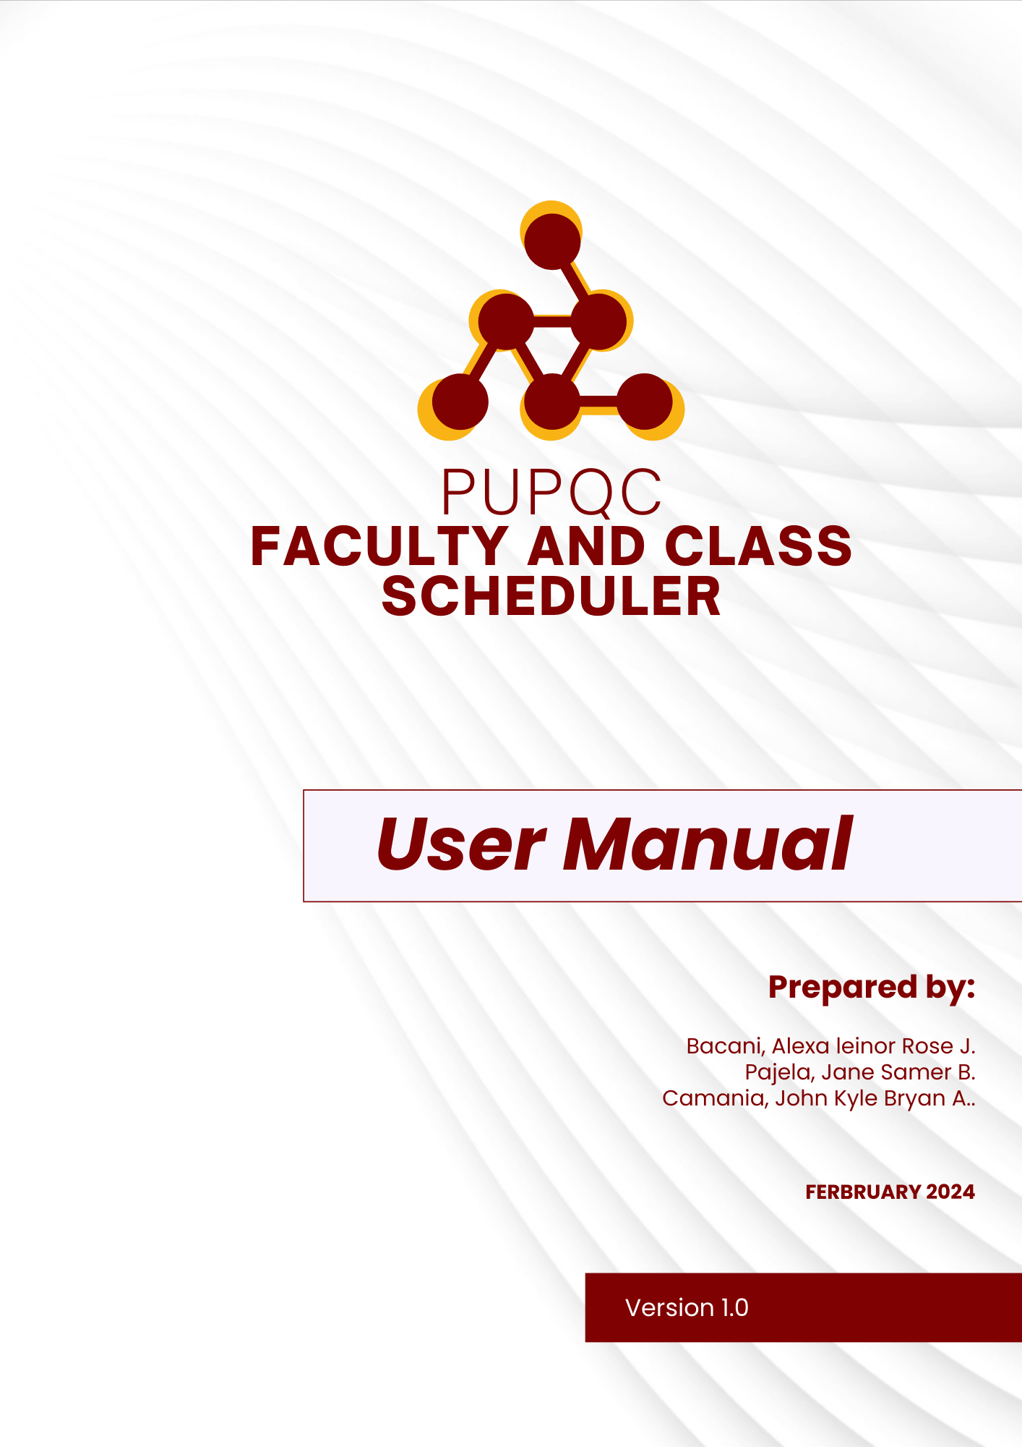

Figure 39. User Manual – Cover Page

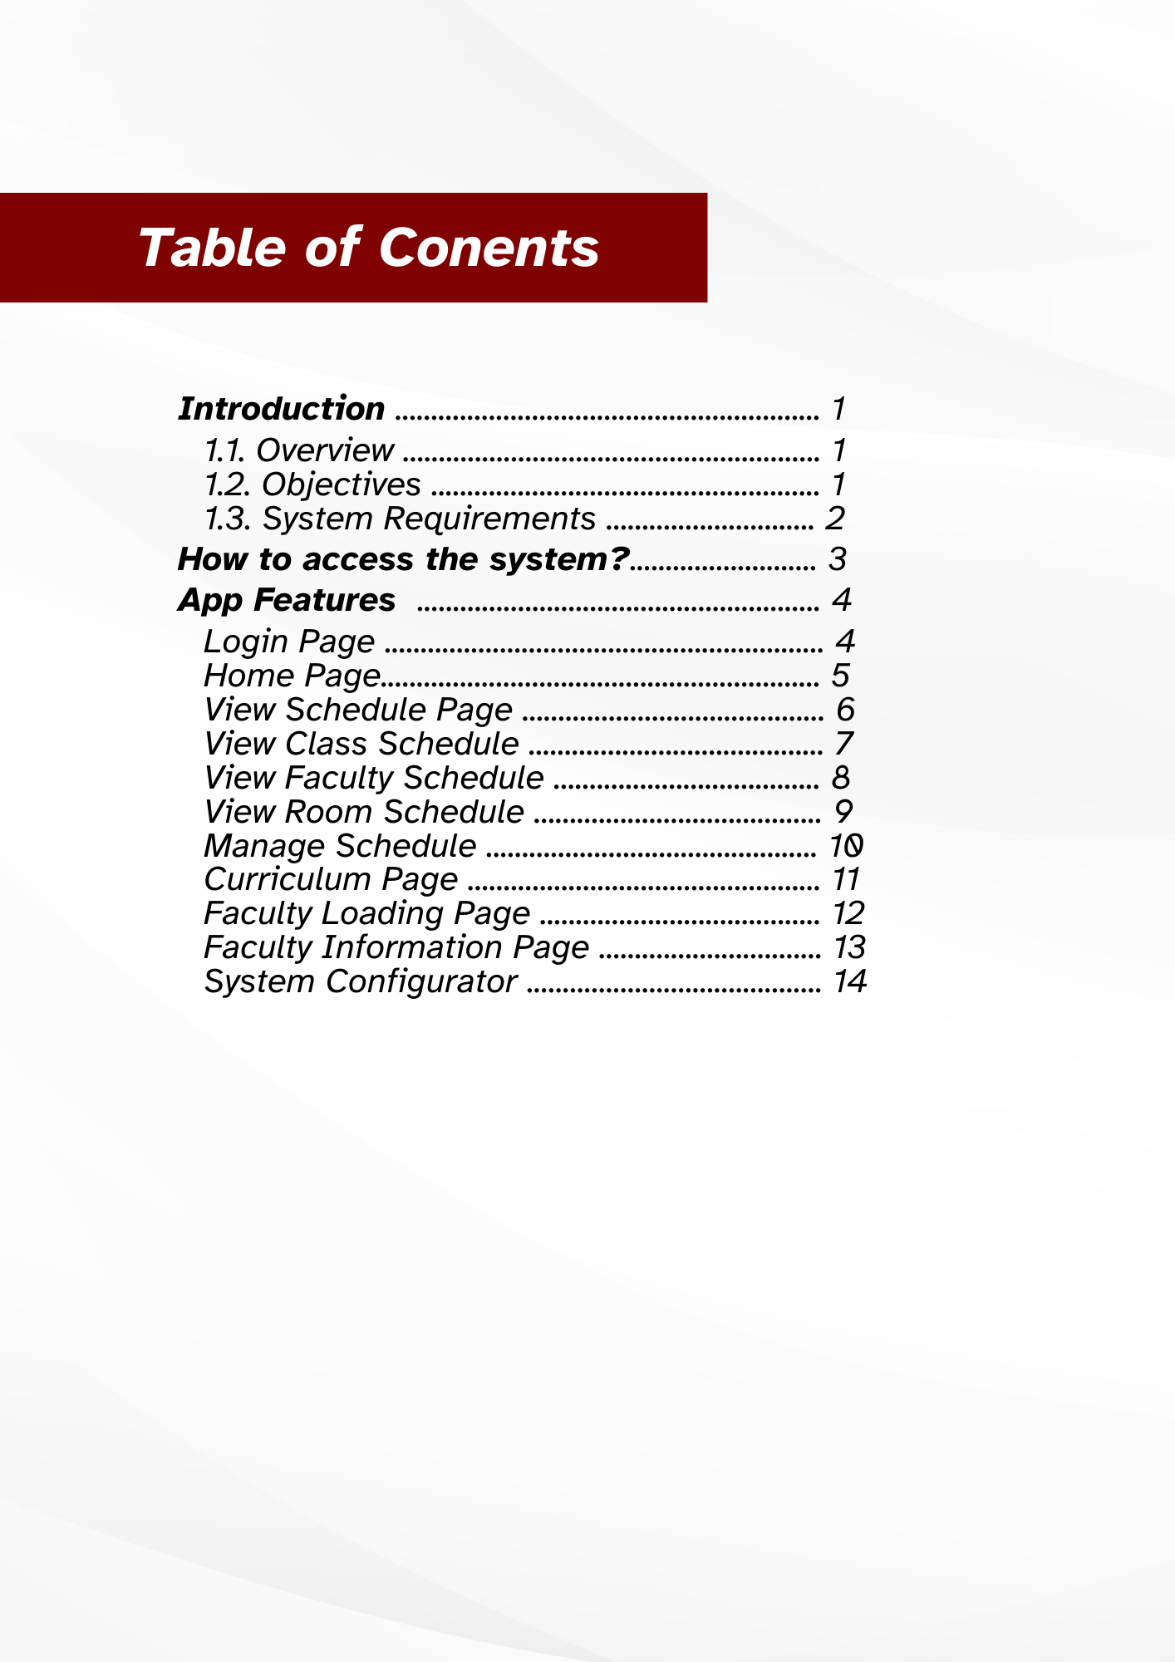

Figure 40. User Manual – Table Contents

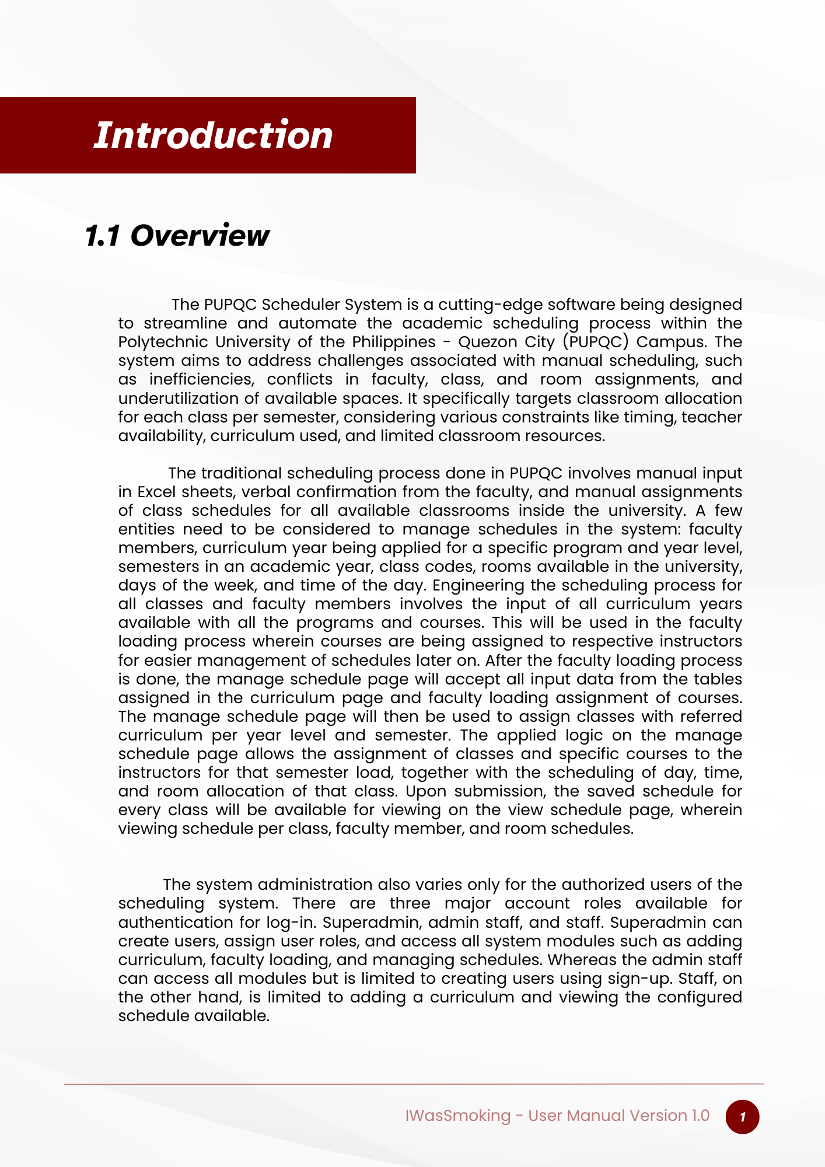

Figure 41. User Manual – Overview

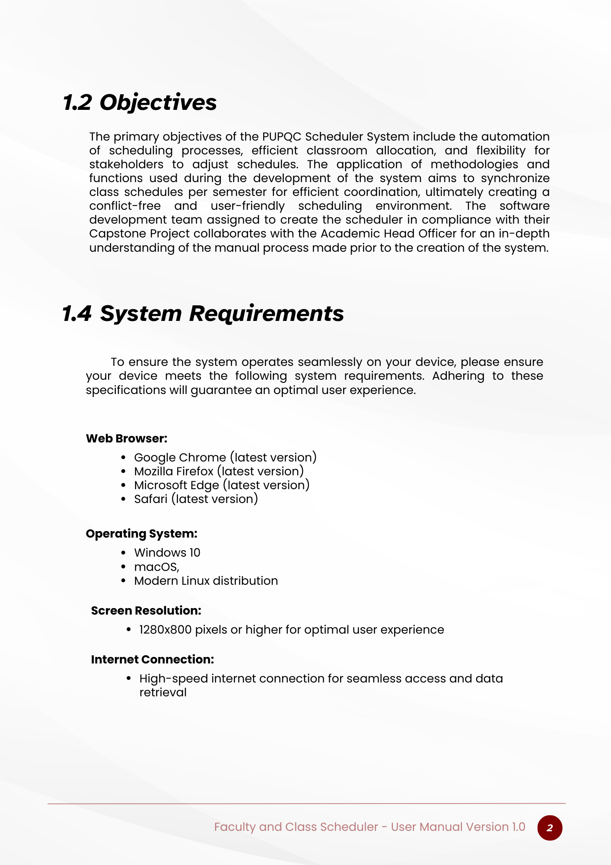

Figure 42. User Manual – Objectives, System Requirements

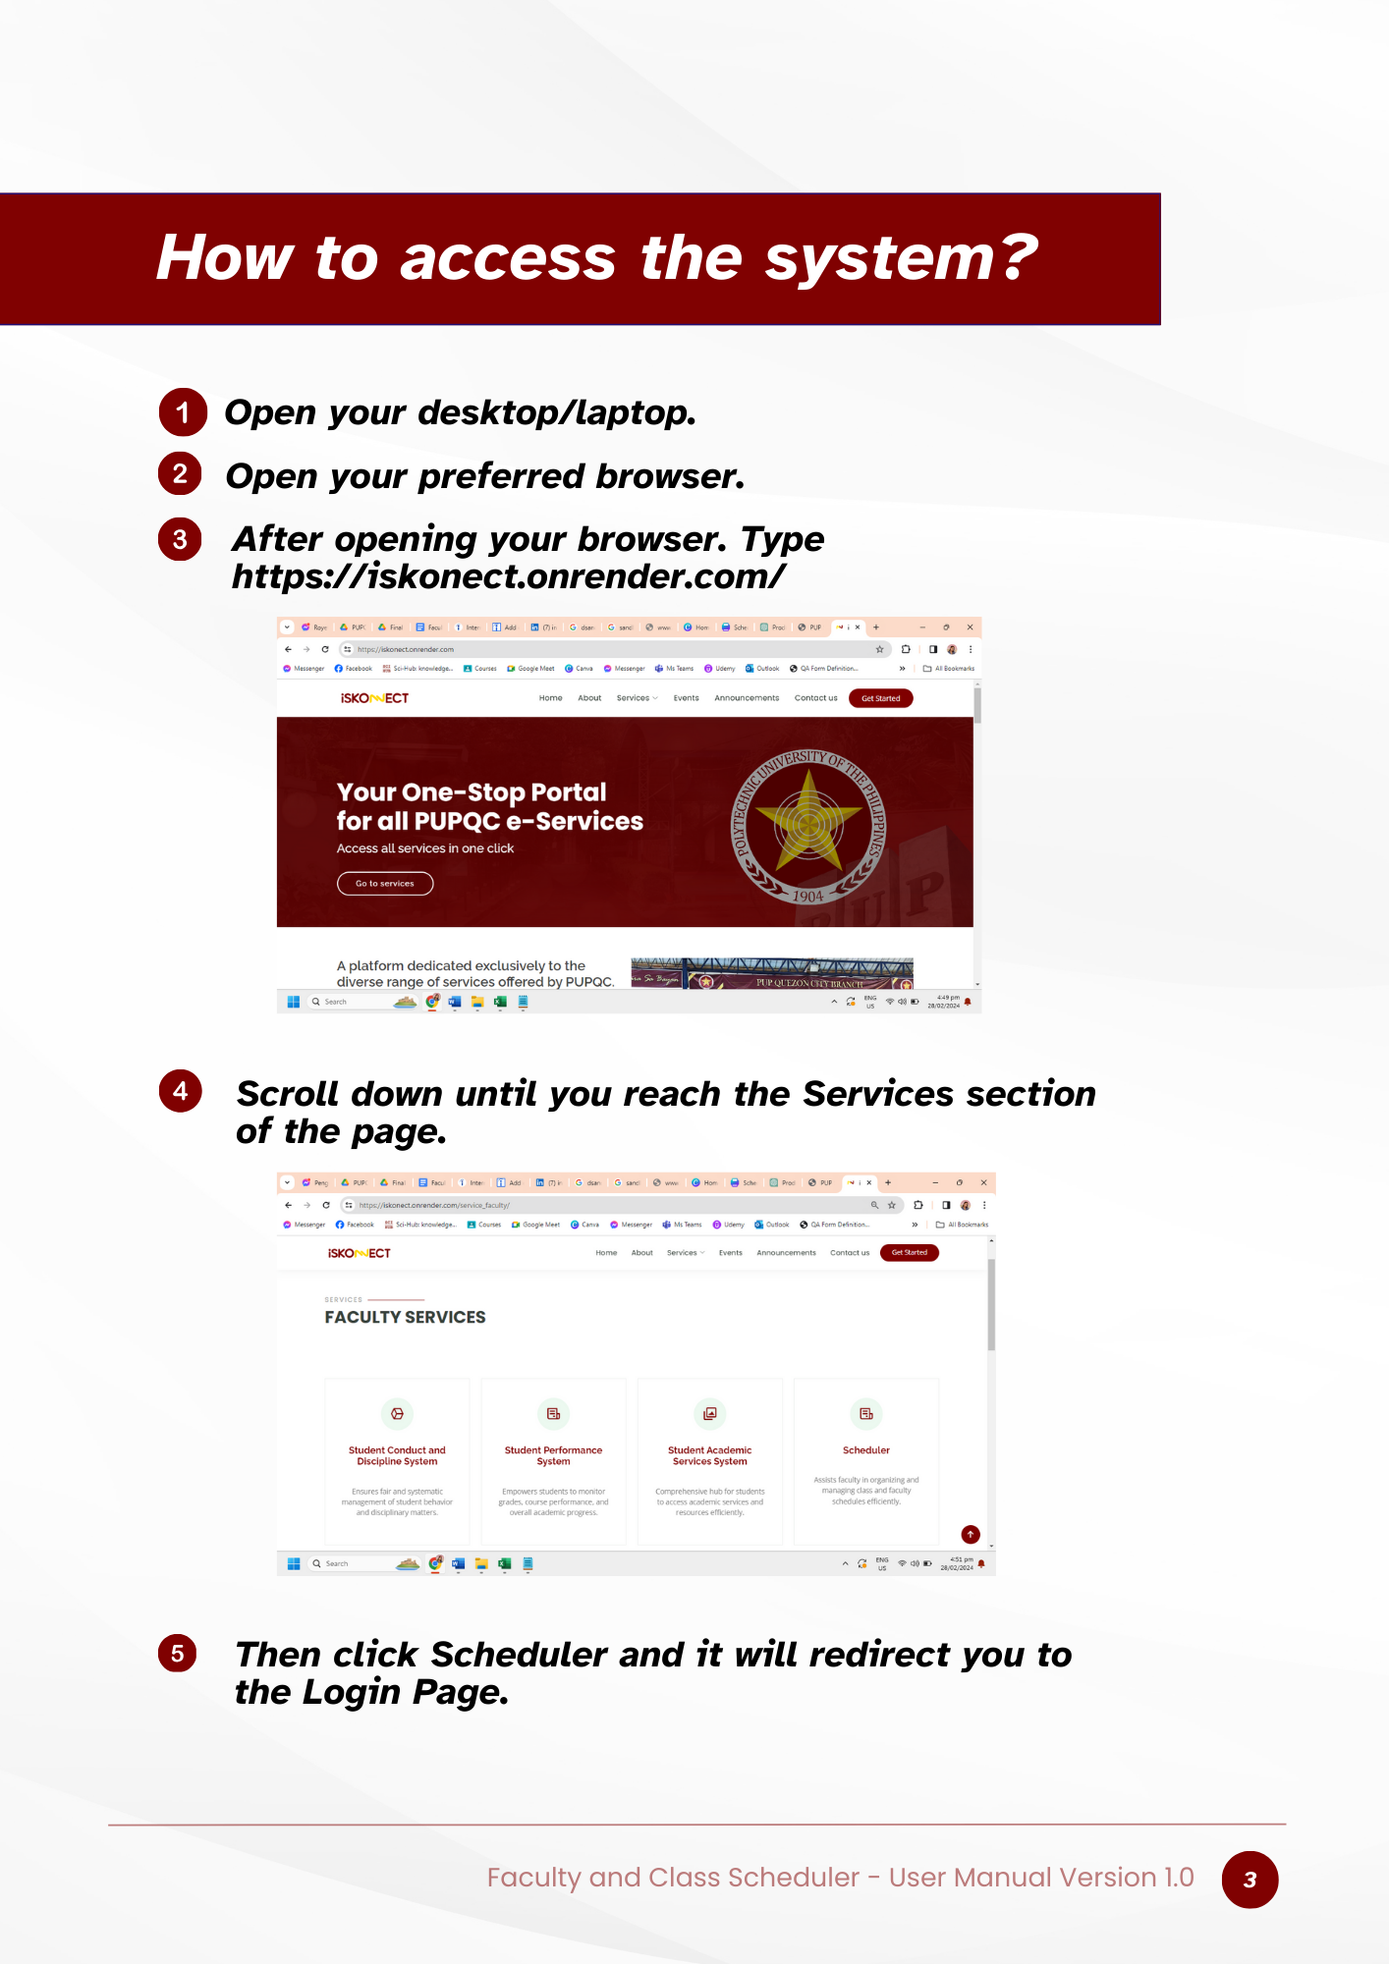

Figure 43. User Manual – Navigation to access the System

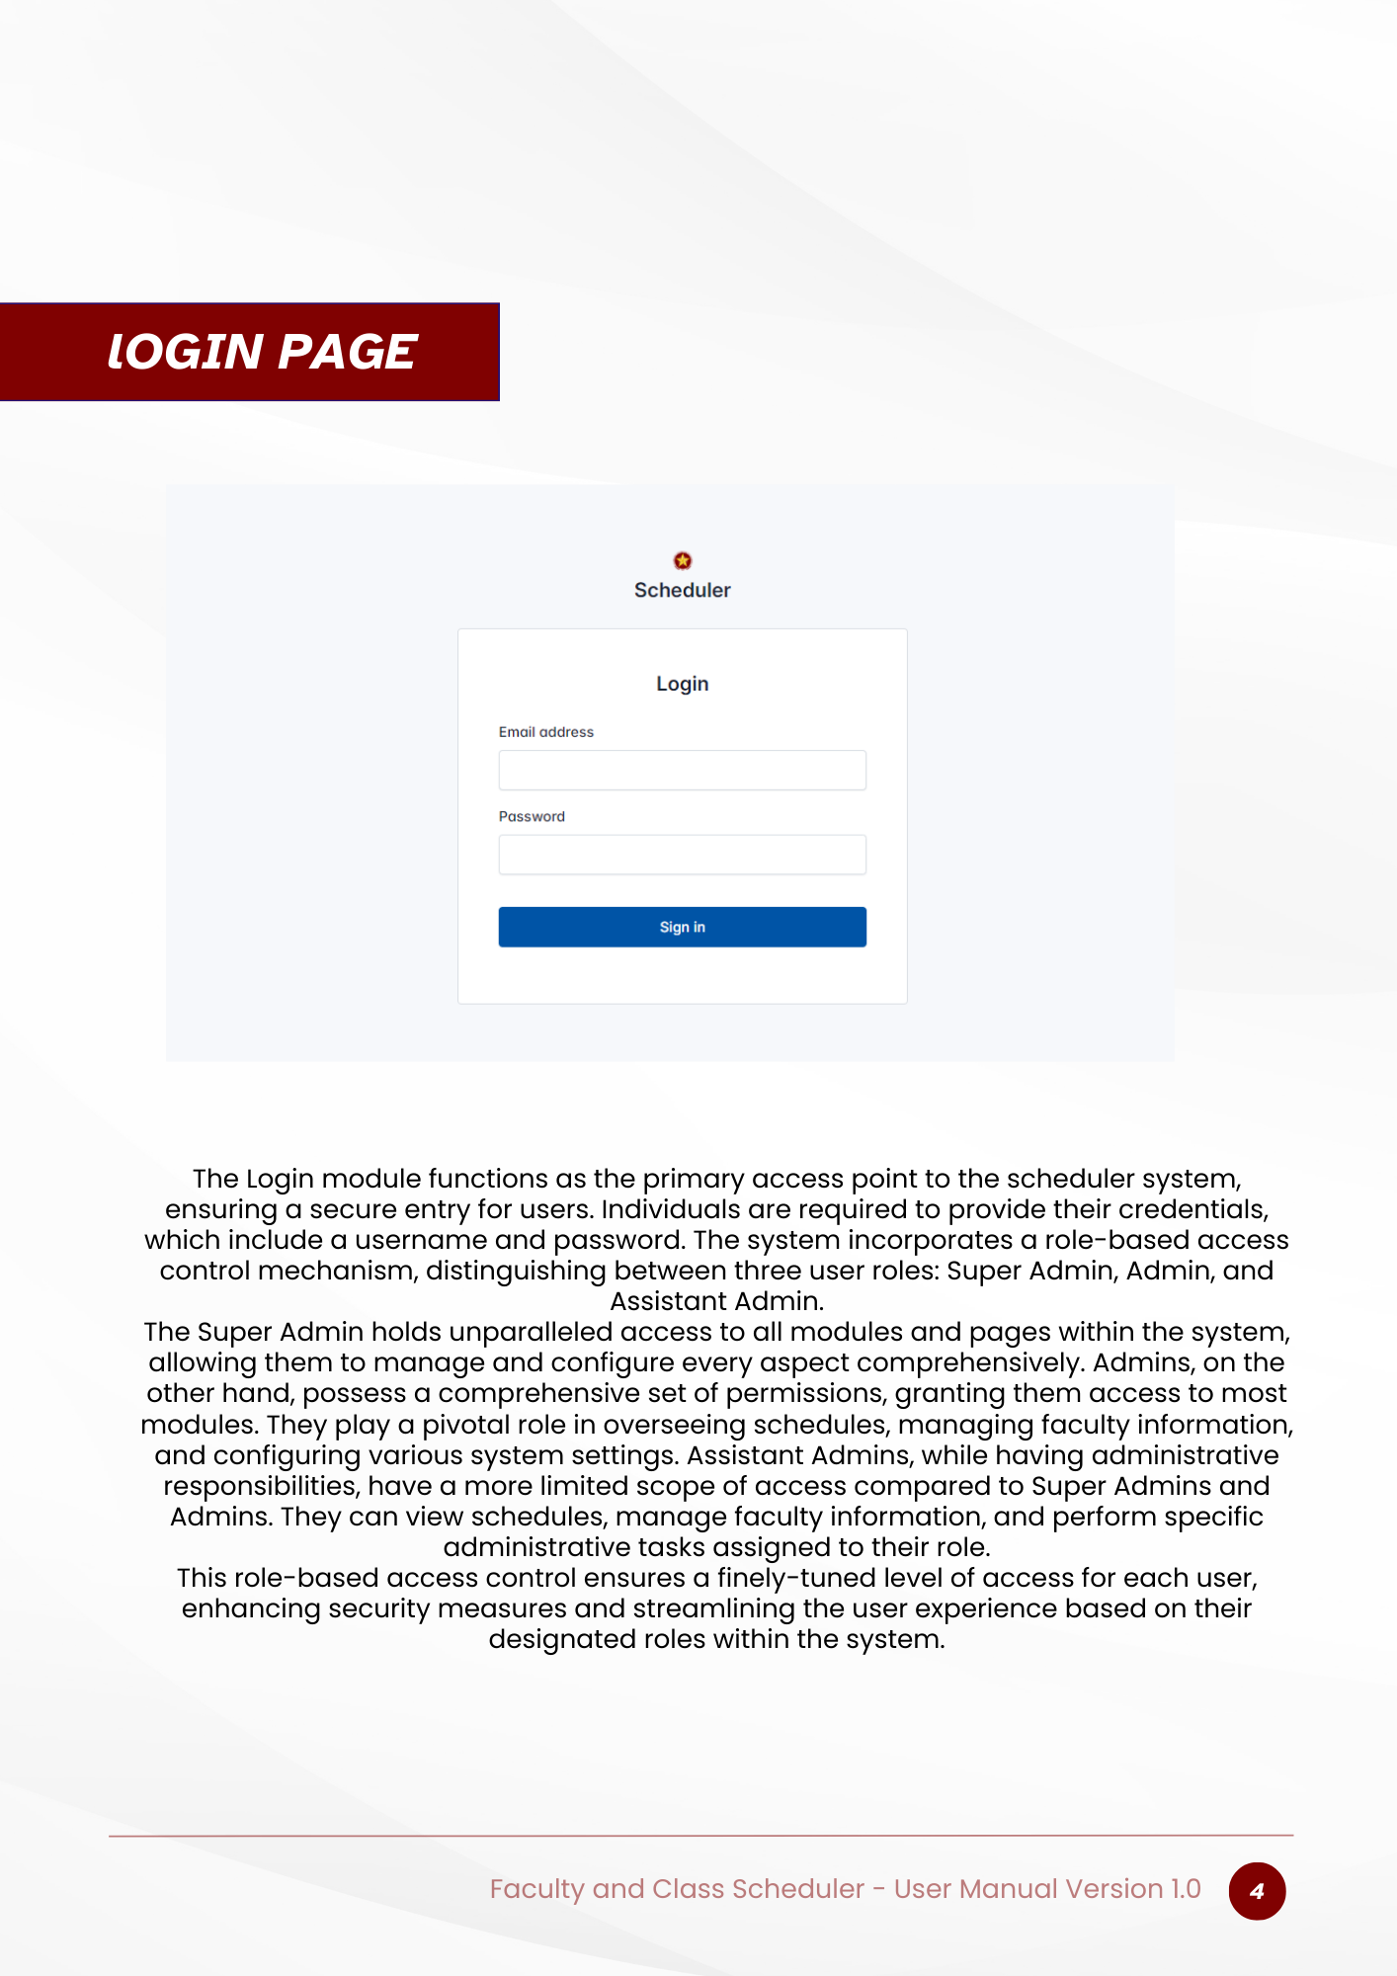

Figure 44. User Manual – Login Page

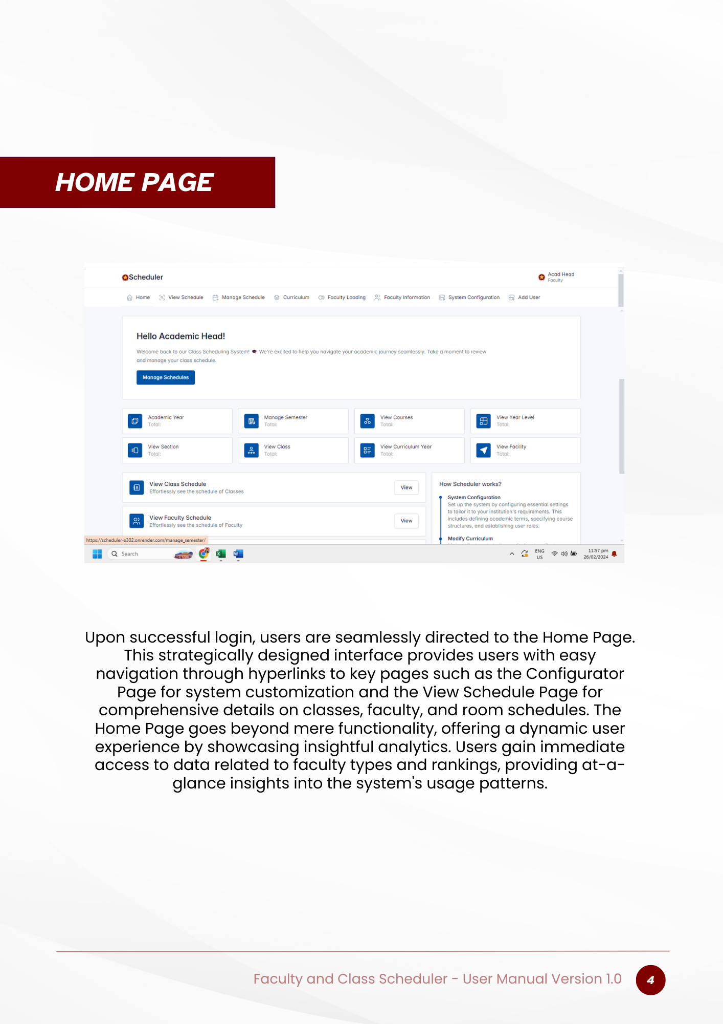

Figure 45. User Manual – Home Page



Figure 46. User Manual – View Schedule Page

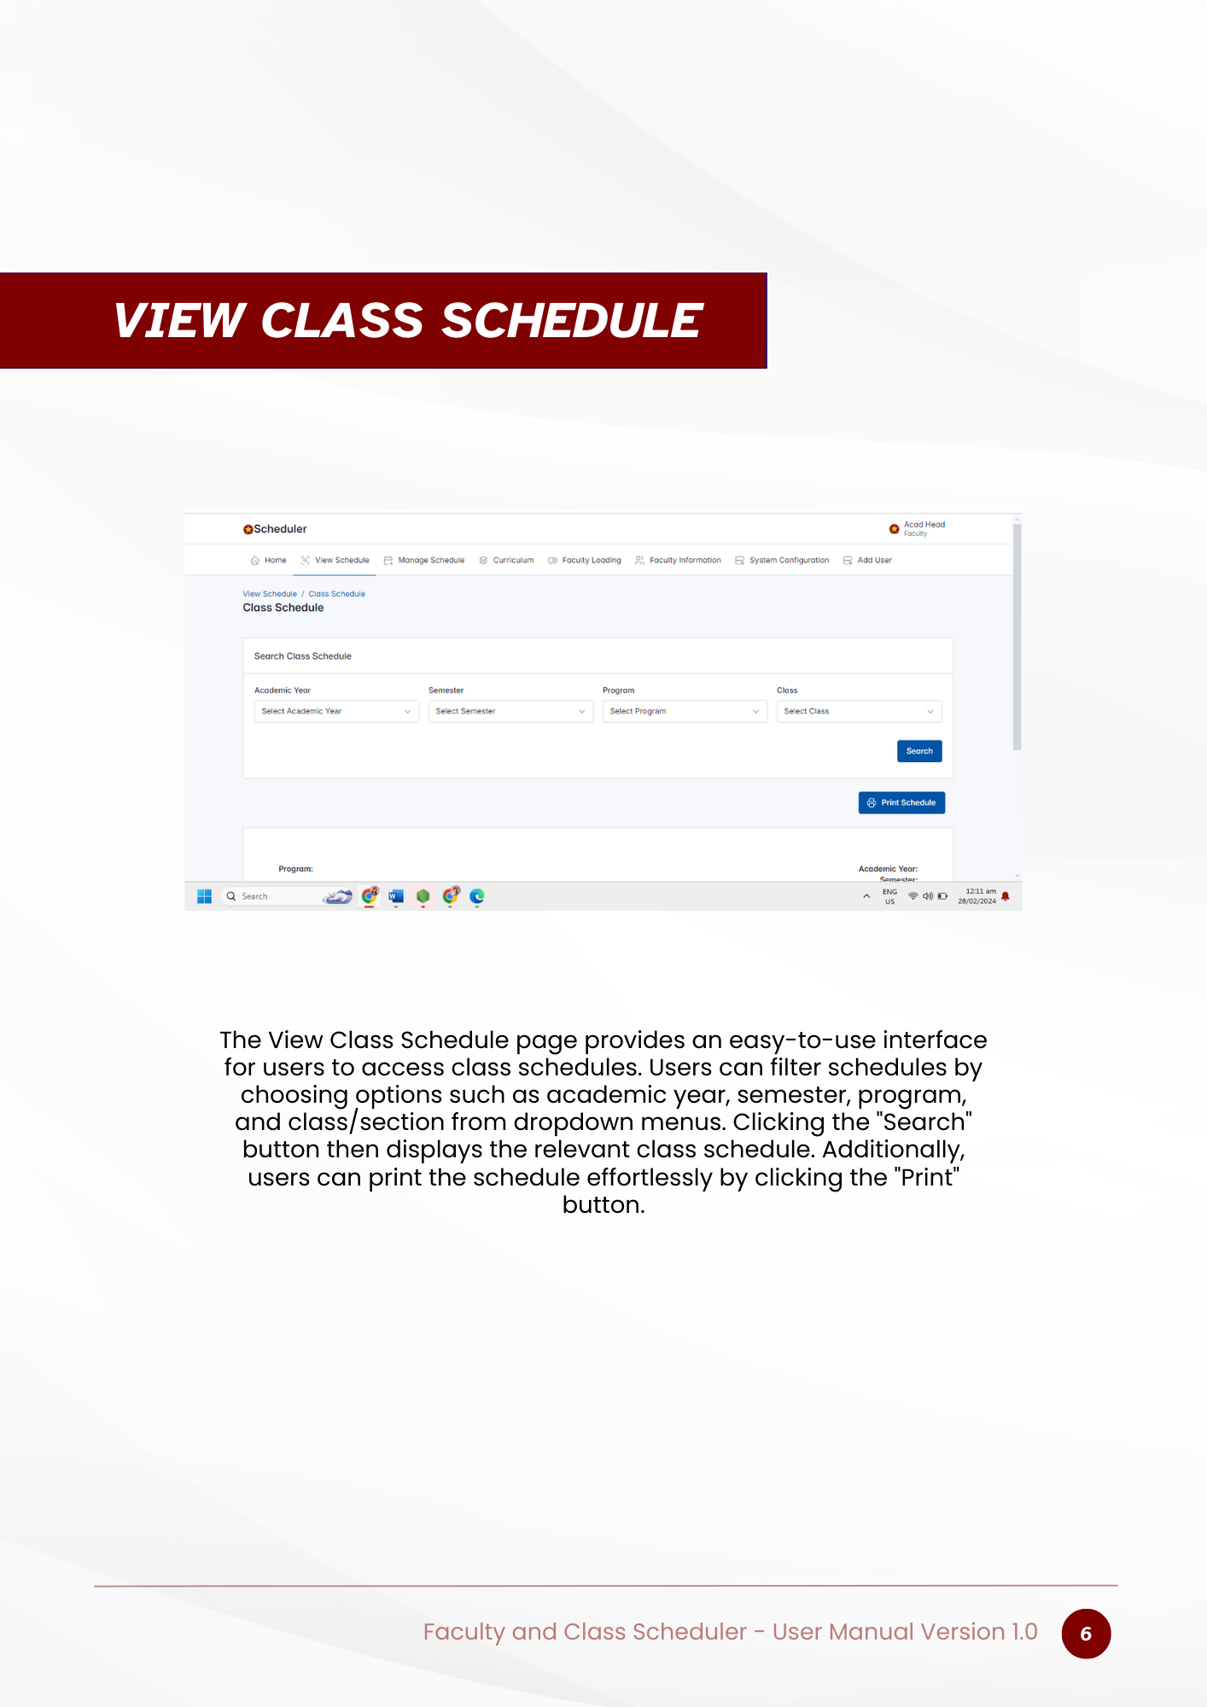

Figure 47. User Manual – View Class Schedule Page

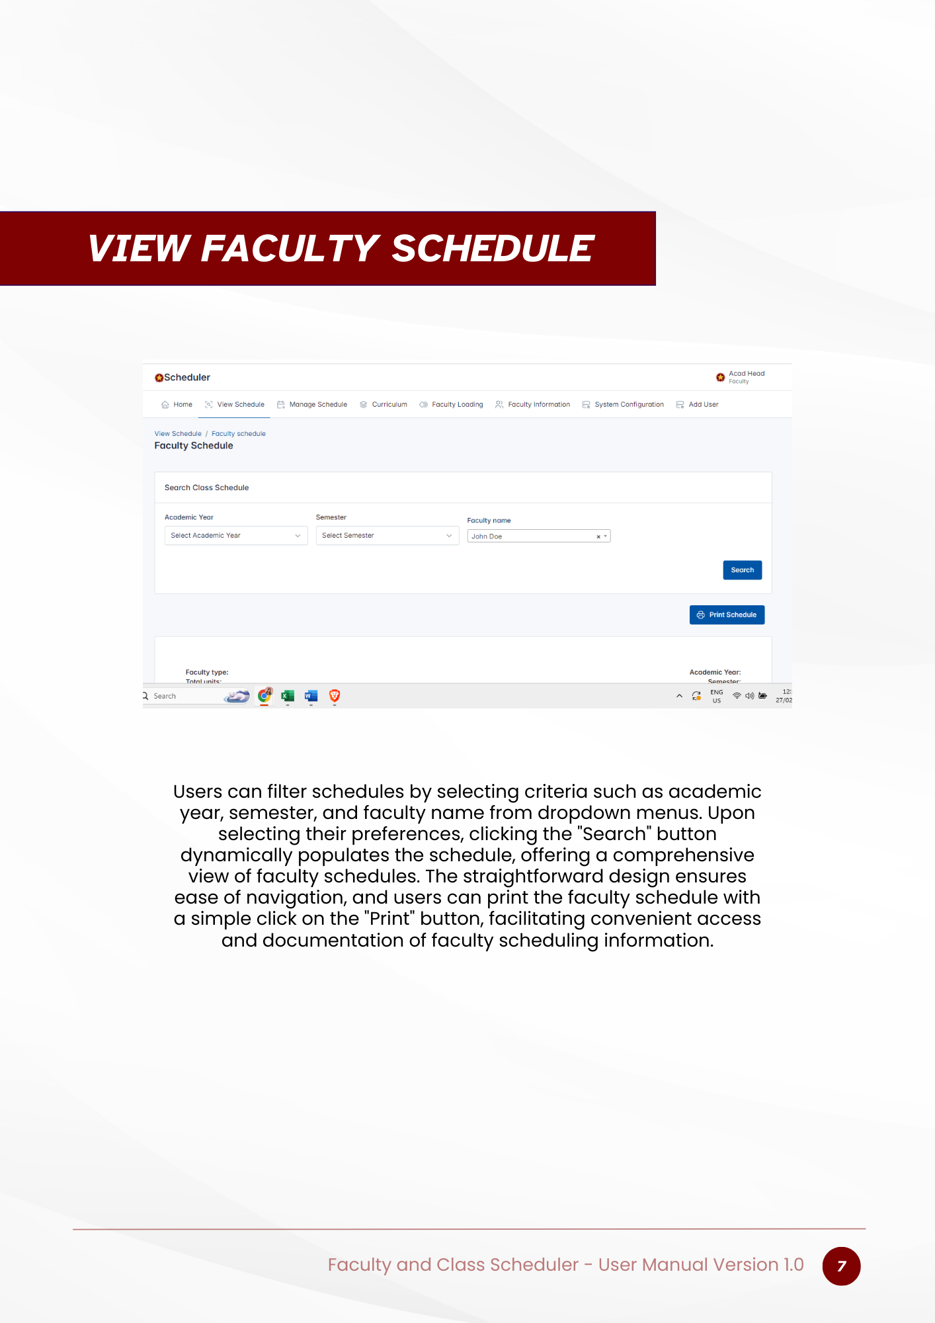

Figure 48. User Manual – View Faculty Schedule Page

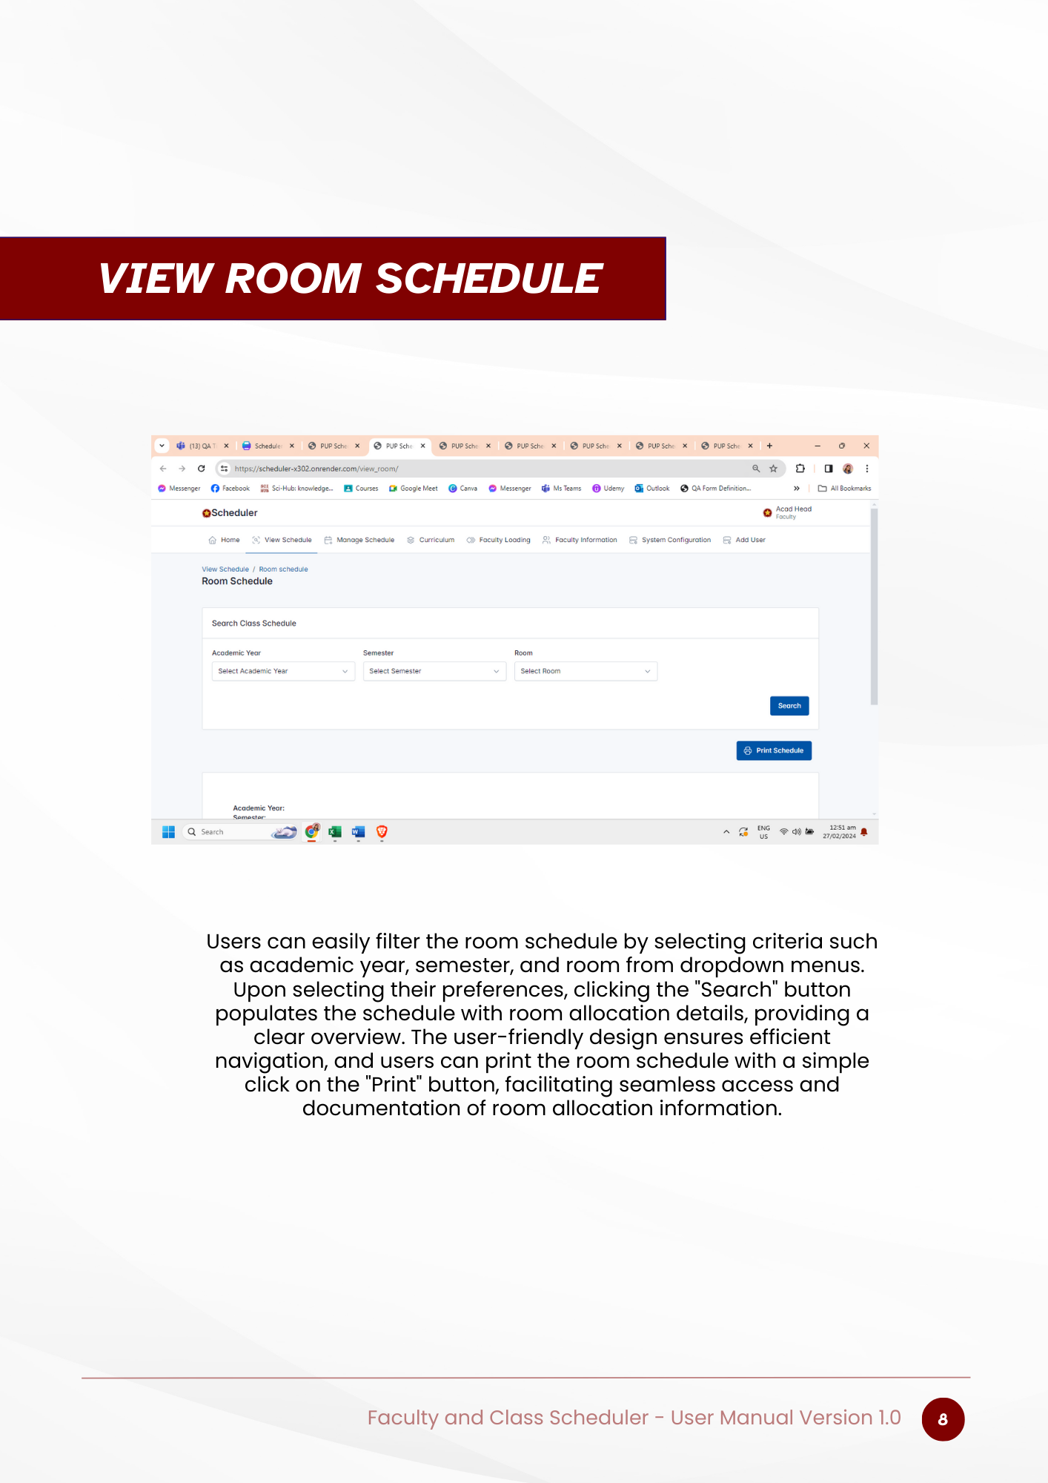

Figure 49. User Manual – View Room Schedule Page

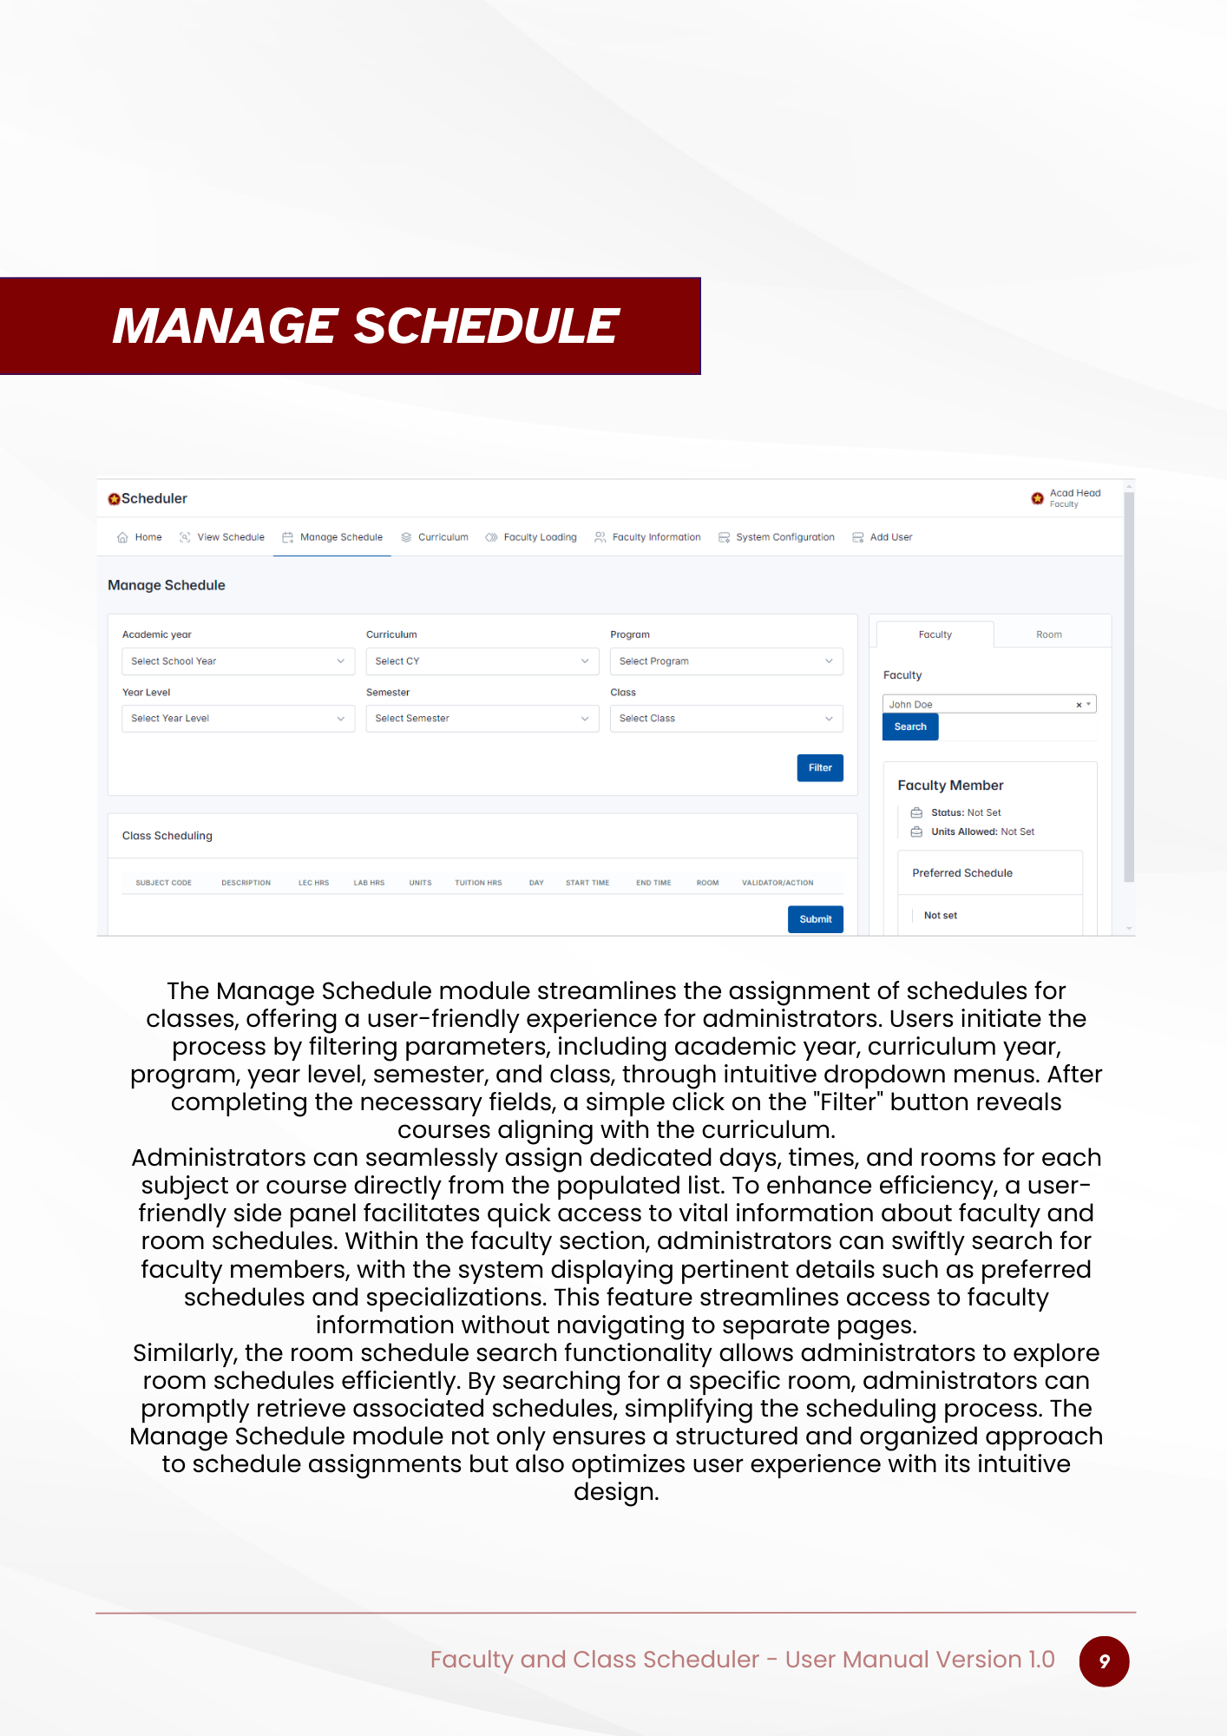

Figure 50. User Manual – Manage Schedule Page

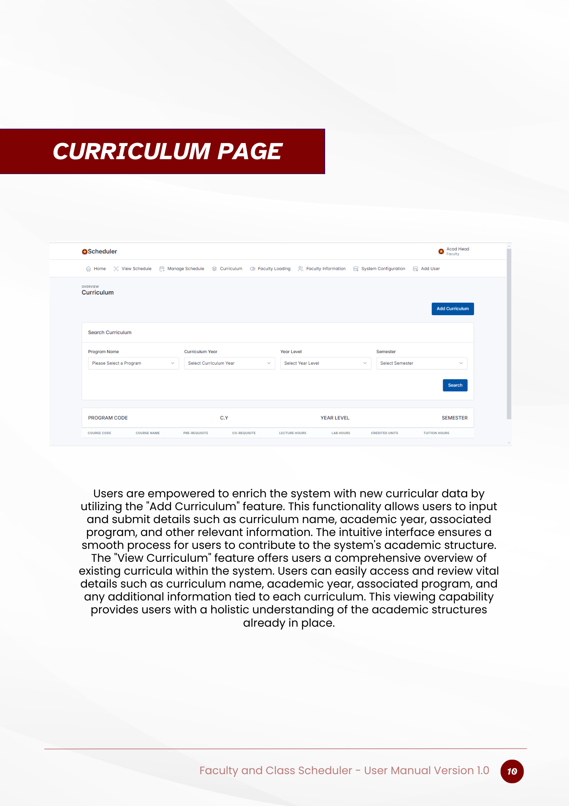

Figure 51. User Manual – Curriculum Page

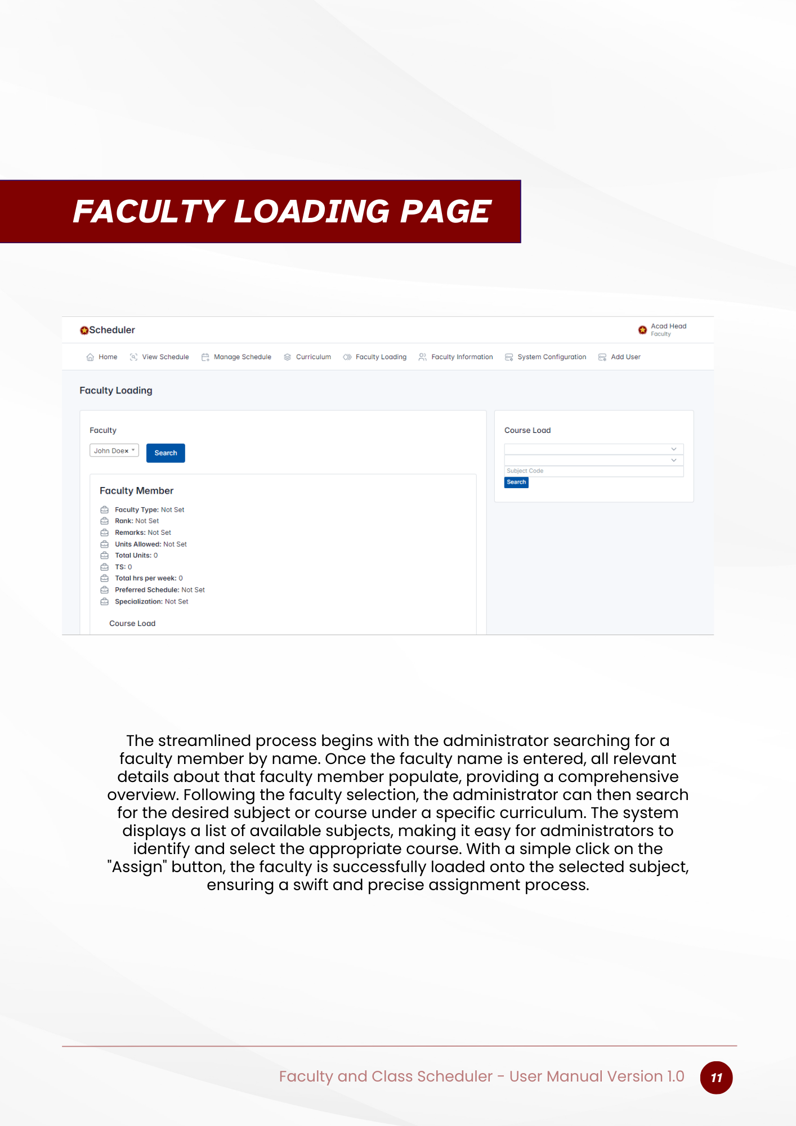

Figure 52. User Manual – Faculty Loading Page

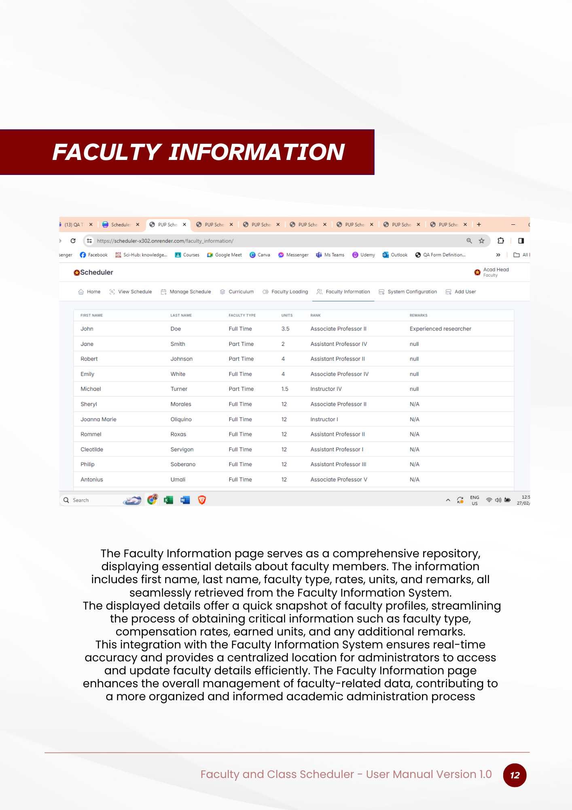

Figure 53. User Manual – Faculty Information Page

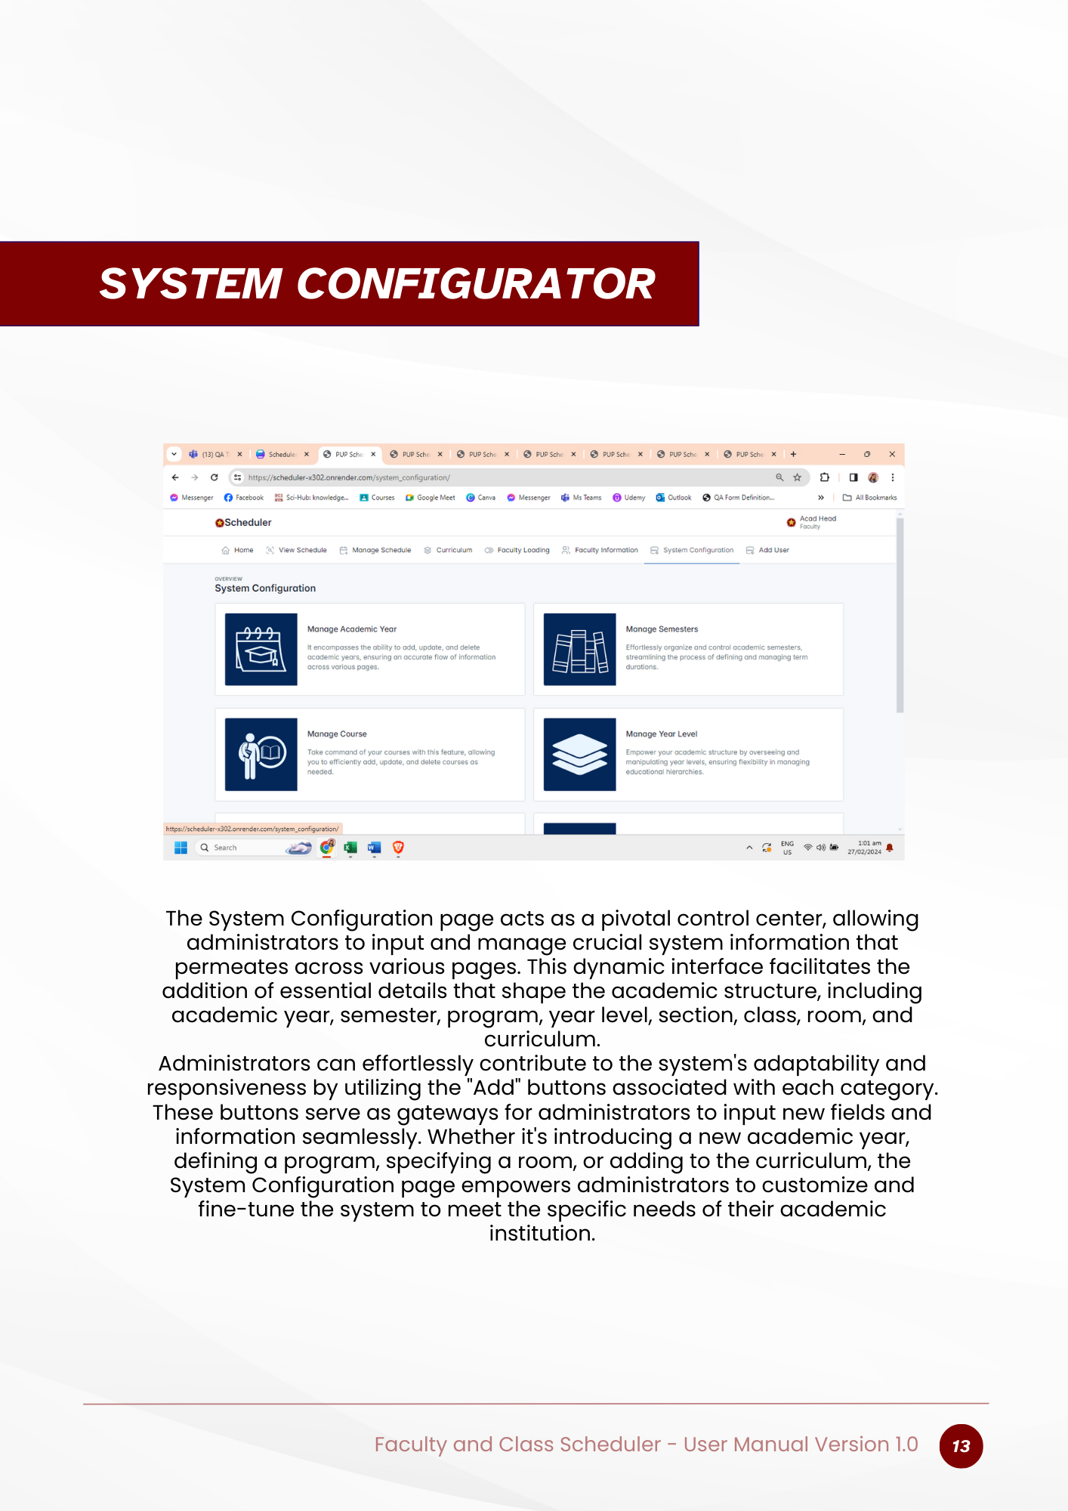

Figure 54. User Manual – System Configurator Page

## Version Control and Source Code Repository

## Version Control System

To successfully manage the source code when developing the PUPQC Scheduler System, an elaborate version of the control system was used by the team. GitHub, a widely used distributed version control system, was chosen for its dependability, scalability, and comprehensive feature set. Github enabled team members to collaborate on distinct branches while seamlessly merging changes. Its branching and tagging features allowed the team to manage various versions of the codebase, trace changes, and restore to earlier states as needed. Furthermore, GitHub offered a centralized repository for storing and distributing code, ensuring visibility and transparency throughout the development process.

## Repository Details

The GitHub repository for the Scheduler System was hosted on GitHub, a prominent platform for hosting Git repositories and working on software projects. The repository was set up to impose access control mechanisms so that only authorized team members could push modifications to the source. GitHub also included capabilities like issue tracking, pull requests, and code reviews, which facilitated efficient cooperation and code review procedures. The repository was divided into branches depending on feature development, issue fixes, and releases, which allowed for more structured software development and versioning.

## Branching

In terms of branching strategies, the team used the Gitflow approach, which entails keeping different branches for development, testing, and production releases. Feature branches were designed to allow developers to collaborate on isolated modifications without affecting the main codebase, such as creating new features or correcting problems. After a feature was completed, it was code-reviewed and tested before being merged into the development branch. The development branch functioned as the integration point for feature branches, undergoing extensive testing and validation to assure stability and compatibility. The improvements were then integrated into the main branch for production releases, following a rigorous deployment process. Branching and merging techniques were carefully designed and carried out to reduce conflicts, preserve code quality, and streamline the development workflow.

## DevOps and CI/CD

## Pipeline Setup

The Faculty & Class Scheduler System's Continuous Integration/Continuous Deployment (CI/CD) pipeline was carefully set up to automate testing and deployment. The pipeline was designed with industry-standard tools and frameworks to provide scalability across platforms. Continuous integration was achieved by frequently integrating code changes into the main codebase, which triggered automated tests to check the software's integrity. Continuous Deployment then enabled the automatic deployment of verified code to staging and production environments, minimizing manual involvement and speeding up the release cycle. The pipeline consisted of steps for code compilation, unit testing, integration testing, staging deployment, user acceptability testing, and production deployment. Each stage was completed consecutively, with automated notifications and alerts set up to notify stakeholders about pipeline progress and findings.

## 15.11.2 Deployment Strategies

The system's deployment procedures included a variety of techniques to ensure that upgrades were delivered seamlessly and reliably to production environments. Continuous release enables the automated deployment of validated code changes to staging and manufacturing environments, lessening downtime and risk associated with manual deployments. Blue-green and canary deployment methodologies were used to reduce risks and provide smooth transitions between updates. Blue-green deployment involves deploying a new version of an application alongside the previous version, allowing for testing and validation before switching traffic to the new version. On top of that, Rollback methods were developed and tested to allow for the reversion to prior versions in the event of unforeseen errors during deployment, ensuring capacity and service continuity of the entire system.

## 15.12 Licensing and Open-source Libraries

## 15.12.1 Licenses

During the production of the system, the team made use of both proprietary and open-source software components, both of which were subject to certain licensing. Open-source libraries and frameworks, such as Django, FastAPI, and PostgreSQL, were incorporated into the system under licenses such as the Apache License, MIT License, and PostgreSQL License, which allow for the usage, modification, and distribution of the program under specified conditions. Proprietary software tools and services, if any, were licensed under their terms and agreements, assuring legal and licensing compliance. License information for all software components used in the system was recorded and stored in the project repository, ensuring transparency and clarity about the conditions of usage.

## 15.12.2 Credits

The project documentation and source code repository contains acknowledgments and attributions for open-source components used in the Faculty and Class Scheduler System. The development team acknowledged the contributions of individual individuals, companies, and communities to the open-source libraries and frameworks used in the system. Credits were assigned following the criteria outlined in each project's license, guaranteeing proper recognition and appreciation for the open-source community's joint work. Links to the original repositories, documentation, and license information were also given to make it easier to explore and contribute to the projects.

## 15.13 Product Backlogs



Figure 55. Product Backlogs – Part 1



Figure 56. Product Backlogs – Part 2